NOTIFICATION: West Drive/ North Drive – Alterations to parking and improvements to informal pedestrian crossing

1 - Introduction of double yellow lines at the bend of West Drive with North Drive
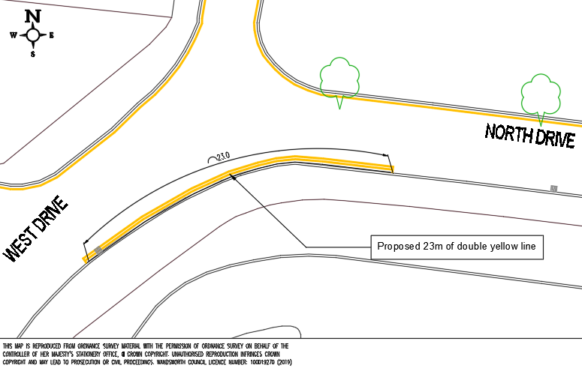

2 – Introduction of double yellow lines at the junction of North Drive with Aldrington Road
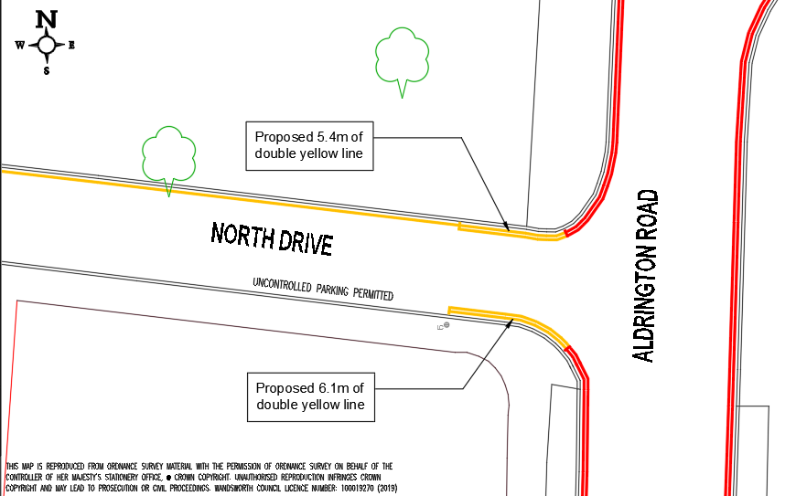

3 - Alterations to informal pedestrian crossing


