Pope’s Urn – a new focal point on the riverside
Alexander Pope (1688-1744) is Twickenham’s most famous resident. One of the greatest English poets, he was already famous in his own lifetime, and his work has had an enduring legacy on English literature. Poet in the City, a leading literary organisation and public art consultancy, is planning to create a modern version or interpretation of Pope’s Urn, an attractive and original concept for a piece of sculpture, as a fitting centrepiece for Champion’s Wharf. This urn is based closely on a famous urn designed by Alexander Pope himself for a friend’s gardens at Hagley in the Midlands. The urn itself no longer exists, but Poet in the City has based its design on drawings of the original, and on other urns from the same period.
The Urn proposed will provide a 21st Century take on a typical Georgian cultural artefact. The new version of Pope’s Urn will have the same elegant profiles as the original but will be simpler and more contemporary in detail. The solidity of the urn will change at different viewpoints, representing the original form whilst bringing it firmly into a new era. Sympathetic to the site, and to the history of Twickenham, this stylish piece of public art will be accompanied by poetry quotes from Alexander Pope, featured in the accompanying seating. Alexander Pope was responsible for some of the most famous expressions in the English language including ‘To err is human, to forgive, divine’, ‘Fools rush in where angels fear to tread’ and ‘A little learning is a dangerous thing’. Some of these popular quotes will appear in newly commissioned seating and on a mural on Champion’s Wharf, celebrating the association of Twickenham with this great poet.
A great lover of landscape and plants, Alexander Pope was arguably also responsible for the abiding love affair between the English and their gardens. His elegant villa on the Thames at Twickenham (on the site of what is now Radnor Gardens) inspired many imitations, including Marble Hill House, and a vision of the so-called Thames Arcadia which still inspires people to this day. In keeping with Pope’s inspiration, it is intended that the urn should provide a beautiful focal point for the new landscaping of Champion’s Wharf.
Specification of size and materials to be used
Standing just over 8 foot high, including its pedestal, the urn will appear appropriately sized in its riverfront context, under the canopy of four new trees. The urn and pedestal will be made out of corten steel, popular with sculptors of today, for example Richard Serra and Sir Anthony Gormley. This contemporary material has been specially chosen to harmonise with the colours of the setting on Champion’s Wharf, and in particular for the red brick of much of the backdrop, including St Mary’s Church and Sundial House. Corten steel naturally weathers to form a protective, oxidised surface and assumes an attractive russet colour which should blend in very well on this site. Corten steel is very strong and maintenance free and it does not require painting. The neoclassical form of the urn will share the language of the 18th Century architecture of the church and the pedestal should relate to more recent neoclassical balustrades which are a feature of the river frontage of the Champion’s Wharf site. Quotations from the poet Alexander Pope will be cut into the pedestal of the Urn and will be carved into the new seating on the site, using CNC cutting techniques. This should result in attractive and legible text, and should provide a popular and accessible introduction to the poet and his work.

Visual images of the urn:
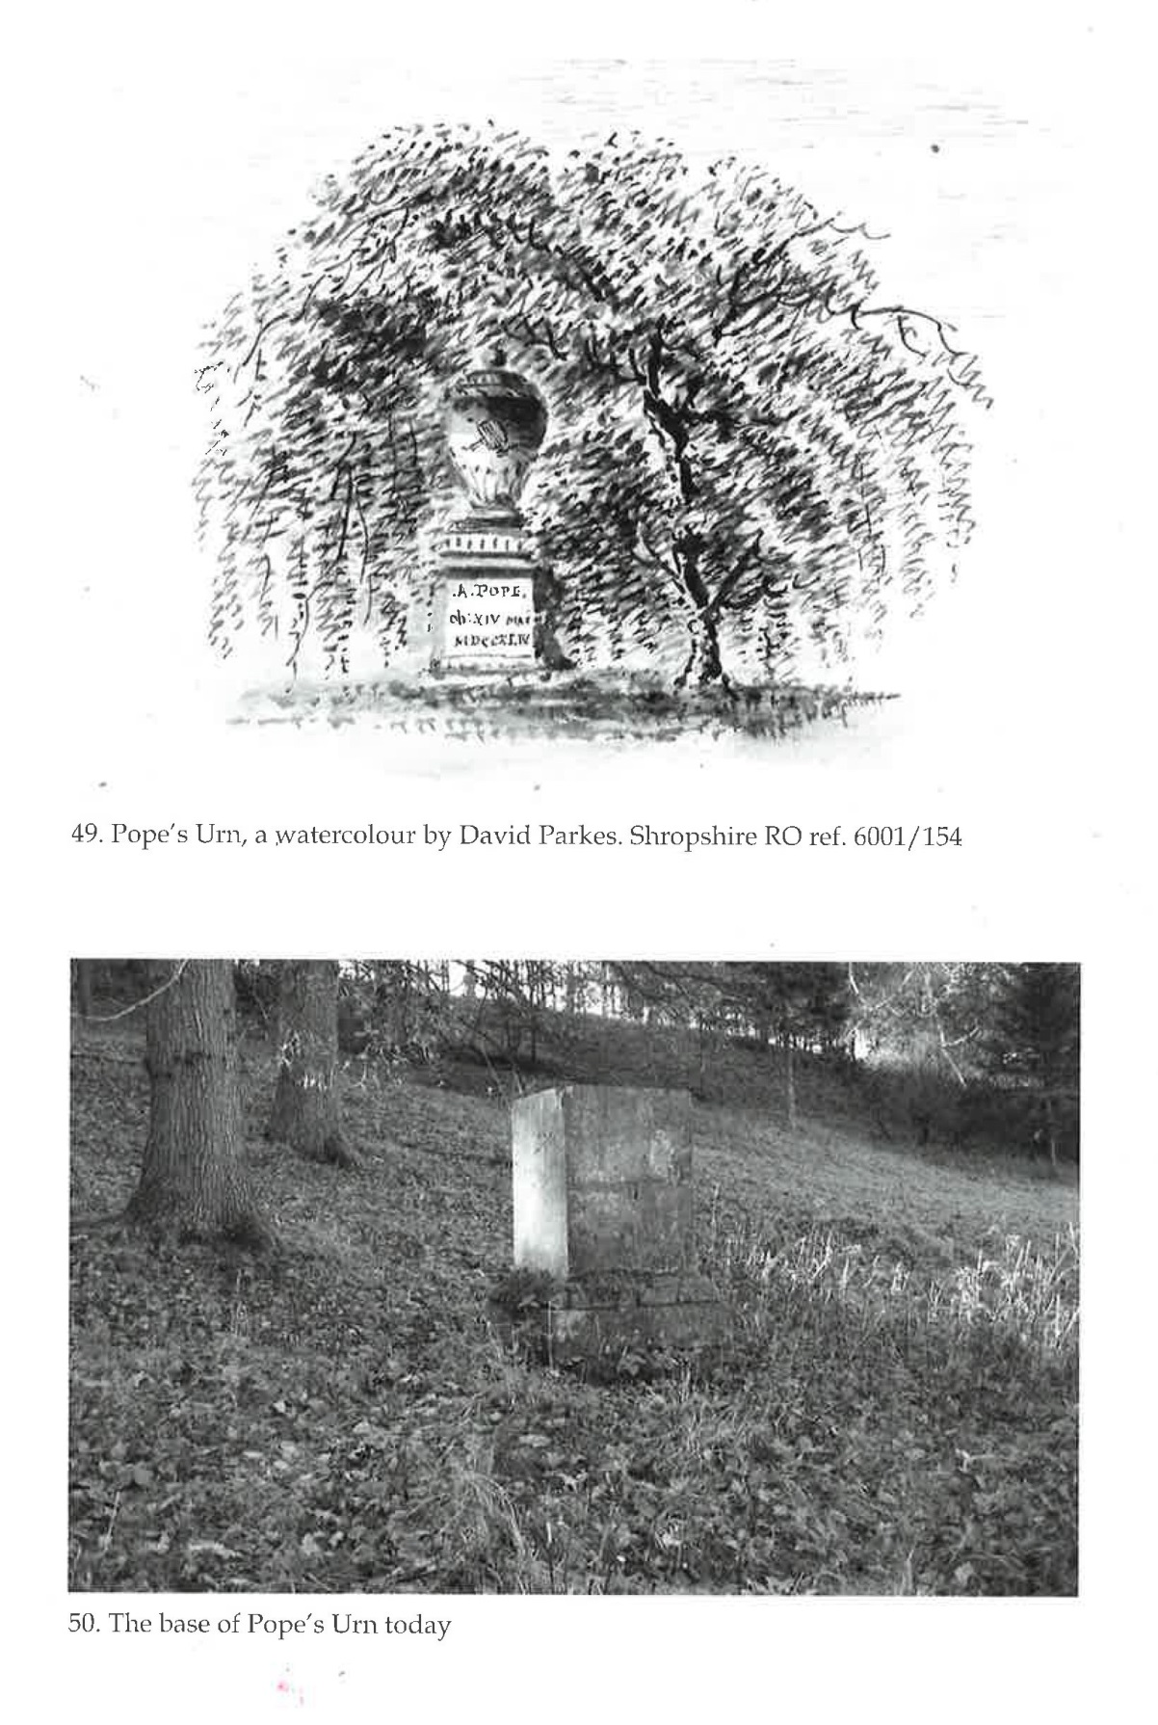

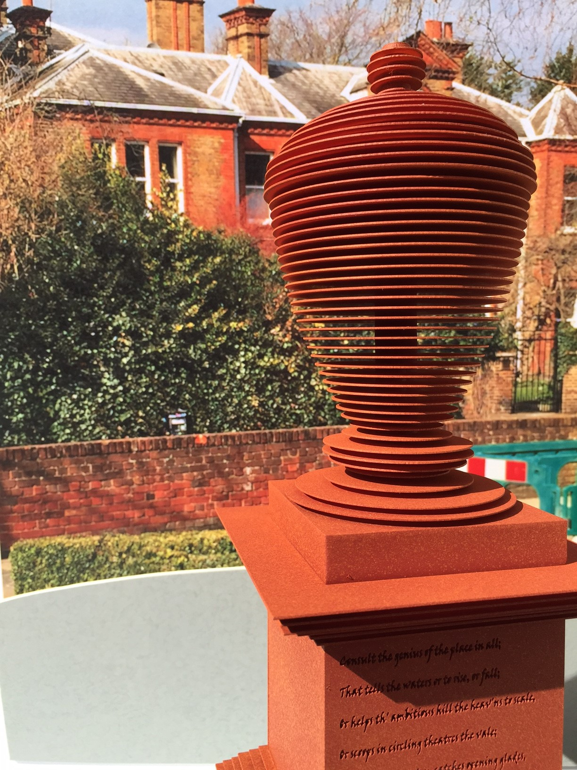
Image of urn in situ on site
Corten Steel
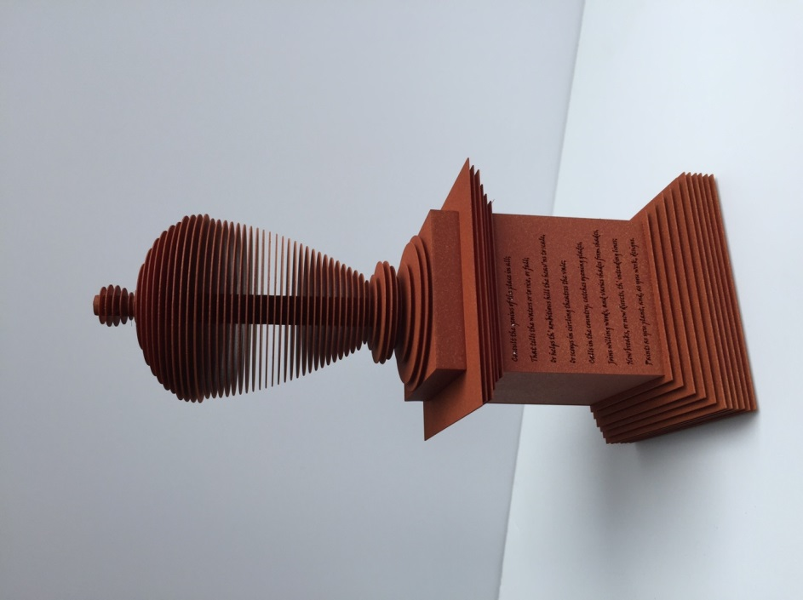
Image of urn and base

