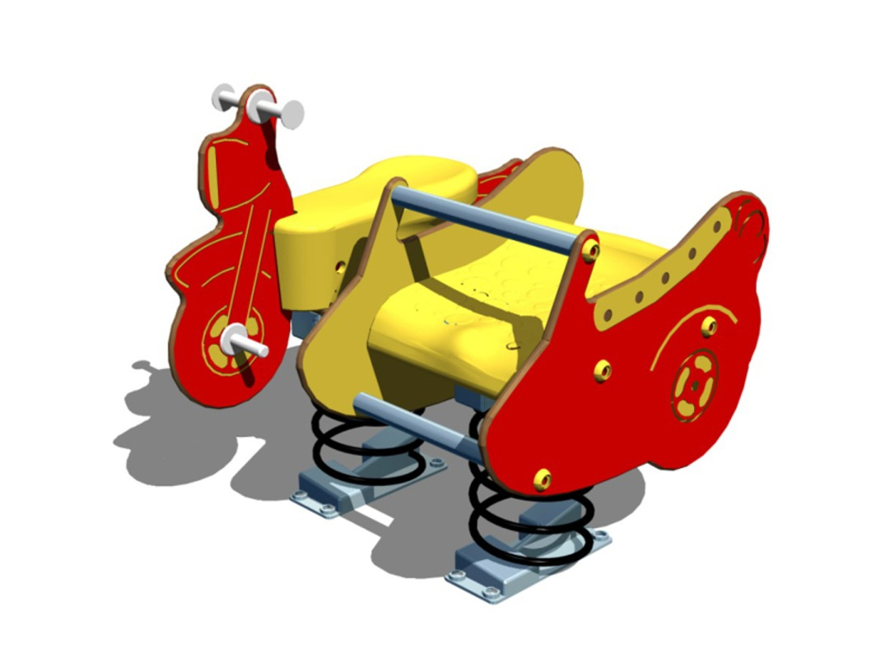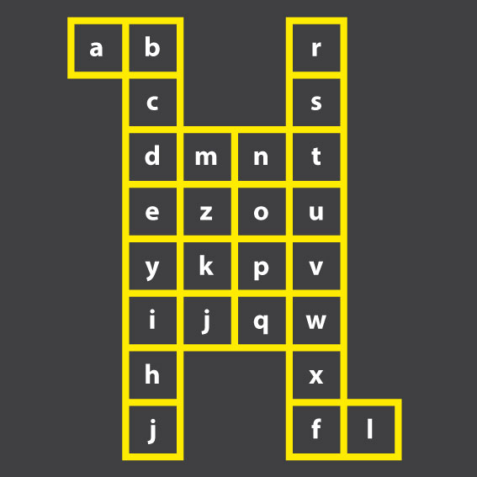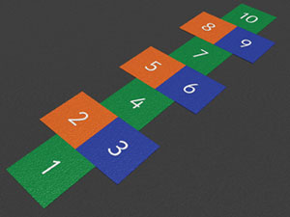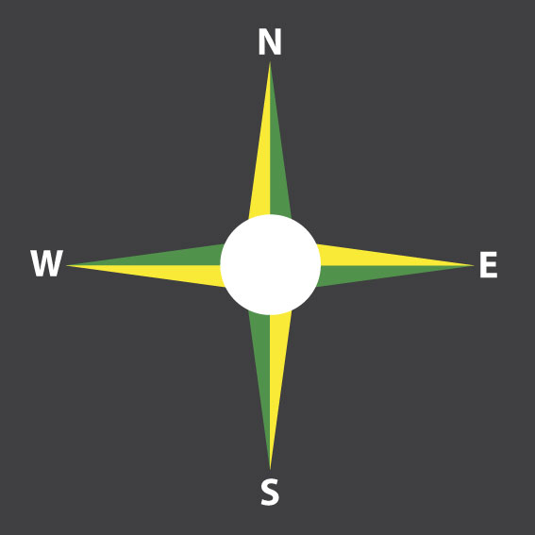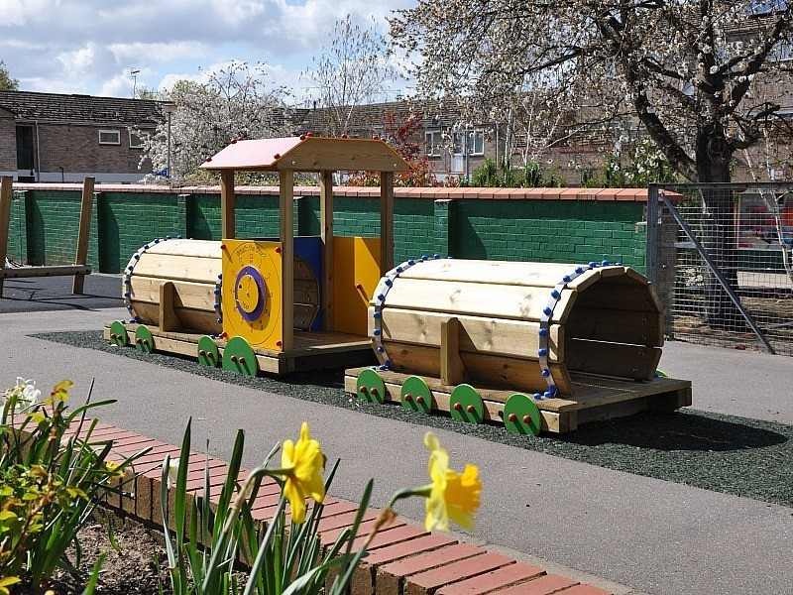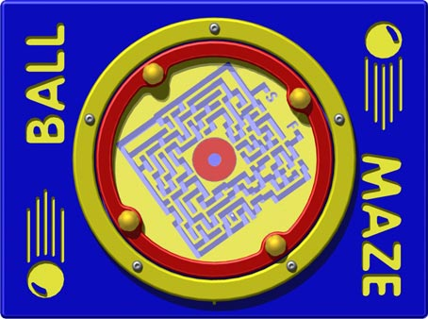**Examples of the proposed new play equipment and markings for Mortlake Green Playground**

Clockwise:

* 4 Point Compass marking,
* Hopscotch board,
* Alphabet grid,
* Example of a play panel,
* Motorbike and sidecar springer
* Play Train Example