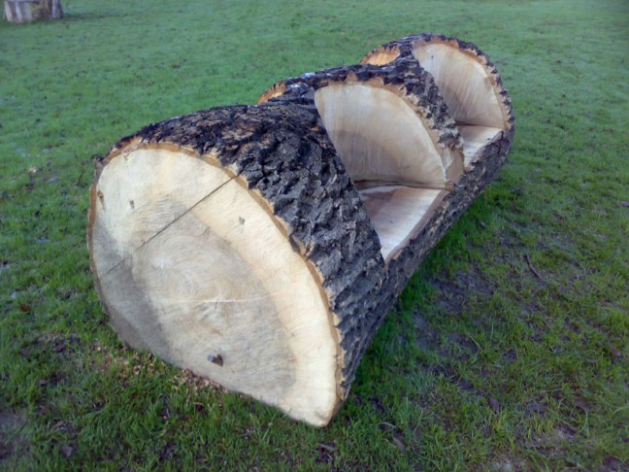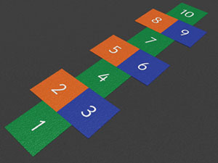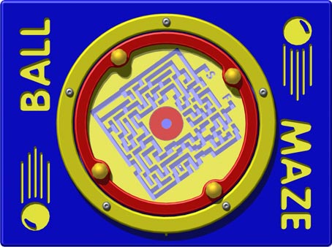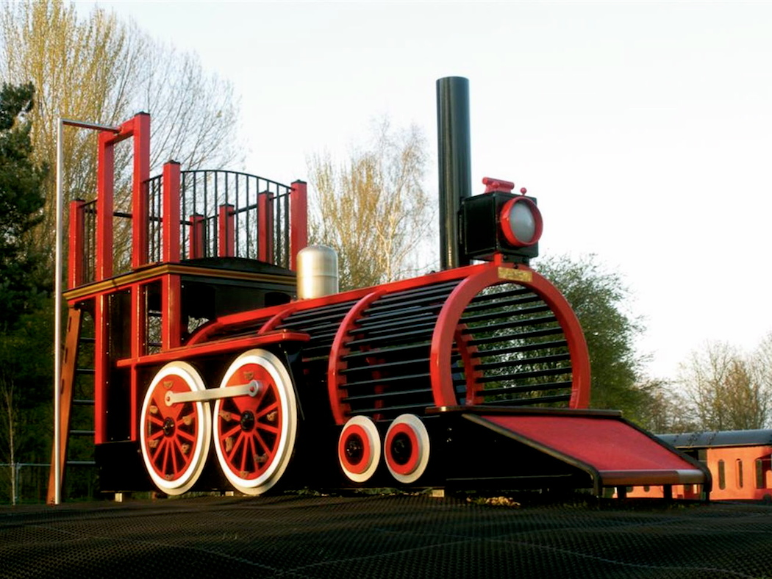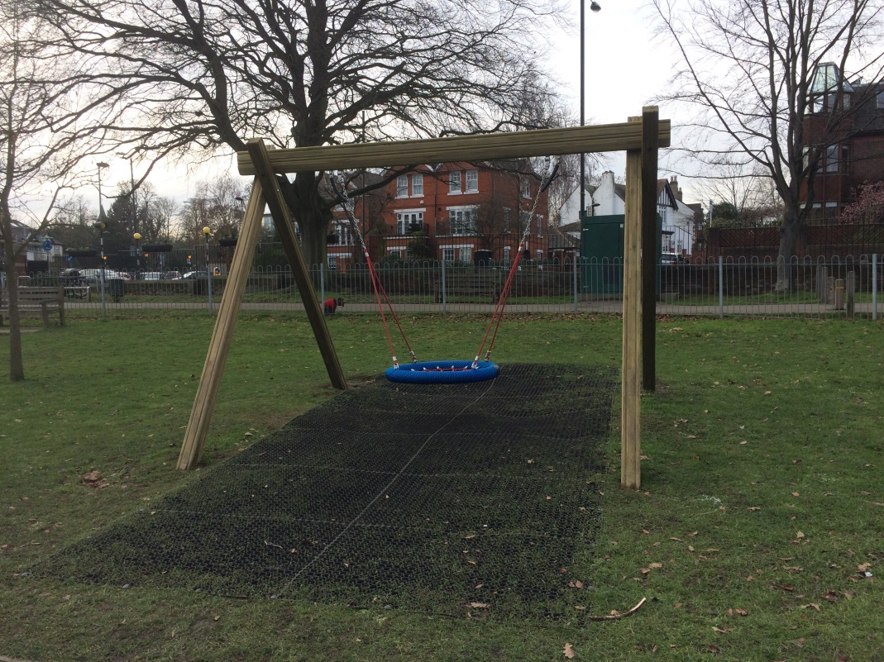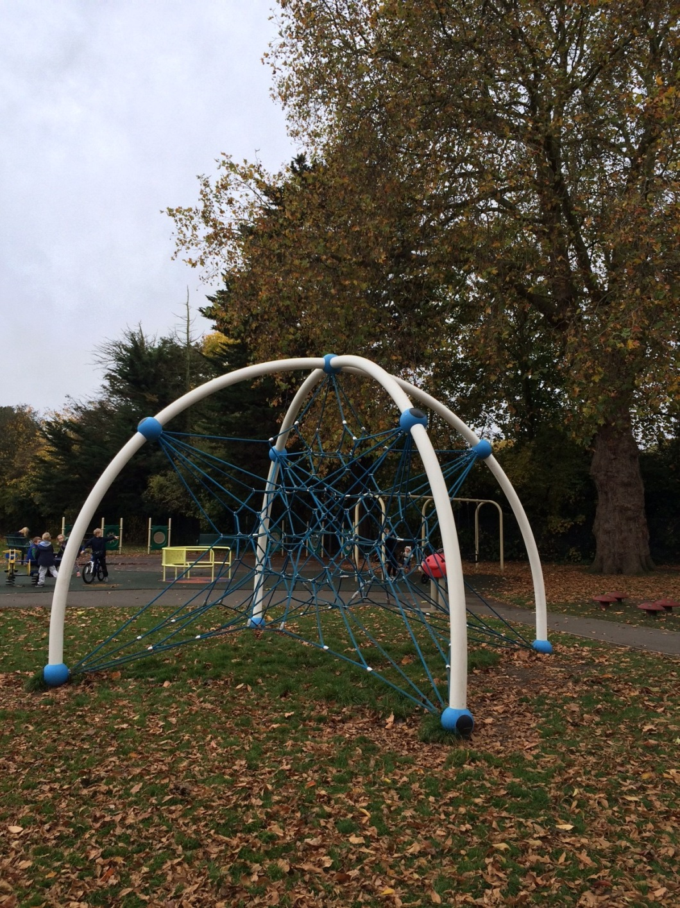**Examples of the proposed new play equipment and surface markings for Mortlake Green Playground**

Clockwise:

* Hopscotch board,
* Selection of logs for an outdoor classroom
* Example of a play panel,
* Space net
* Basket swing
* Play train example