Cumulative Impact Analysis

- Introduction
Cumulative Impact is defined as the potential impact on the promotion of the licensing objectives of a number of licenced premises concentrated in one area. In some areas where the number, type or density of licensed premises is high, or exceptional, serious problems of nuisance, crime or disorder may occur within or some distance away from the area.
A Cumulative Impact Assessment may be published by a Licensing Authority to help it to limit the number or type of applications granted in areas where there is evidence to show that the number or density of licensed premises in the area is having a cumulative impact and leading to problems which are undermining the licensing objectives.
The Policing and Crime Act 2017 sets out what a licensing authority must do in order to publish a cumulative impact assessment (CIA). This includes publishing the evidential basis for its opinion and consulting on this evidence. A cumulative Impact Assessment must be published, and consulted upon, every three years. The evidence underpinning the publication of the CIA must be suitable as a basis for a decision to refuse an application or impose conditions.
The evidence of cumulative impact on the promotion of the licensing objectives needs to relate to the particular problems identified in the specific area to be covered by the CIA. The Secretary of State’s Guidance provides a list of Information which licensing authorities may be able to draw on when considering whether to publish a CIA including

- local crime and disorder statistics, including statistics on specific types of crime and crime hotspots;
- statistics on local anti-social behaviour offences;
- health-related statistics such as alcohol-related emergency attendances and hospital admissions;
- environmental health complaints, particularly in relation to litter and noise;
- complaints recorded by the local authority, which may include complaints raised by local residents or residents’ associations;
- residents’ questionnaires;
- evidence from local and parish councillors;
- evidence obtained through local consultation;
- Underage drinking statistics.

This report lays out the evidence that indicates that:

- the Cumulative Impact Policy for Richmond Town Centre should be retained.
- the Cumulative Impact Policy for Twickenham Town Centre should be retained.
- no other area of the borough should be included in the Cumulative Impact Assessment at this time.

- Council Wards

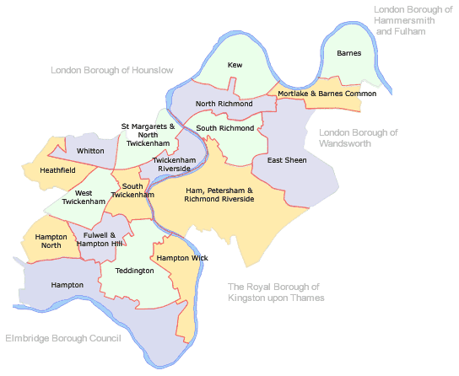

- Licensed premises

There are currently some 790 licensed premises in the London Borough of Richmond Upon Thames. The borough has five main commercial centres; Richmond, Twickenham, Teddington, East Sheen and Whitton. The busiest of these areas is Richmond. From the map (shown below) it can be seen that the highest concentrations of licensed premises lie within Richmond and Twickenham commercial centres. The next most concentrated area is East Sheen. It should be noted that not all these premises have licences to sell alcohol, some may be licensed to sell hot food only after 23.00 hours or to provide only public entertainment. A more detailed analysis of the number and type of licensed premises in each of the two existing Cumulative Impact Zones are shown later.

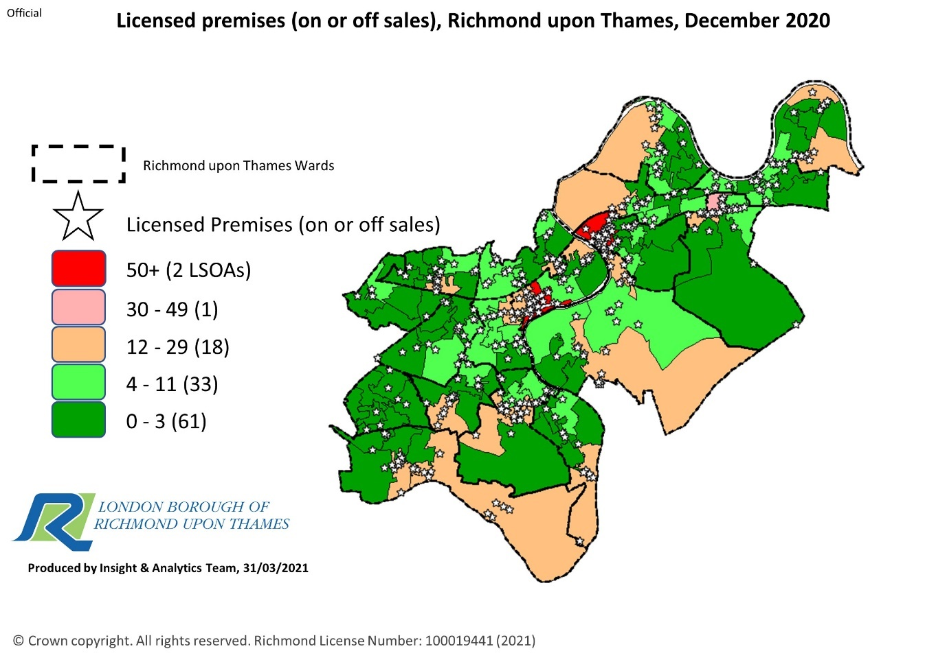

- Violence with injury – non domestic
South Richmond has highest levels of violence with injury (non-domestic) reports, followed by Twickenham Riverside. Below is a map of violence with injury (non-domestic) recorded by the Metropolitan Police between April 2019 and March 2020 by Lower Layer Super Output Area (LSOA) boundaries. The map provides a more localised picture of police reports on violence than shown in the Ward analysis table shown later. It indicates that the two existing Cumulative Impact Areas of Richmond Town Centre and Twickenham Town Centre lie within areas of the highest police callouts for violence with injury (44 and 32 respectively).
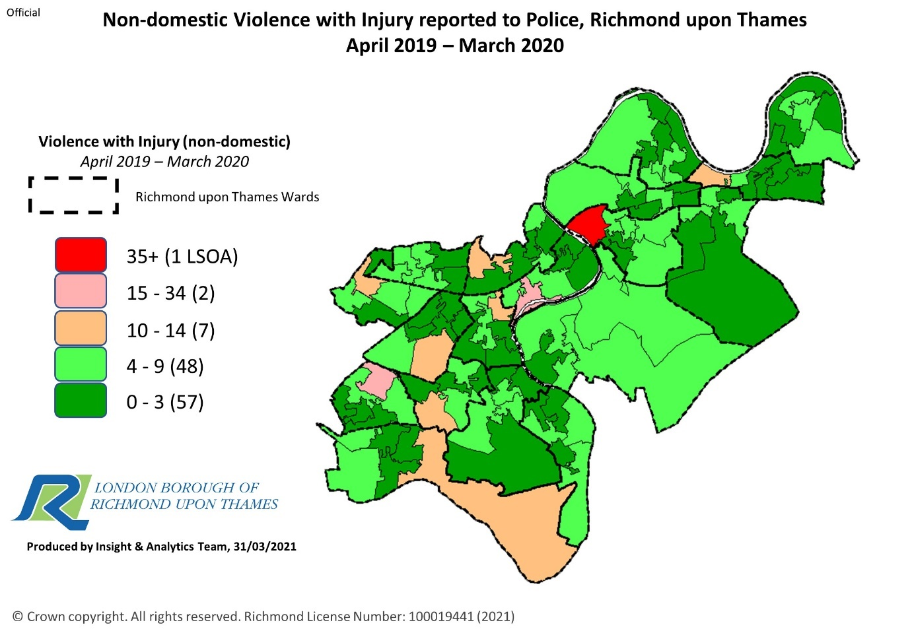
The table below shows the actual number of violence with injury callouts to the police reported by Ward. For comparison, the table shows violence with injury callouts to the police from the 1st April 2019 – 31st March 2020 and from the 1st April 2020 to the 301st March 2021. The Wards of South Richmond and Twickenham Riverside had the highest number of callouts in 2019-2020. Although the actual numbers are lower, the Wards of South Richmond and Twickenham Riverside again recorded the highest violence with injury- non domestic call outs in 2020-2021.
Violence with Injury - Non Domestic
Time Period: April 19 - March 20 and April 20- March 21
Data Source: Metropolitan Police Service
1/4/2019 – 31/3/2020 |  | 1/4/2020- 31/3/2021
Ward | Count | Ward |  | Count
Barnes | 24 | Barnes |  | 16
East Sheen | 24 | East Sheen |  | 21
Fulwell and Hampton Hill | 29 | Fulwell and Hampton Hill |  | 21
Ham, Petersham and Richmond  Riverside | 33 | Ham, Petersham and Richmond  Riverside |  | 28
Hampton | 27 | Hampton |  | 25
Hampton North | 34 | Hampton North |  | 32
Hampton Wick | 23 | Hampton Wick |  | 16
Heathfield | 30 | Heathfield |  | 32
Kew | 25 | Kew |  | 21
Mortlake and Barnes Common | 20 | Mortlake and Barnes Common |  | 20
North Richmond | 31 | North Richmond |  | 27
South Richmond | 68 | South Richmond |  | 51
South Twickenham | 23 | South Twickenham |  | 18
St Margarets and North  Twickenham | 35 | St Margarets and North  Twickenham |  | 16
Teddington | 22 | Teddington | 20
Twickenham Riverside | 49 | Twickenham Riverside | 36
West Twickenham | 22 | West Twickenham | 21
Whitton | 24 | Whitton | 27

- Assaults
Below is a map of assaults recorded by the Metropolitan Police between April 2019 and March 2020 by Lower Layer Super Output Area (LSOA) boundaries. This includes domestic and non-domestic calls. The map shows that the highest areas for assaults recorded by the Metropolitan Police are in the two Existing Cumulative Impact Zones of Richmond and Twickenham Town Centres (94 and 69 respectively)

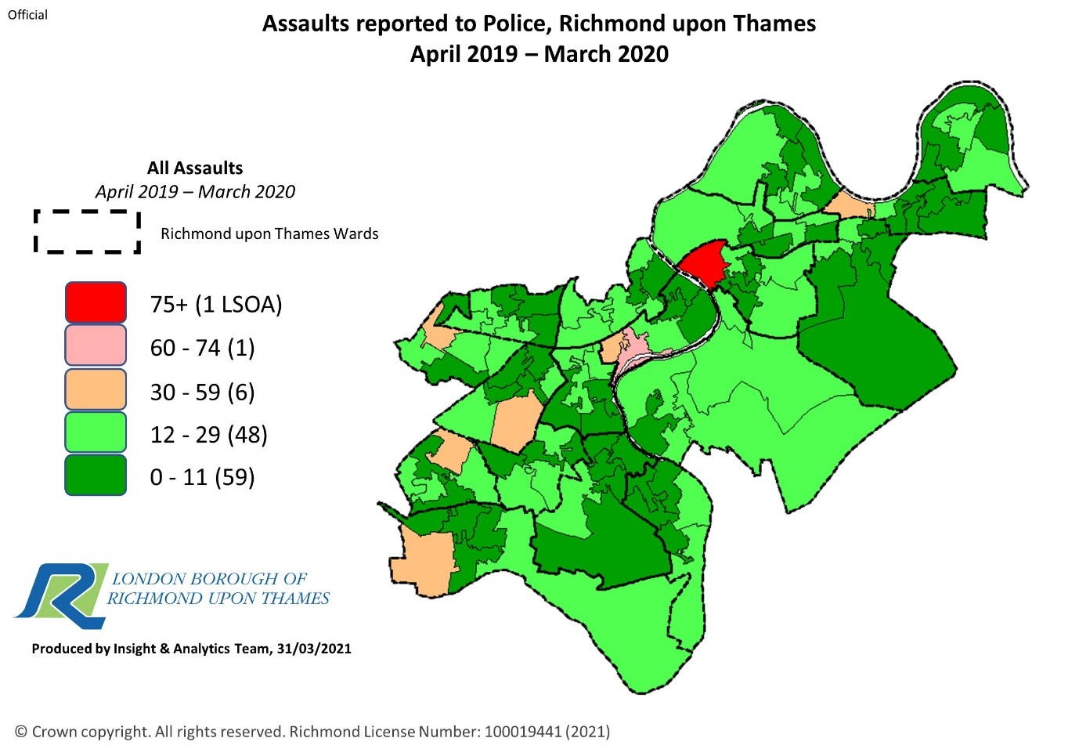

The table below shows the actual number of assaults to the police reported by Ward. For comparison, the table shows assaults reported to the police from the 1st April 2019 to the 31st March 2020 and from the 1st April 2020 to the 31st March 2021. The Wards of South Richmond, Twickenham Riverside and St Margarets and North Twickenham had the highest number of recorded assaults in 2019-2020. In 2020-2021 the Wards of Hampton North and South Richmond recorded the highest level of assaults.
Assaults
Time Period: April 19 - March 20 and April 20- March 21
Data Source: Metropolitan Police Service
1/4/2019 – 31/3/2020 |  | 1/4/2020- 31/3/2021
Ward | Count | Ward | Count
Barnes | 78 | Barnes | 66
East Sheen | 58 | East Sheen | 56
Fulwell and Hampton Hill | 85 | Fulwell and Hampton Hill | 77
Ham, Petersham and Richmond  Riverside | 100 | Ham, Petersham and Richmond  Riverside | 104
Hampton | 80 | Hampton | 88
Hampton North | 109 | Hampton North | 143
Hampton Wick | 76 | Hampton Wick | 84
Heathfield | 102 | Heathfield | 121
Kew | 79 | Kew | 78
Mortlake and Barnes Common | 93 | Mortlake and Barnes Common | 86
North Richmond | 107 | North Richmond | 96
South Richmond | 164 | South Richmond | 130
South Twickenham | 84 | South Twickenham | 73
St Margarets and North  Twickenham | 126 | St Margarets and North  Twickenham | 65
Teddington | 60 | Teddington | 72
Twickenham Riverside | 127 | Twickenham Riverside | 96
West Twickenham | 86 | West Twickenham | 94
Whitton | 83 | Whitton | 94

- Anti-social behaviour (ASB) reported to the police
North Richmond, and South Richmond Wards had the highest levels of ASB complaints reported to the police in 2019/2020. Across the borough recorded ASB events increased in 2020/21. However, it should be noted that these figures include Covid related breaches and cannot be considered normal for the borough. The figures for 2018/19 generally follow the pattern for 2019/20 with the exception of North Richmond which shows a significantly lower level of ASB complaints (263) compared to those of 2019/20 (417). Below is a map of ASB complaints recorded by the Metropolitan Police between April 2019 and March 2020 by Lower Layer Super Output Area (LSOA) boundaries. It confirms that the two existing Cumulative Impact Zones of Richmond Town Centre and Twickenham Town Centre lie within the areas of the highest ASB complaints.

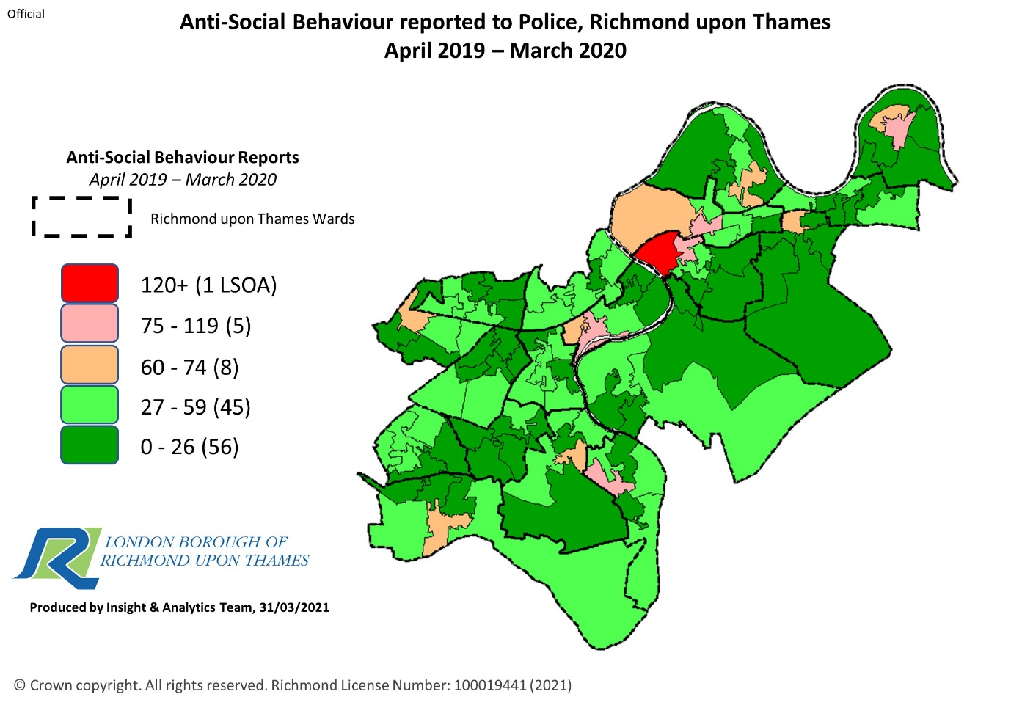

ASB nuisance, rowdy and inconsiderate behaviour (for 2020 is impacted by Covid related complaints)
Time Period: April 19 - March 20 and April 20- March 2021
Source: Metropolitan Police Service

1/4/2019 – 31/3/2020 |  | 1/4/2020- 31/3/2021
Ward | Count | Ward | Count
Barnes | 250 | Barnes | 430
East Sheen | 150 | East Sheen | 313
Fulwell and Hampton Hill | 132 | Fulwell and Hampton Hill | 393
Ham, Petersham and Richmond  Riverside | 167 | Ham, Petersham and Richmond  Riverside | 557
Hampton | 202 | Hampton | 445
Hampton North | 195 | Hampton North | 380
Hampton Wick | 210 | Hampton Wick | 381
Heathfield | 190 | Heathfield | 401
Kew | 232 | Kew | 461
Mortlake and Barnes Common | 193 | Mortlake and Barnes Common | 423
North Richmond | 417 | North Richmond | 546
South Richmond | 485 | South Richmond | 795
South Twickenham | 212 | South Twickenham | 445
St Margarets and North  Twickenham | 208 | St Margarets and North  Twickenham | 408
Teddington | 215 | Teddington | 407
Twickenham Riverside | 241 | Twickenham Riverside | 562
West Twickenham | 158 | West Twickenham | 316
Whitton | 169 | Whitton | 417

7. Ambulance call outs
The number of alcohol–related ambulance callouts in Richmond varies by time of day. During 2019/20, the key timeframe for ambulance callouts flagged as alcohol-related was 9pm to 3am, accounting for more than 2 in 5 of the alcohol-related total for the year (42%). This was particularly evident on a Friday and Saturday evening, where the 9pm to 3am timeslot accounted for almost 1 in 5 of all alcohol related callouts (18.8%). Ambulance callouts for assault increase from 5pm, with a peak between 11pm and midnight, before declining from 3am. Overall, 65% of callouts in 2019/20 took place between 5pm and 3am. The most common days were Friday and Saturday, during which 39% of callouts took place. There appears to be a strong link between ambulance call outs and hours granted for the sale of alcohol.
South Richmond, St Margarets and North Twickenham and Twickenham Riverside have the highest ambulance call outs for alcohol, with Hampton and South Richmond having the highest level of ambulance callouts for assaults. The levels for ambulance call outs for alcohol dropped by 50% in South Richmond, 85% in St Margarets and North Twickenham and 42% in Twickenham Riverside during the pandemic.
Note: this information is not provided at LSOA level. March data was not available at the time of extract.

Ambulance call outs for alcohol
Time Period: April 19 - March 20 and March 20 – February 21
Data Source: London Ambulance Service via SafeStats
Note: the totals relate to all ambulance call despatches for alcohol-related incidents i.e. multiple despatches to a single incident would each be counted

1/4/2019 – 31/3/2020 |  | 1/4/2020- 28/2/21
Ward | Count | Ward |  | Count
Barnes | 13 | Barnes |  | 10
East Sheen | 17 | East Sheen |  | 21
Fulwell and Hampton Hill | 30 | Fulwell and Hampton Hill |  | 19
Ham, Petersham and Richmond  Riverside | 13 | Ham, Petersham and Richmond  Riverside |  | 16
Hampton | 18 | Hampton |  | 19
Hampton North | 31 | Hampton North |  | 20
Hampton Wick | 20 | Hampton Wick |  | 19
Heathfield | 16 | Heathfield |  | 15
Kew | 21 | Kew |  | 17
Mortlake and Barnes Common | 27 | Mortlake and Barnes Common |  | 29
North Richmond | 28 | North Richmond |  | 18
South Richmond | 80 | South Richmond |  | 40
South Twickenham | 39 | South Twickenham |  | 24
St Margarets and North  Twickenham | 98 | St Margarets and North  Twickenham |  | 15
Teddington | 32 | Teddington | 28
Twickenham Riverside | 59 | Twickenham Riverside | 34
West Twickenham | 22 | West Twickenham | 24
Whitton | 23 | Whitton | 13

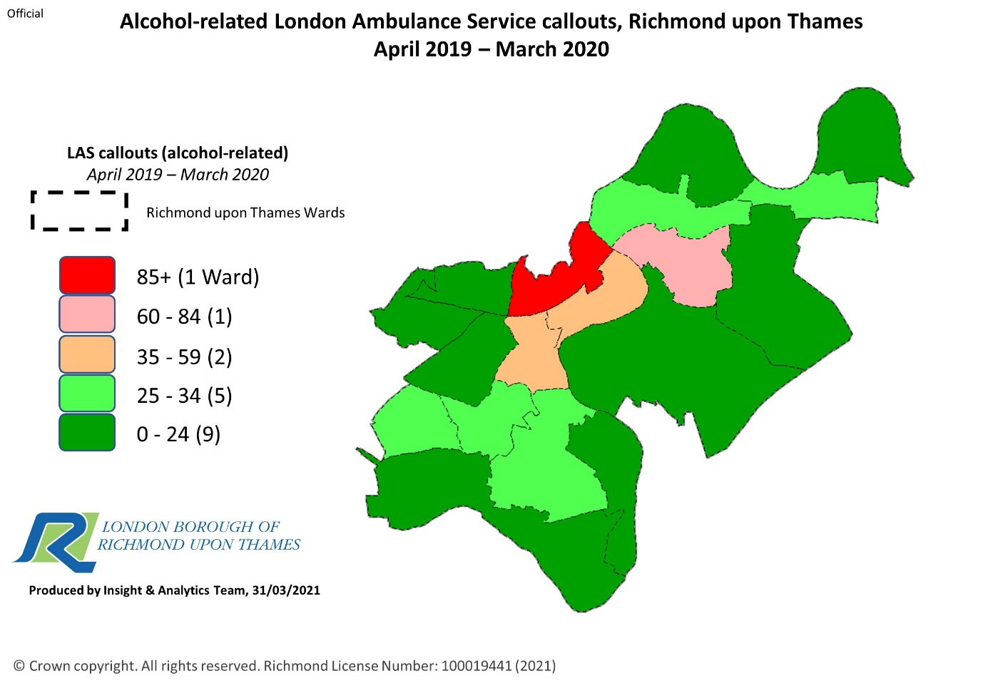

Ambulance call outs for assault
Time Period: April 19 - March 20 and April 20 – February 21
Data Source: London Ambulance Service via SafeStats
Note: the totals relate to all ambulance call despatches i.e. multiple
despatches to a single incident would each be counted.

1/4/2019 – 31/3/2020 |  | 1/4/2020- 28/2/2021
Ward | Count | Ward |  | Count
Barnes | 10 | Barnes |  | 5
East Sheen | 5 | East Sheen |  | 6
Fulwell and Hampton Hill | 4 | Fulwell and Hampton Hill |  | 4
Ham, Petersham and Richmond  Riverside | 9 | Ham, Petersham and Richmond  Riverside |  | 15
Hampton | 31 | Hampton |  | 30
Hampton North | 9 | Hampton North |  | 15
Hampton Wick | 12 | Hampton Wick |  | 11
Heathfield | 15 | Heathfield |  | 16
Kew | 19 | Kew |  | 4
Mortlake and Barnes Common | 21 | Mortlake and Barnes Common |  | 11
North Richmond | 10 | North Richmond |  | 17
South Richmond | 31 | South Richmond |  | 39
South Twickenham | 21 | South Twickenham |  | 8
St Margarets and North  Twickenham | 16 | St Margarets and North  Twickenham |  | 13
Teddington | 9 | Teddington | 12
Twickenham Riverside | 22 | Twickenham Riverside | 13
West Twickenham | 7 | West Twickenham | 4
Whitton | 17 | Whitton | 18

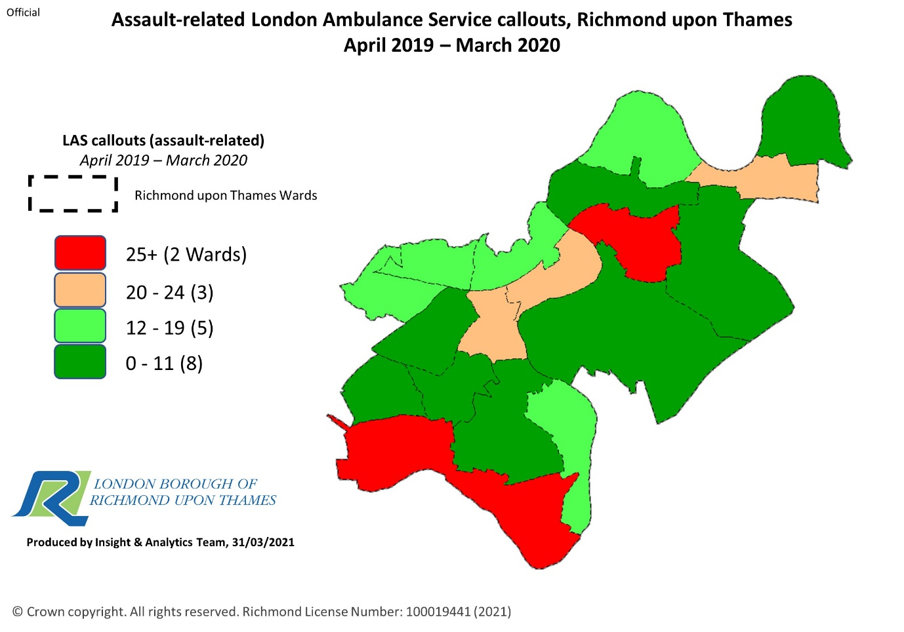

- Complaints relating to licensed premises
Between March 2019 and April 2020 Richmond Council recorded 15 licensing complaints relating to existing licenced premises. Between 1st April 2020 and 31st January 2021 94 licensing complaints were recorded, the majority relating to potential breaches of COVID regulations. Below is a table indicating the complaints received by Ward between 1st April 2019 and 31st March 2020 and between 1st April 2020 And 31st January 2021.
1/4/2019 – 31/3/2020 |  | 1/4/2020- 30/11/2020
Ward | Count | Ward |  | Count
Barnes | 1 | Barnes |  | 28 (all but 1 relating to one premises)
East Sheen | 0 | East Sheen |  | 1
Fulwell and Hampton Hill | 0 | Fulwell and Hampton Hill |  | 4
Ham, Petersham and Richmond  Riverside | 0 | Ham, Petersham and Richmond  Riverside |  | 4
Hampton | 0 | Hampton |  | 4
Hampton North | 0 | Hampton North |  | 3
Hampton Wick | 1 | Hampton Wick |  | 2
Heathfield | 0 | Heathfield |  | 0
Kew | 1 | Kew |  | 3
Mortlake and Barnes Common | 0 | Mortlake and Barnes Common |  | 0
North Richmond | 0 | North Richmond |  | 2
South Richmond | 4 | South Richmond |  | 17
South Twickenham | 1 | South Twickenham |  | 3
St Margarets and North  Twickenham | 1 | St Margarets and North  Twickenham |  | 2
Teddington | 1 | Teddington | 9
Twickenham Riverside | 2 | Twickenham Riverside | 10
West Twickenham | 0 | West Twickenham | 1
Whitton | 3 | Whitton | 1

The number of complaints received in 2019-202 is low and generally confirms the view that the majority of residents in the borough are satisfied with the licensing arrangements in the borough. The figures for 2020/21 reflect concerns about the pandemic and the perceived responses by business to what has been an exceptional year. These figures should not be used when assessing the impact of licensed premises on the licensing objectives. It is included for information only.
9. Trading Standards – Test Purchases
Between April 2019 and March 2020 Richmond Trading Standards conducted 21 test purchases across the borough to establish whether alcohol would be sold to young persons under the age of 18. Of these only one premises sold alcohol to a young person without any request for identification.
In 2020 92 test purchases were carried out at premises which had a challenge 25 condition on its licence. This condition requires staff to ask for identification from any person that appears to be 25 years of age or younger before selling them alcohol. Of these only 13 sought identification and refused the sale when this was not provided.
All test purchases are carried out in premises selling alcohol for consumption off the premises only.

- Current Cumulative Impact Zones
Currently there are 2 Cumulative Impact Zones in the Borough, Richmond Town Centre and Twickenham Town Centre. Both were adopted in 2005 when the Licensing Act 2003 came into force. The areas covered by the current policy are shown in the map below.

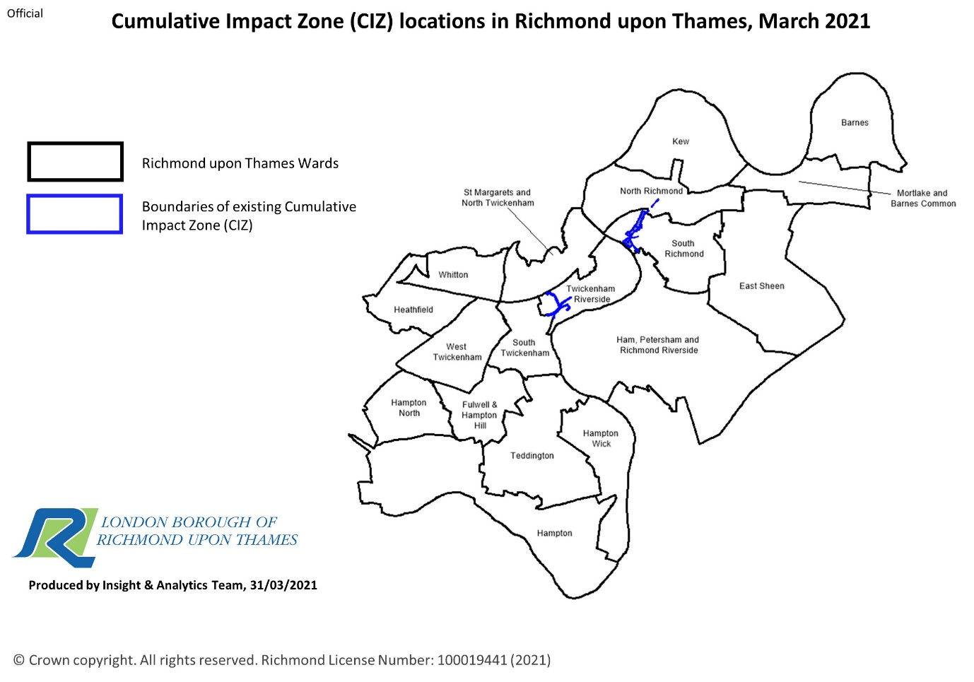

- Richmond Town Centre existing CIZ
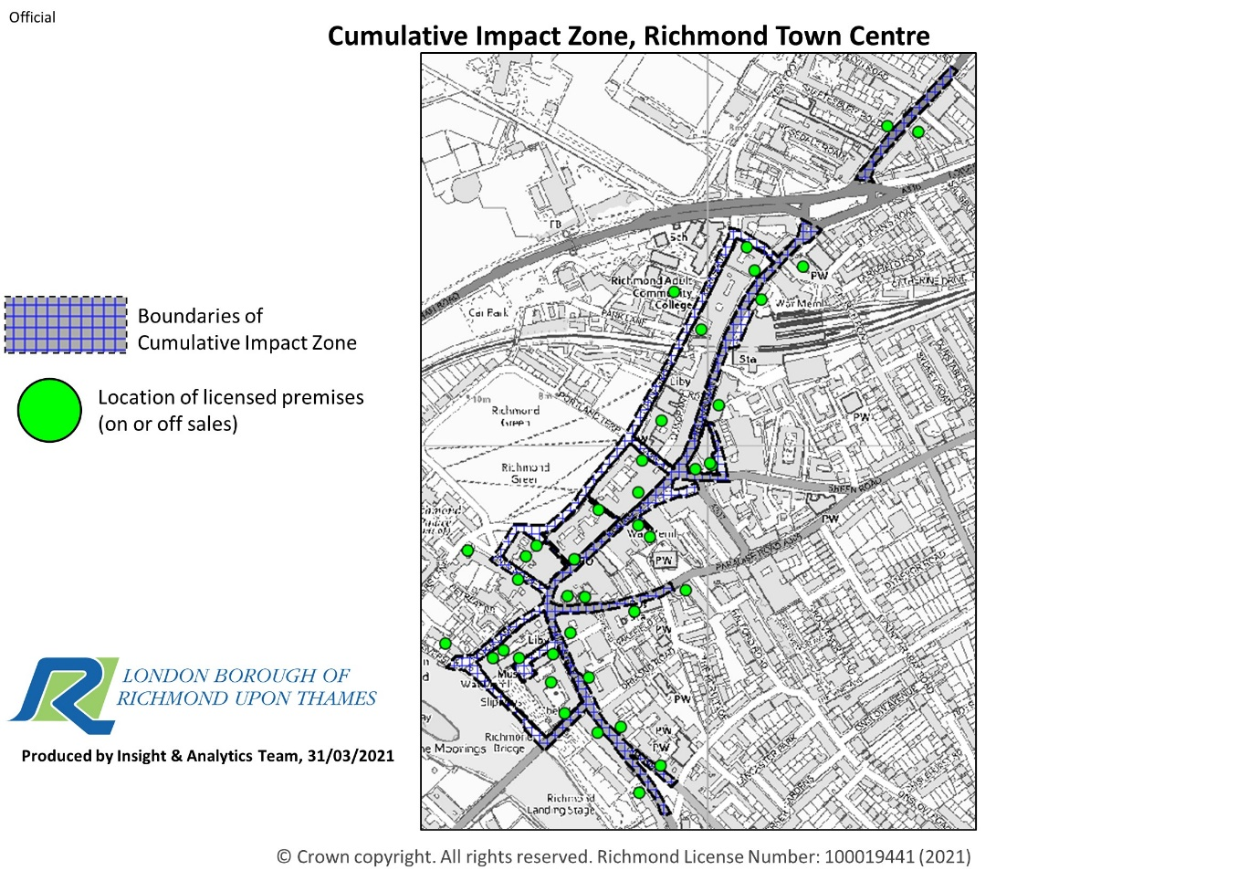
Within the Richmond Town Centre Cumulative Impact Zone 113 premises hold a premises licence or club premises certificate under the Licensing Act 2003.
Active licences within Richmond Town Centre CIZ
Type | Number
Cinema/Theatres | 5
Bar/Club/Pub | 26
College/University | 1
Restaurants | 53
Café’s/delicatessen | 5
Convenience stores/supermarkets/off licence | 14
Hotels | 1
Hairdressers | 1
Office/retail outlet | 2
Takeaway premises selling alcohol | 2
Takeaways/premises selling late night food only (no alcohol) | 3

Maximum terminal hour for the sale of alcohol in premises within the Richmond Town Centre CIZ
Total number of premises | Terminal hour up to 23.00 | Terminal hour 23.01 – 00.00 hours |  | Terminal hour 00.01 – 01.00 hours | Terminal hour 01.01 hours – 02.00 hours |  | Beyond 02.00 hours
110 | 45 (41%) | 48(43.5%) | 13 (12%) |  |  | 4 (4%) | 0
Maximum Terminal hour for the sale of hot food and drink only
Total number of premises | Terminal hour up to 01.00 | Terminal hour 01.01-02.00 hours | Terminal hour 02.01 – 03.00 hours
3 | 1 | 1 | 1
Richmond Town Centre Cumulative Impact Zone largely falls within South Richmond Ward
This Ward has the highest recorded level of complaints to the police about violence with injury, assaults and anti-social behaviour, the highest number of ambulance call outs for assault (together with Hampton Ward) and the second highest for ambulance call outs for alcohol. Although relatively low in numbers, the area also attracts a number of complaints to the Council’s licensing team. Where the information is available by Lower Layer Super Output Area (LSOA) boundaries, Richmond Town Centre records the highest incidence of assaults and anti-social behaviour. Richmond Town Centre has the highest density of licensed premises in the borough. Whilst levels of crime and anti-social behaviour across Richmond is low compared to other London boroughs, the high density of licensed premises in Richmond Town Centre is impacting adversely on crime and anti-social behaviour in the area. It is proposed, therefore, that the evidence suggests that Richmond Town Centre retains the special policy with regard to Cumulative Impact as any increase in premises numbers or hours will add to the existing relatively high levels of crime and anti-social behaviour in the area, particularly later into the evening.
In publishing this cumulative impact assessment, the authority is setting down a strong statement of approach to considering applications or the grant or variation of premises licences in the Richmond Town Centre Cumulative Impact Area. The authority considers that the number of premises licences in Richmond Town Centre is such that it is likely that granting further licences would be inconsistent with the authority’s duty to the licensing objectives.

- Twickenham Town Centre existing CIZ
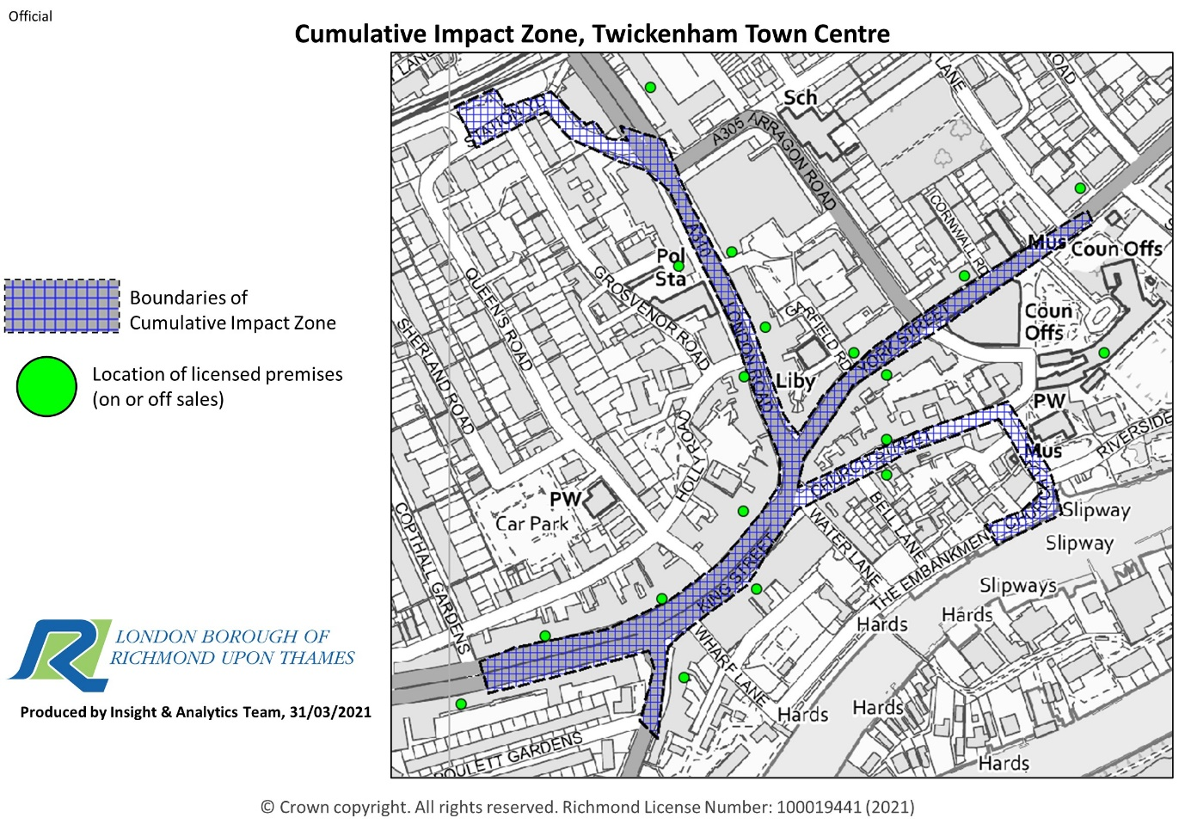
Active licences within Twickenham Town Centre CIZ
Type | Number
Pubs/Bars | 12
Restaurants | 26
Convenience stores/supermarkets/off licence | 14
Café’s/delicatessens | 1
Office | 1
Private members club/ sports club | 2
Takeaway premises selling alcohol | 1
Takeaways/premises selling late night food only (no alcohol) | 5

Maximum terminal hour for the sale of alcohol in premises within the Twickenham Town Centre CIZ
Total number of premises | Terminal hour up to 23.00 | Terminal hour 23.01 – 00.00 hours |  | Terminal hour 00.01 – 01.00 hours | Terminal hour 01.01 hours – 02.00 hours |  | Beyond 02.00 hours
57 | 23 (40%) | 21 (37%) | 9 (16%) |  |  | 4 (7%) | 0

Maximum Terminal hour for the sale of hot food and drink only
Total number of premises | Terminal hour up to 01.00 | Terminal hour 01.01-02.00 hours | Terminal hour 02.01 – 03.00 hours
5 | 1 | 3 | 1

The Twickenham Town Centre CIZ lies within Twickenham Riverside Ward. Plans to redevelop Twickenham Riverside are well advanced with provision for new open spaces, restaurants, housing and offices opening up to the River Thames. This redevelopment is designed to be family friendly and it is anticipated that it will be an attraction for visitors, thus changing the dynamic of the area.
This Ward currently has the second highest level of complaints to the police about violence with injury (non-domestic) and assaults. The Ward also records high levels of anti-social behaviour and ambulance call outs. Where the information is available by Lower Layer Super Output Area (LSOA) boundaries, Twickenham Town Centre records the second highest rates of violence with injury (non-domestic), assaults and anti-social behaviour. Twickenham Town Centre has the second highest density of licenced premises in the borough. The high density of licensed premises in Twickenham Town Centre is impacting adversely on crime and anti-social behaviour in the area.
It is proposed, therefore, that the evidence suggests that Twickenham Town Centre retains the special policy with regard to Cumulative Impact as any increase in premises numbers or hours will add to the existing relatively high levels of crime and anti-social behaviour in the area, particularly later into the evening.
In publishing this cumulative impact assessment, the authority is setting down a strong statement of approach to considering applications or the grant or variation of premises licences in the Twickenham Town Centre Cumulative Impact Area. The authority considers that the number of premises licences in Twickenham Town Centre is such that it is likely that granting further licences would be inconsistent with the authority’s duty to the licensing objectives.
- Inclusion of new areas in the Cumulative Impact Assessment.
There is no other area of the borough where there is any clear link between a high density of licensed premises and high levels of crime and disorder, anti-social behaviour and ambulance call outs.

