Hampton Square
Consultation Results
on behalf of London Borough of Richmond upon Thames
April 2014

Hampton Square
Consultation Results
on behalf of London Borough of Richmond upon Thames
April 2014

Contents

1.0 Introduction 5
2.0 Environment 6
3.0 Services and Facilities 8
4.0 Connections 11
5.0 Your Views and Priorities 13
6.0 About the Respondents 15

1.0 Introduction
- Hampton Square is an important local centre providing a range of services and facilities for local residents. In 2013 the square benefitted from an investment of £800,000 in the public realm from London Borough of Richmond upon Thames, as part of the Uplift Programme, which has greatly improved the local environment.
- Consultation was undertaken with residents between 28 February 2014 and 4 April 2014. The purpose of the consultation was for the Council to find out what further improvements residents would like to see at Hampton Square.
- During the consultation period, an online questionnaire was available at the London Borough of Richmond upon Thames Council website. Hard copy questionnaires were also available at local facilities including The Hampton public house, Tangley Park Family Centre, Hampton and Hampton Hill libraries.
- As part of the consultation process, questionnaires were available for completion at a stall as part of the Hampton Square market on Sunday 9 March 2014.
- At the close of the consultation period for Hampton Square on 4 April, a total of 175 completed questionnaire responses were received.
- This report provides a summary of the questionnaire results received along with comments made to consultants that were present at the consultation event.

Summary
- Over 80% of respondents to the questionnaire are ‘satisfied/very satisfied’ with the improvements that have been made to Hampton Square.
- Over three quarters of respondents visit Hampton Square a minimum of once per week.
- The most used facility in Hampton Square is the Sainsbury’s foodstore (90%), followed by the Boots Pharmacy (51%).
- The most requested additional facility at Hampton Square is a Post Office (27 respondents), followed by a café/coffee shop (26 respondents).
- Over two thirds of respondents were mainly ‘satisfied/ very satisfied’ with accessing Hampton Square safely and conveniently with regards to parking, footpaths and alleyways and public transport. Around half of respondents are neither ‘satisfied nor dissatisfied’ with cycling provision or security and safety.
- Increased cycle parking was the most mentioned improvement that could be made to Hampton Square (12 respondents) in response to accessing Hampton Square safely and conveniently.
- The favourite aspect of the improved Square is the open format / space (36 respondents).

Environment
Q1: Respondents were asked how satisfied or dissatisfied they are with improvements to Hampton Square.

  - The following responses were made to the question ‘how satisfied or dissatisfied are you with improvements to Hampton Square?’:

- Open space / planting improvements: Over 80% of respondents were ‘very satisfied’ or ‘satisfied’ (49% and 34% of respondents respectively) with the open space and planting improvements at Hampton Square.

- Play facilities improvements: Over 40% of respondents were ‘very satisfied’ or ‘satisfied’ with improvements to play facilities. The most common response to views on play facilities was ‘neither satisfied nor dissatisfied’ (40%).

- Improvements to appearance of buildings: Just under 40% of respondents were ‘very satisfied’ or ‘satisfied’ with the appearance of buildings. The most common response to views on the appearance of buildings was ‘neither satisfied nor dissatisfied’ (42%). The poor quality exterior of Sainsbury’s being mentioned in the comments received.

- Improvements to lighting: Over half of respondents (56%) were ‘satisfied / very satisfied’ with the lighting improvements in Hampton Square.

Table 1.1: Responses to question 1 ‘How satisfied or dissatisfied are you with the following improvements to the environment in Hampton Square?’
 | Very Satisfied |  | Satisfied |  | Neither satisfied nor dissatisfied |  | Dissatisfied |  | Very dissatisfied
 | No. | % | No. | % | No. | % | No. | % | No. | %
Open space / planting | 59 | 34 | 85 | 49 | 17 | 10 | 7 | 4 | 5 | 3
Play facilities | 19 | 11 | 52 | 31 | 68 | 40 | 22 | 13 | 8 | 5
Appearance of buildings | 20 | 12 | 46 | 27 | 73 | 42 | 25 | 14 | 8 | 5
Lighting | 19 | 11 | 77 | 45 | 62 | 36 | 9 | 5 | 4 | 3

  - Further comments received on the questionnaires included mostly that Hampton Square is much improved following the Uplift programme (15 responses) whilst a further 11 respondents felt that more play equipment could be provided.

Table 1.2: Further comments received to question 1 ‘How satisfied or dissatisfied are you with the following improvements to the environment in Hampton Square?’
Comment | No.
Hampton Square is now much improved | 15
More play facilities required | 11
Area floods / puddles | 6
Poorly laid paving | 6
Waste of money | 6
Maintenance of flower beds needed | 5
Should have retained Children’s Playground | 3
Ground lighting not working | 3
Sainsbury’s exterior improvements | 3
Further comments received, those with less than 3 common responses have not been included in the table.

Comments include:

“What a beautiful job has been done. It's a vast improvement. Thank you”.

“It's nice to see children running round and enjoying the fountain in summer but I think further play facilities would be beneficial”.

“It needed tidying up but not at this cost we needed a medical centre”.

“The paving had been laid in the most appalling way as is dangerously uneven all over more evident when tripped on and the sun is casting shadows off the protrusions”.

“The grass area floods in heavy rain as do sections of the paved areas. Also there does not seem to be a gardening contract in place to keep the planted beds looking in good condition”.

Services and Facilities
Q2: Respondents were asked how often they visit Hampton Square.

  - When asked how often respondent’s visit Hampton Square, three quarters stated that they visit Hampton Square a minimum of once a week, with over 40% visiting either daily or 2-3 times a week.

Chart 2.1: Responses to question 2 ‘How often do you visit Hampton Square?’
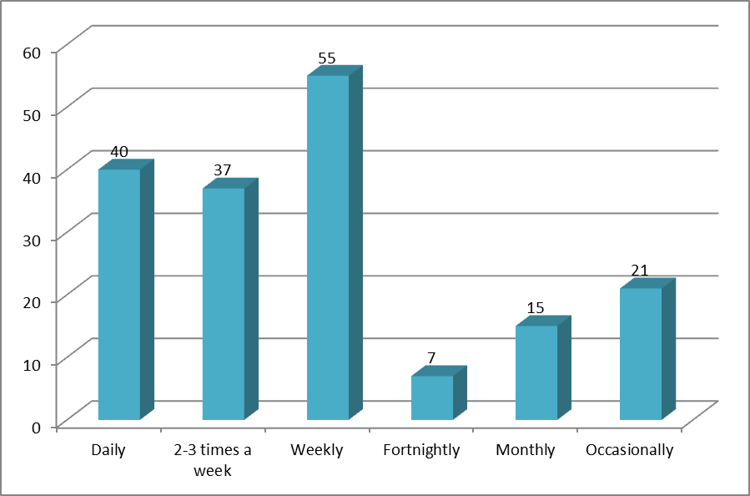
175 responses

Q3(i): Respondents were asked what facilities and services they or their families tend to use when they visit Hampton Square?

  - Respondents were asked which facilities they use when they visit Hampton Square and were able to tick multiple answers.

- The most used facility was the anchor food store Sainsbury’s, with 90% of respondents (157) stating that the visit the store.
- Just over half of respondents visit the Boots pharmacy.
- The new Hampton Market is also very popular amongst respondents with almost half of people visiting.

Table 3.1: Responses to question 3 (i) ‘What facilities and services do you or your family tend to use when you visit?’
Facility / Service | No. | %
Sainsbury's | 157 | 90
Boots Pharmacy | 89 | 51
Market | 81 | 46
Hampton on Thames Community Association | 29 | 17
The Hampton | 23 | 13
Public play facilities | 20 | 11
Police station | 16 | 9
Tangley Park Family Centre | 13 | 7
Hampton Youth Project | 11 | 6
other commercial services | 9 | 5
Tangley Park Nursery | 3 | 2
Percentage based on 175 respondents

Q3(ii): Do you have any comments about how any of the services or facilities could be improved?

  - Further comments were received regarding how any of the services could be improved. These included:

- There is a need for a coffee shop/café in Hampton Square (6).
- A larger range of shops would be welcomed (5).
- The police station isn’t open for as long or as often as respondents would like (4).

Table 3.2: Responses to question 3 (ii) ‘How could any of the services or facilities be improved?’
Comment | No.
Café/coffee shop required | 6
More shops in Hampton Square | 5
Open police station (longer) | 4
Improved pub needed | 4
Cycle parking required | 3
More frequent market | 3
Shelter should be provided | 3
More play facilities | 3
Health service is missing from Hampton | 3
Further comments received, those with less than 3 common responses have not been included in the table.

Comments include:

“Additional shops would be good as really Sainsbury is the only draw to the square. I would especially like somewhere inviting to have a coffee”.

“…. the market is great as there are local enterprises with stalls but a greater range of produce (more fruit and veg. for example) would be good - once a fortnight would be better too”.

Q3(iii): Do you think there are any services or facilities missing at Hampton Square?
  - Comments received regarding whether any services or facilities are missing at Hampton Square included:

- The need for a post office (28).
- The need for a coffee shop or café area in the Square (27).
- The desire for health care facilities to be located back into the Square (11).

Table 3.3: Responses to question 3 (iii) ‘Do you think there are any services or facilities missing at Hampton Square?’
Comment | No.
Post office | 28
Café / coffee shop | 27
Health care | 11
Public toilets | 9
More variety of shops | 6
More play facilities | 6
Cycle parking | 5
Restaurants | 4
Newsagent | 3
Bank | 3
Further comments received, those with less than 3 common responses have not been included in the table.

Connections
Q4: Respondents were asked if they felt satisfied or dissatisfied with accessing Hampton Square safely and conveniently?

  - When questioned if respondents are satisfied / dissatisfied accessing Hampton Square:

- Parking: More than three quarters (77%) of respondents are ‘satisfied / very satisfied’ with parking for Hampton Square.
- Foothpaths and alleyways: Over two thirds of respondents (69%) are ‘satisfied/ very satisfied’ with the foothpaths and alleyways.
- Cycling: One third of respondents are ‘satisfied/ very satisfied’ with cycling provision at Hampton Square and almost half (47%) are’ neither satisfied nor dissatisfied’.
- Public transport: Around two thirds of respondents feel ‘satisfied/ very satisfied’ with the public transport provision.
- Safety and security: Over one third of respondents are ‘satisfied/very satisfied’ (45%), whilst a further 41% are ‘neither satisfied nor dissatisfied’ with safety and security (41%).

Table 4.1: Responses to question 4: ‘How satisfied or dissatisfied are you with accessing Hampton Square safely and conveniently?’
 | Very Satisfied |  | Satisfied |  | Neither satisfied nor dissatisfied |  | Dissatisfied |  | Very dissatisfied
 | No. | % | No. | % | No. | % | No. | % | No. | %
Parking | 41 | 24 | 92 | 53 | 27 | 16 | 10 | 6 | 2 | 1
Footpaths and alleyways | 25 | 15 | 93 | 54 | 30 | 17 | 22 | 13 | 2 | 1
Cycling provision | 14 | 8 | 43 | 25 | 79 | 47 | 25 | 15 | 8 | 5
Public Transport | 31 | 18 | 80 | 47 | 48 | 28 | 9 | 5 | 3 | 2
Security and safety | 12 | 7 | 65 | 38 | 70 | 41 | 18 | 11 | 5 | 3

  - When asked to comment on how improvements could be made on accessing Hampton Square the most mentioned issue was the lack of cycle parking available (12). Less frequent comments received mentioned that there is a need for better signage to aid wayfinding throughout Hampton (4) and directions within the Sainsbury’s car park need improvement as the car park layout is currently thought to be confusing (4)

Table 4.2: Further comments received to question 4 (i): ‘How satisfied or dissatisfied are you with accessing Hampton Square safely and conveniently?’
Comment | No.
Cycle parking needed | 12
Better signage needed | 4
Better signage within the car park | 4
Lack of parking | 4
Car park lighting | 4
Better lit alleyways | 3
Car park unsafe for pedestrians | 3
Police patrolling the area | 3
Areas in the Square floods | 3
Cycle routes needed | 3
Better public transport | 3
Further comments received, those with less than 3 common responses have not been included in the table.

Comments include:

“Need to have clear walkways in the car parks as very unsafe when you have children with you, no proper path to walk on”.

“Car park on the Sainsbury side is poor layout & directional arrows are mostly ignored/misunderstood”.

“No signs in Hampton directing people to the Square - some report difficulty in finding the Square even when using a Sat Nav”.

Your Views and Priorities
Q5: Respondents were asked what is their favourite aspect is, considering everything on offer at Hampton Square?

  - When respondents were asked to state their favourite aspect at Hampton Square, the most mentioned aspects included:
- The open format and space that it is now part of the Hampton Square (36 respondents).
- The new planting and trees in the Square (26)
- The new Sunday market is popular with respondents (21)
- The Sainsbury’s foodstore (20)
- The new water fountain (19)

Table 5.1: Comments received to question 5: ‘Considering everything on offer at Hampton Square what is your favourite aspect?’
Comment | No.
Open format/space now at Hampton Square | 36
Plants and trees | 26
Market | 21
Sainsbury’s | 20
Water Fountain | 19
Lawn area | 14
Attractive layout | 7
Free parking | 5
Pub | 5
Focal point | 5
White House | 4
Nice and clean | 4
Sheep | 4
Vast improvement on previous layout | 4
Seating | 4
Youth Centre | 4
Revitalised the area | 3
Further comments received, those with less than 3 common responses have not been included in the table.

Comments include:

“The welcoming open feel that you get when you walk from the car parking areas is great, such an improvement on what the run down square was like before”.

“The water feature (in the summer for children) and the grass and planting areas which have transformed the space”.

“The area has given the appearance of being much more accessible and communal. Great open and friendly spaces, shapes and layouts. The colourful youth centre looks professional and fun ... the whole area looks presentable”.

“The space and greenness. The fountains give the place a real lift. The whole space no longer looks run down and shabby”.

Q6: Respondents were asked if they had any further comments
  - When asked for further comments, respondents stated that a vast improvement has been made to Hampton Square (6). It was also mentioned that the flower beds require regular maintenance in order to upkeep the improved appearance (5).
Table 5.2: Comments received to question 6: ‘Do you have any further comments?’
Comment | No.
Vast improvement has been made to Hampton Square | 6
Maintain flowerbeds | 5
Keep the Square clean / maintained | 4
More events needed in the Square | 4
Uplift was a waste of money | 4
Child friendly cafe | 3

Comments included:

“It has opened the area up and allowed a sitting area for people who like to sit and watch the world go by………”.

“Think the local pub would do good to re-vamp and if not a café would be added value to the area to keep all communal population engaged”.

“I hope you will keep these beds looked after and don't let them deteriorate”.

About the Respondents
Sex
 | No. of responses
Female | 108
Male | 64

Connection to Hampton Square
 | No. of responses
I live close to Hampton Square | 94
I work close to Hampton Square | 1
I own a business close to Hampton Square | 0
I am part of a local community organisation | 5
I visit Hampton Square | 38

Age group
 | No. of responses
Under 18 | 8
18-29 | 12
30-39 | 23
40-49 | 28
50-59 | 46
60-65 | 15
Over 65 | 33
Prefer not to say | 10

Ethnic Group
 | No. of responses
White | 154
Asian or Asian British | 1
Mixed / Mixed British | 5
Black / Black British | 1
Any other ethnic background | 3

Disability
 | No. of responses
Yes | 6
No | 152
Prefer not to say | 8

