Here are examples of equipment that we are looking to install.

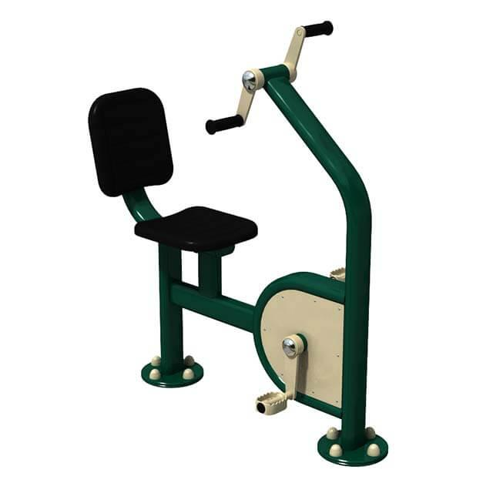 | 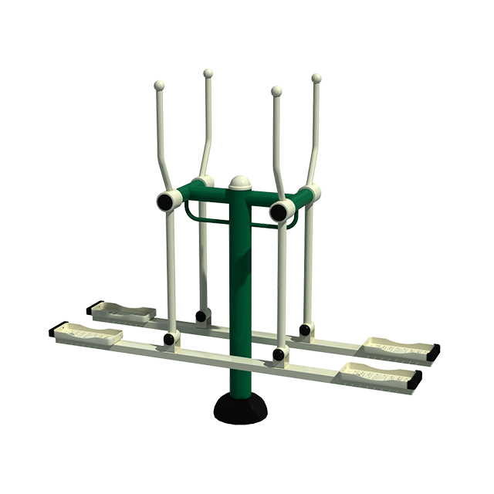 | 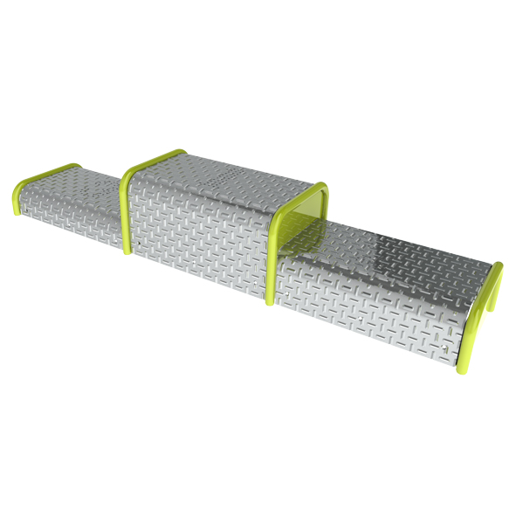 | 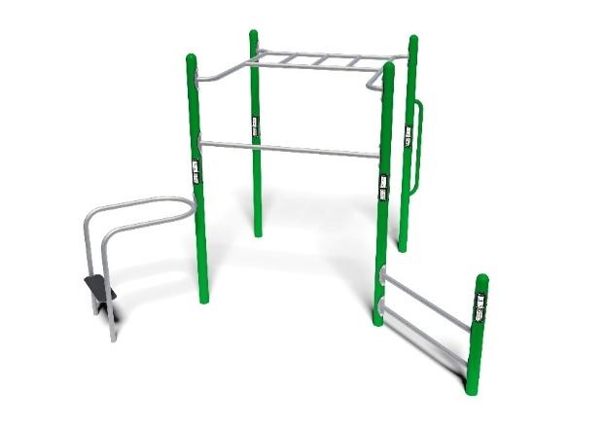
Arm and Pedal Bike | Double Skier | Triple Step | Multi-purpose fitness frame
Lat Pull and Chess Press Combo | Seated leg press | Spinning Bike | Tai Chi spinner wheelchair accessible
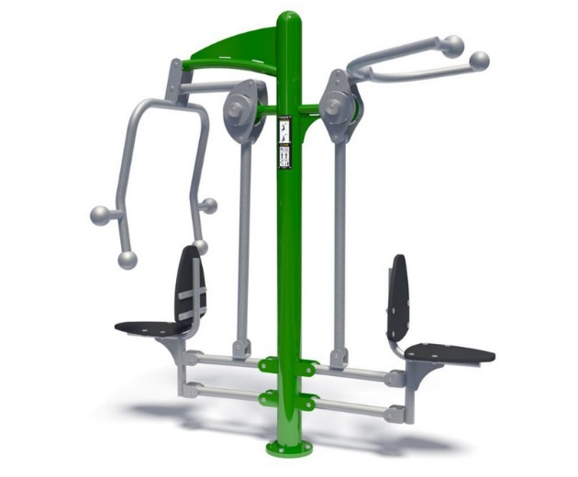 | 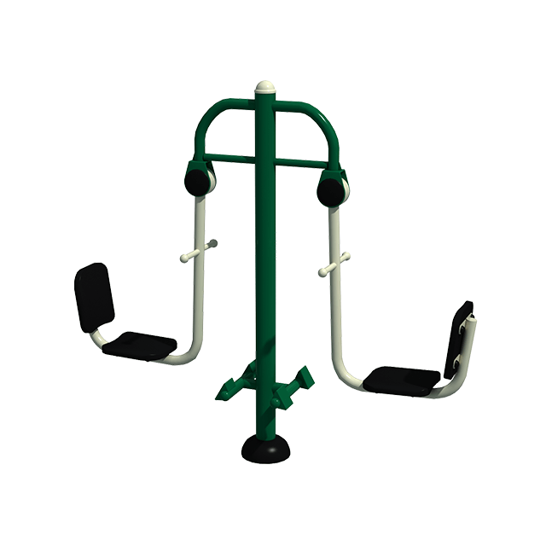 | 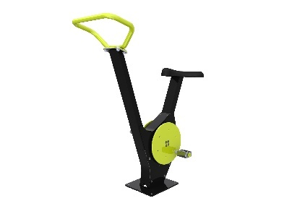 | 