**Richmond Cycling Strategy**

**2016-2026**

**Consultation Draft**

**October-November 2016**

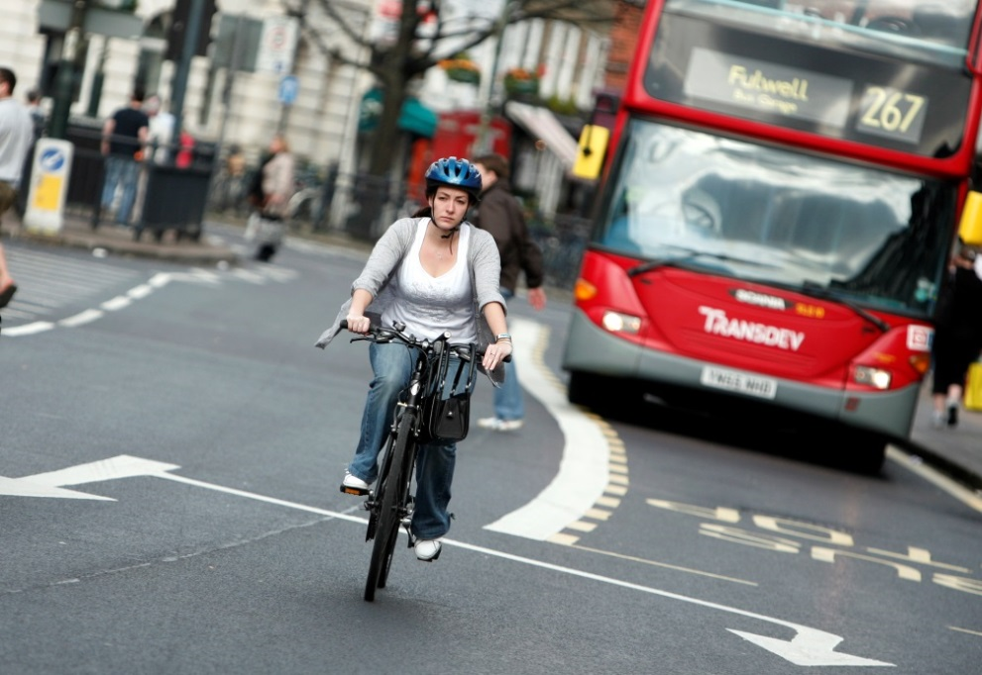

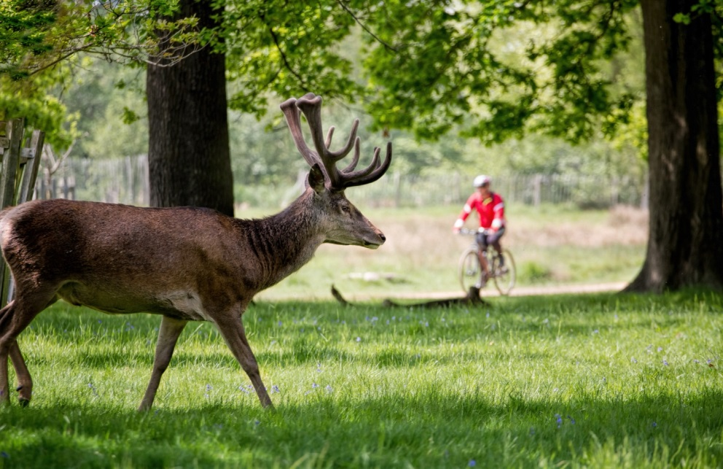

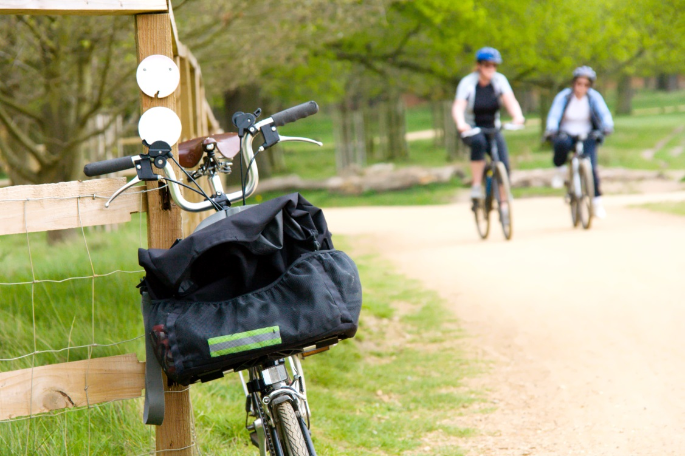

We want to know what you think about our proposed cycling strategy. You can take part in our consultation by completing our questionnaire.

You can complete the survey online - visit <https://consultation.richmond.gov.uk/environment/cycling> for details and more information.

If you would like to ask a question about the consultation or require a paper copy of the questionnaire please contact 020 8891 7660 or [highwaysandtransport@richmond.gov.uk](mailto:highwaysandtransport@richmond.gov.uk)

Contents

Foreword ……………………………………………………………………………….. 4

Executive Summary …………………………………………………………………… 5

1. Introduction ……………………………………………………………………. 8
2. Cycling in Richmond – Context, Opportunities and Challenges ……….. 9
3. Objectives and Action Plan …………………………………………………. 14
   1. Making cycling journeys safer and easier ………………………… 14
   2. Developing cycling as an everyday option ……………………….. 19
   3. Promote cycling as a safe, fun and healthy way to get around ... 21
4. Programme ……………………………………………………………………. 25
5. Targets and Monitoring ………………………………………………………. 28

Appendices

Foreword



The popularity of cycling in our borough is clear for all to see, both during peak commuting hours and also at weekends on the borough’s leisure routes. It is therefore important that the borough has a clear vision and strategy for how we intend to support and encourage further growth in cycling over the next 10 years.

The benefits of cycling are well known – it offers cyclists a healthy, quick and low cost way of getting around the borough. However, cycling benefits everyone, not just those who choose to cycle: fewer cars on the roads, less congestion on public transport and improved local air quality for all.

There has been a great deal of work going on behind the scenes already to start delivering elements of the strategy. However, this must be achieved by balancing the needs of all road users and through mutual respect between user groups.

There is still much more to be done and we would very much welcome views from the borough’s residents, businesses and visitors on our proposed strategy.

**Cllr Peter Buckwell**

**Cabinet Member for Highways and Street Scene**

I have long been a cycling enthusiast and it is fantastic to see so many of our residents cycling around the borough: commuters travelling to work, mums and dads on cargo cycles taking their children to school, elderly and disabled citizens cycling to the shops or taking to tricycles and families cycling through our green spaces at weekends.

Our cycling strategy embraces this growth in cycling, recognising that Richmond has the highest modal share for cycling in London. It sets out a clear ambition and way forward to support further growth, which I hope will encourage an even broader range of ages and abilities to take up cycling as their preferred mode of travel, particularly for shorter journeys.

I look forward to working with residents and local cycle groups to see the actions being delivered over the coming years, and very much welcome their views on our draft strategy document. The strategy will be a living document so that it can evolve along with us.

**Cllr Jean Loveland**

**Cycling Champion**

Executive Summary

**1. Strategy background, vision and objectives**

1.1 The London Borough of Richmond upon Thames has one of the highest proportions of people cycling in London (7% of journeys). This is because many of the borough’s residents and visitors have quickly recognised that cycling can be a healthy, low cost, quick, enjoyable and environmentally friendly way to travel. This coupled with the borough’s natural assets such as its parkland and rivers mean it is an attractive place to cycle.

1.2 The Council is keen to support this growth given the benefits that more people cycling can deliver to the wider community; through reduced congestion on the roads and public transport, better local air quality, less noise and improved health and wellbeing. This is supported by the policies set out in the Council’s Core Strategy and Development Management Plan, as well as national and regional policies and strategies.

1.3 The Council’s existing delivery programme has seen sustained recent investment in cycling, including new cycle routes delivered, more cycle parking in town centres and thousands of children trained in cycle safety. However, there is still more that can be done to help encourage even more people to cycle and to make it safer for all.

1.4 In 2013 the previous Mayor of London launched his Vision for Cycling in London. The Richmond Cycling Strategy takes account of this Vision and the high level aspirations from the new Mayor’s Manifesto, whilst also recognising Richmond’s unique characteristics and challenges. The draft strategy includes an overall vision, three core objectives and a series of actions to help to achieve this vision. It sets out a programme for delivery of the actions, some ambitious targets and an associated monitoring plan.

**Richmond Cycling Vision** To get more people cycling more often by making cycling easier, safer and more integrated

**Strategy objectives**

A Making cycling journeys safer and easier

B Developing cycling locally as an everyday option

C Promote cycling as a safe, fun and healthy way to get around

**2. Actions**

2.1 Under each of the above objectives a series of actions are listed that will help to deliver that particular objective. These actions are summarised below.

2.2 Funding for the actions within this plan is likely to come from a range of sources including the Local Implementation Plan, developer funding, Borough Cycle Programme, Incubator Funding and Mini Holland funding.

2.3 The draft strategy includes a set of targets and indicators that will help to measure delivery of the below actions and success against the Council’s vision. These are outlined in Chapter 5 of the strategy.

**Objective A:**

**A1 Cycle network improvements** – Delivery of an improved borough wide core cycle network, including Quietway routes which will be developed in partnership with TfL. Other improvements away from the core network will be delivered to improve safety, comfort, connectivity and legibility e.g. connections to key facilities (schools, railway stations etc), conversion of suitable one way streets to two way for cyclists, and filtered permeability. Measures will be tailored to the characteristics of each street along the network, for instance with more limited interventions along quieter routes, but more substantial measures on busier roads where feasible and supported locally. Particular consideration will be given to signage of shared routes. A copy of the draft network plan (2016-2026) can be found in the Appendices.

**A2 Better Junctions and links** – reviewing accident data annually to identify problem locations and appropriate improvements; working with cycle groups to identify other junctions that can be a barrier to cycling; guardrail review (with a view to removal); trial of innovations such as ‘All Green’ phases and two stage right turns; and work with Royal Parks to improve access/egress points.

**A3 Better Bridges** – installation of cycle ramps on footbridges; review of cycling provision on road bridges and consideration of opportunities for new foot/cycle bridges eg between Twickenham and Ham.

**A4 Integrating cycling into new schemes** – consider the needs of cyclists in the development of any new scheme with consideration given to safety, connectivity, comfort, legibility and the latest London Cycle Design Standards.

**A5 Well maintained roads and routes** – where works are being carried out, care to be taken to ensure the site is safe for cyclists, ensuring that appropriate guidance is followed. Maintenance regimes reviewed to consider giving priority to the Principal Road Network and core cycle network. Consideration to also be given to improving any ‘ironwork’ in the carriageway.

**A6 More cycle training –** Continuation of the Council’s cycle training programme, with increased promotion amongst target groups such as families and harder to reach groups such as young men.

**A7 Safer HGVs** – Council progression from Bronze FORS to Silver FORS (Fleet Operator Recognition Scheme) by 2020 and to Gold FORS by 2026; all new Council contracts to meet FORS Bronze standard and other conditions regarding vehicle equipment and driver training; running of Exchanging Places events and trialling innovative safety equipment.

**A8 Education and enforcement against poor road user behaviour** – campaign work, training and joint operations with the Met Police targeting **any** road user breaking the regulations, for instance cyclists travelling through red lights or on the footway or motorists encroaching into the ASL or using mobile phones whilst driving.

**A9 Speed limits and traffic calming –** implementation of measures that help to reduce speeds, where appropriate, such as 20mph limits and physical traffic calming.

**Objective B:**

**B1 Improved cycle parking –** at home, work, school, railway stations (through creation of Cycle Hubs), on street and in new development. Regular audits will be undertaken to review usage.

**B2 Better cycle security** – work in collaboration with the Met Police to reduce bike theft; raise awareness of good bike locking/marking practice via the Council website.

**B3 Encouraging improved cycle maintenance** – running of regular Dr Bike events; provision of subsidised maintenance classes for residents; promotion of classes run by others on Council website.

**B4 Facilitating bike ownership** – provision of advice on website; investigation of feasibility of a bike swap event for schools enabling parents to upsize their children’s bikes.

**B5 Improving cycle hire options –** options such as the installation of Brompton docks at railway stations will be trialled. The Mayor of London’s cycle hire scheme cannot currently be expanded to the borough as there is insufficient TfL funding to achieve a meaningful expansion.

**B6 Removing abandoned bikes** – Continued removal of abandoned bikes to free up cycle parking for other cyclists.

**Objective C:**

**C1 Providing an information resource for all** – revamp of Council webpages; production of leaflets for promotion at events and in reception areas; targeted campaigns to raise awareness of cycle training programme and to encourage responsible cycling/driving.

**C2 Better local community engagement** – running of local events and Dr Bikes; promotion of events run by other organisations on Council website, awareness raising as part of wider cycle scheme consultations and delivery of routes.

**C3 Ongoing schools engagement** – continued work with schools to encourage them to develop Travel Plans and work towards higher levels of accreditation; free cycle training for all schools; and a new School Cycle Champion programme.

**C4 More effective business engagement** – encouraging businesses to sign up to the Healthy Workplace charter, which includes an assessment of how staff travel and advice on how they can be encouraged to travel more actively. Raise awareness of the support available to businesses (eg free cycle training, safety talks , cycle parking etc).

**C5 Working with Public Health Partners** – working closely with public health colleagues to raise awareness of benefits of cycling and the support available from the Council to enable more people to start cycling. Identify target groups that would most benefit from taking up cycling.

1. Introduction

1.1 The London Borough of Richmond upon Thames has the highest proportion of people cycling out of any London borough (7% of journeys). This is because many of the borough’s residents and visitors have quickly recognised that cycling can be a healthy, low cost, quick, enjoyable and environmentally friendly way to travel. This coupled with the borough’s natural assets such as its parkland and rivers mean it is an attractive place to cycle.

1.2 The Council is keen to support this growth given the benefits that more people cycling can deliver to the wider community; through reduced congestion on the roads and public transport, better local air quality, less noise and improved health and wellbeing. This is supported by the policies set out in the Council’s Core Strategy and Development Management Plan, as well as national and regional policies and strategies (see Appendix 1).

1.3 The Council’s existing delivery programme has seen sustained recent investment in cycling, such as new cycle routes delivered, more cycle parking in town centres, thousands of children trained in cycle safety.

1.4 However, there is still more that can be done to help encourage even more people to cycle and to make it safer for all.

1.5 In 2013 the Mayor of London at the time, Boris Johnson, launched his Vision for Cycling in London. The Richmond Cycling Strategy takes account of this Vision and associated TfL Business Plan, also the high level aspirations from the new Mayor’s Manifesto, whilst also recognising Richmond’s unique characteristics and challenges.

**Richmond Cycling Vision** To get more people cycling more often by making cycling easier, safer and more integrated

1.6 The strategy includes three core objectives and a series of actions to help to achieve this vision. It sets out a programme for delivery of these actions, some ambitious targets and an associated monitoring plan.

1.7 The Council is seeking comments from Richmond’s residents, businesses, workers and visitors, as well as stakeholder groups on this draft document. Comments from the consultation will then be incorporated and the strategy finalised. The strategy will be a ‘living document’ which means it will continue to be updated to reflect emerging issues, priorities and available funding.

2. Cycling in Richmond – opportunities and challenges

**2.1 Why promote cycling?**

2.1.1 Encouraging more people to take up cycling contributes to a range of health, sustainability, social, economic and environmental objectives. It can have benefits for everyone – cyclists, public transport users, motorists, businesses, the Council and NHS trusts, as shown in Figure 2.1. It is therefore important to consider how to grow cycling within Richmond.

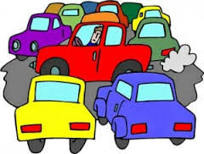**Figure 2.1 - Benefits of Cycling**

**2.2 Borough profile**

2.2.1 Place - The Borough is made up of a collection of ‘villages’, with the River Thames running through the centre. The borough’s main town centre is Richmond; and there are four district centres at Twickenham, Teddington, East Sheen and Whitton, as well as many smaller local centres. The borough benefits from large areas of open space including Richmond and Bushy Parks. Its special quality and character has led to the designation of 72 Conservation Areas and over 1100 listed buildings. As such, Richmond is a very attractive borough to cycle around, with many opportunities for quieter routes through parkland, along waterways and through leafy residential areas.

2.2.2 Residents - The 2014 estimates from the Office of National Statistics indicate that there are around 194,000 people living in the Borough. The number of older residents is increasing and the community is becoming more diverse, with wider differences in household wealth, more disabled people and more ethnic diversity (although there is a lower than London average percentage of residents from ethnic minority groups). Although the Borough is characterised by expensive private housing, there are pockets of relative deprivation. Encouraging a broader cross section of people to cycle is a key challenge to be addressed.

2.2.3 Health indicators show that Borough residents generally take care of themselves with higher levels of life expectancy at birth, healthier eating, more exercise and lower levels of smoking, heart disease and cancers compared to the national average. Nonetheless, almost half of adults are estimated to be obese or overweight. The health benefits of increased physical activity are vast with significant positive impacts including reduced blood pressure and improved wellbeing. This strategy will look at how collaboration between the transport and public health teams can encourage more people to incorporate cycling into their everyday routines.

2.2.4 Visitors – There are a number of major attractors within the Borough acting as a draw for visitors. These include Kew Gardens, Hampton Court, Richmond and Bushy Park, Richmond and Twickenham Riverside and Greens, Petersham Meadows, the Barnes Wetland Centre, and the rugby stadiums. How to encourage more people to visit these attractions by bicycle needs to be a key factor.

2.2.5 Employment and commuting – According to the 2011 census, approximately one fifth of borough residents travel to work within the borough. A quarter work in Westminster or the City of London, 12% in Hounslow, 6%in Kingston and 2% in Surrey, with the remainder travelling to other destinations in London and further afield. Conversely, a large proportion of those who commute into the borough for work travel here from neighbouring boroughs: 20% from Hounslow, 10% from Kingston, 10% from Spelthorne/Elmbridge, 7% from Wandsworth, 5% from Ealing, 3% from Merton, and 3% from Hammersmith & Fulham. This shows that many commuting trips are local in nature and there is great potential for some of these trips to be converted to cycling.

2.2.6 Figure 2.2 shows how trips for different journey purposes within the borough are currently made, with between 5 to 7% of trips being made by bicycle. Figure 2.3 shows how cycling modal share compares across neighbouring and South London boroughs, with Richmond having the highest share for cycling

**Fig. 2.2 – Graph showing how people travel in the London Borough of Richmond upon Thames for different journey purposes.**

2.2.7 Transport links – The borough benefits from good transport facilities, with the A316 and A205 providing strategic linkages managed by TfL. A range of high frequency bus services including night buses serve the area, as well as an extensive network of walking and cycle routes on and off road. The rail network is good, but largely radial with overland (Waterloo and London Overground lines) and underground (District Line) rail links. These road, rail, and river corridors can often contribute to a feeling of severance between the communities either side. Where there is improved provision for pedestrians and cyclists across these barriers, this can offer an incentive for travel on foot or by bike rather than by car. People and/or traffic converge at a limited number of crossings, putting pressure on these locations. Whilst much of the area has good public transport accessibility levels (PTAL), there are a few areas with lower levels, such as parts of Ham, Petersham, and the extreme west of the Borough where improved cycle facilities would be particularly beneficial.

2.2.8 There are high traffic levels in the borough, including through traffic, which has led to significant road congestion particularly in the morning and evening peaks as people travel to work and school. However, it should be noted that traffic levels have been gradually declining over the last 10 years (see Figure 2.4). Around 25% of households do not have a car2 so rely on more sustainable forms of transport to get around. There is considerable pressure on parking as many older properties do not have off street parking. Approximately 30% of the Borough’s residents are within Controlled Parking Zones.

**Fig. 2.3 and Fig 2.4 - Graphs showing cycling mode share compared to neighbouring and South London Boroughs (TfL, 2014), and average annual daily traffic flows in LBRUT on main roads (DfT)**

2.2.9 Air quality - The whole of the Borough is currently designated as an Air Quality Management Area. The primary pollutants are nitrogen dioxide (NO2) and particulates (PM10). These are largely caused by road traffic which means the worst conditions are along the main road corridors. Particular hotspots are Richmond and Twickenham town centres, the Upper Richmond Road and the A316.

**2.3 Opportunities**

2.3.1 Richmond already has relatively high levels of cycling compared to other boroughs. However, there are still further opportunities to grow this further. TfL has indicated that of all the cycling trips that could potentially be made by Richmond residents, only 19% have yet been realised. It is estimated that a quarter of all trips currently made by motorised transport could potentially be converted to cycling. According to TfL research, Richmond is well placed to see many of these potential cycling trips realised. A market analysis has been undertaken by TfL which seeks to categorise all Londoners into one of seven different segments, depending on a range of indicators such as age, life stage, income, and current travel patterns. The population in each segment has a different likelihood of taking up cycling as shown in Figure 2.5.



|  |  |
| --- | --- |
|  | Most likely to cycle |
| **Urban Living** |  |
| **Young couples / families** |
| **High earning professionals** |
| **Suburban lifestyle** |
| **Hard pressed families** |
| **Manual trades** |
| **Comfortable maturity** | Least likely to cycle |

**Figure 2.5 – Market Segmentation (TfL Analysis of Cycling Potential, 2010)**

2.3.2 The people living within a postcode classified as ‘Urban Living’ can be expected to generate 4.6 times as many cycling trips as a postcode of comparative population size, classified as ‘Comfortable Maturity’. The map in Figure 2.5 shows that Richmond has a high proportion of residents in the ‘Urban Living’ and ‘High earning professionals’ categories, who have a higher likelihood of reacting positively to new cycling schemes and initiatives run by the Council. However, in the far west of the borough there is a higher number of people within the ‘Suburban lifestyle’ and ‘Comfortable Maturity’ categories, who may be harder to engage. It should be noted that each group may have slightly different motivators or barriers to taking up cycling, with information and marketing needing to be adjusted accordingly.

**2.4 Challenges**

2.4.1 Despite the benefits to be gained and the considerable opportunities presented by the borough’s natural assets and demography, there are still significant challenges to overcome in encouraging more people to take up cycling and delivering the cycling infrastructure required to achieve this. Research undertaken by TfL, shown in Figure 2.6, illustrates some of the main reasons that non-cyclists give for not wanting to take up cycling. However, it is important to note that these are perceptions.

2.4.2 The main concerns that people have are regarding safety and traffic levels on London’s roads. Greater emphasis must therefore be placed on making cyclists feel safer and reducing accident casualties. There is also work to be done to build confidence amongst a broader cross section of the community that almost anyone can become a competent and regular cyclist, through training and ongoing support. For existing cyclists, the research found that in addition to safety concerns, issues such as bike storage and road maintenance are also problems which the Council will address in section 3 of the strategy.

**Figure 2.6** – Barriers to cycling amongst non-cyclists (Attitudes to Cycling, TfL, 2013)

2.4.3 There are also a range of challenges for the Council in delivering the infrastructure required to overcome the barriers outlined above. To address safety concerns the Council has sought to design cycle routes that provide dedicated cycle lanes where possible. However, this requires sufficient space on the footway or carriageway which can be challenging where roads are narrow. These proposals can only be delivered with the support of the local community and can be contentious if they involve taking road space away from motorised traffic or parking, even though more people cycling has the potential to reduce congestion and parking stress.

2.4.4 With increased investment in cycling, there must also be a renewed respect and tolerance amongst all road user groups, with particular consideration given towards the most vulnerable users i.e. pedestrians. Getting this message across can be challenging and needs to be achieved through sophisticated campaign work, education and training.

3. Objectives and Action Plan

**Richmond Cycling Vision** To get more people cycling more often by making cycling easier, safer and more integrated

3.0.1 In order to achieve Richmond’s cycling vision and overcome the issues and challenges outlined in Chapter 2, the following high level objectives are proposed. This chapter then details the actions that are proposed to help achieve each of these objectives in turn.

**Strategy objectives**

A Making cycling journeys safer and easier

B Developing cycling locally as an everyday option

C Promote cycling as a safe, fun and healthy way to get around

**3.1 Objective A – Making cycling journeys safer and easier**

3.1.1 It order to encourage more of Richmond’s residents, employees and visitors to cycle it is important that they feel safe on the borough’s roads and that they can cycle with confidence and ease. Routes should be safe, as direct as possible, continuous, comfortable and easy to navigate.

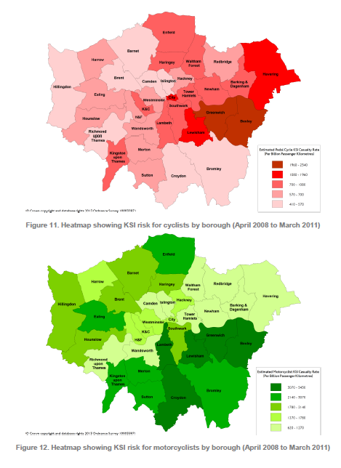3.1.2 The graph in Figure 2.5 shows that safety concerns are the most commonly cited barrier to taking up cycling so it is important for the Council to consider how to improve safety and also people’s perception of safety. The Council regularly reviews accident data to review any common trends and to address these accordingly. The latest analysis is included in the Technical Appendices to this strategy (see Appendix 2). The borough has a low rate of cycle casualties compared to other boroughs (see Figure 3.1 - the lighter the colour the lower the rate).

**Figure 3.1 –Cycle KSI casualty rate (per billion passenger kms) 2008-11 (TfL)**

Richmond

3.1.3 There has been a decrease in the number of cyclists killed or seriously injured (KSI) on borough roads since the 2011 peak (see Figure 3.2). There have been three cyclist fatalities within the last five years: one in 2011 and two in 2014. It should be noted that the overall number of cyclist KSIs occurring within the London Borough of Richmond upon Thames (on all roads) saw an absolute increase between 2013 and 2014 due to an increase in the number of accidents on the Transport for London Road Network (TLRN). There has also been an increase in the number of slight accidents on the borough’s roads over the last 10 years – see graphs in Appendix 2 for further detail. However, these are total numbers, rather than rate based statistics and do not take into account the increased number of people cycling on the borough’s roads. It is thought that the increase in KSIs up to 2011 may have been due to the recession when more people took up cycling as a more cost effective way to travel around, meaning a proportional increase in accidents. However, with heightened publicity around cycle safety, this may have then helped to reduce KSI numbers in the following years.

**Figure 3.2 – Cycling KSI and slight casualties in LBRUT over last 10 years (TfL)**

3.1.4 The more detailed analysis has also highlighted the following points, based on an average between 2009-2014. It should be noted that a more detailed analysis for 2015 is not yet available:

* A higher proportion of accidents involve male cyclists (76%) than female cyclists (24%), but this may reflect the proportions of male and female cyclists on the roads, the routes choices they make and the nature in which they cycle.
* 72% of all cycle casualties involved a car and 6% involved an LGV. Only 2% involved an HGV.
* 44% of cycle casualties involved residents of LBRUT, followed by residents from Wandsworth (8%) and Hounslow (8%)
* By far, the most common contributory factor in accidents involving a cyclist who was killed or seriously injured were poor driver/rider observation (80%). Other main contributory factors were poor driver/rider judgement (45%) and the driver/rider being reckless (44%)
* The highest proportion of adult cyclist KSIs took place in the afternoon peak period (47%). There is a similar pattern with child KSIs.

3.1.5 The actions in this section will set out the improvements to cycle routes that the Council intends to make over the coming years to make them safer and more attractive. However, it must also be recognised that whilst improved junction and road design will go some way to improving safety, a proportion of accidents are caused by the way that cyclists and other road users interact with each other and are better addressed through education and by encouraging people to adjust their speed and observation and be more considerate to one another on the road.

**OBJECTIVE A - ACTIONS:**

**A1 Cycle network improvements**

To help encourage further growth in cycling, investment in a core Richmond cycle network is required over the next 10 years. This will integrate existing and potential routes across the borough. The proposed core network is shown in Figure 3.3 and comments on these route alignments are welcomed as part of the strategy consultation.

Part of this network will be ‘Quietways’ which will be targeted at cyclists who may not feel confident cycling on busy main roads or who simply prefer quieter routes. Interventions are intended to be comparatively low level except where they cross busy junctions. Quietways will be a pan London network which will be delivered in partnership with TfL, neighbouring boroughs and The Royal Parks. Signage of these routes will be in accordance with the TfL pan London strategy, whilst recognising the need to keep signage to a minimum and not cause a proliferation of clutter. Clear signage of any routes that are shared with pedestrians will be particularly important in order to help minimise conflict. At least two Quietway routes will be delivered in the borough by the end of 2017.

The Council will also work with cycle groups, such as Richmond Cycling Campaign, to identify other improvements away from the primary cycle network that improve safety, comfort, connectivity, and legibility. This will include investigating the conversion of one way streets to two-way for cyclists and filtered permeability. Improvements to more local connections from the primary network to key facilities (railways stations, schools etc) will also be implemented.

**A2 Better Junctions and links**

Accidents involving cyclists often occur at junctions where there is more likely to be a conflict in movement. To tackle this issue the Council will:

* Review accident data annually to identify problem locations and appropriate improvements, and to identify any other casualty trends;
* Work with cycle groups to identify other junctions that can be a barrier to cycling and need improving;
* Review guard-rail to consider where this can be removed;
* Review ASLs, seeking to increase coverage and depth where necessary;
* Trial innovations such as advanced cycle signals, ‘All Green’ phases and two stage right turns where appropriate;
* Work in partnership with TfL to identify improvements on the TLRN and the Royal Parks to improve access/egress from routes in the Royal Parks.

**A3 Better Bridges**

Richmond upon Thames has a number of foot bridges across rivers and railway lines, which are not wide enough to permit cycling and can therefore be perceived as barriers to cycling. This will be addressed by implementing a rolling programme of cycle ramps over footbridges. Improvements to existing road bridges will also be considered. Opportunities for new bridges or improving existing pedestrian bridges to enable cycle access will also be identified such as a new pedestrian and cycle bridge between Twickenham and Ham.

**A4 Integrating cycling into new schemes**

The needs of cyclists will continue to be considered in the development of any new transport or development scheme, including the Council’s uplift programme, with consideration given to safety, connectivity, comfort, legibility and the London Cycle Design Standards (LCDS). All schemes will be reviewed by the officer responsible for cycling matters.

**A5 Well maintained roads and routes**

Where maintenance or utility works are being carried out, care will be taken to ensure that the site is safe for cyclists, particularly when a site is left unattended. The Council ensures this by requiring the statutory undertaker to comply with the relevant parts of the ‘Safety at Streetworks Code’ published by the DfT. There is also additional guidance within the LCDS. Maintenance regimes for the primary cycle network and Principal Road Network will also be reviewed to ensure that routes and signage are well maintained, with opportunities taken to improve any ‘ironwork’ in the carriageway which may pose a risk to cyclists i.e. gullies etc.

**A6 More cycle training**

Cycle training equips people with the skills they need to cycle safely and with confidence and helps participants to:

* Develop observation and manoeuvrability skills
* Learn to use the Highway Code and other laws relating to riding on the highway
* Learn the importance of hazard awareness and cycle maintenance

The ‘Bikeability’ scheme is a national standard in cycle training, and is used to offer consistency in training to set skill levels (1-3) across the country. Training is currently available to anyone living, working or studying within the borough.Level 1 training is offered to all schools (in Year 5) at a small charge, and Level 2 to Yr 6 pupils free of charge. Adults are charged at a subsidised rate, except for those in receipt of benefits who are entitled to free training. The training is tailored to best meet the ability of the participant, which can range from a total novice to an experienced cyclist who just wants a few pointers on tackling busier junctions.

At present around two thirds of adult participants are women. However, there is a need to increase promotion of cycle training, particularly to those groups who tend to be involved in higher proportions of accidents (i.e men), other harder to reach groups, families and those returning to cycling after long breaks. Cycle training is also promoted to medium and large businesses to try and engage not only would be new cyclists but also existing commuter cyclists, particularly men who might not otherwise consider the need for training. We will promote cycle training through a variety of channels, including through the website, through posters and flyers posted in community buildings (such as GPS, hospitals and libraries) and by working with cycle groups.

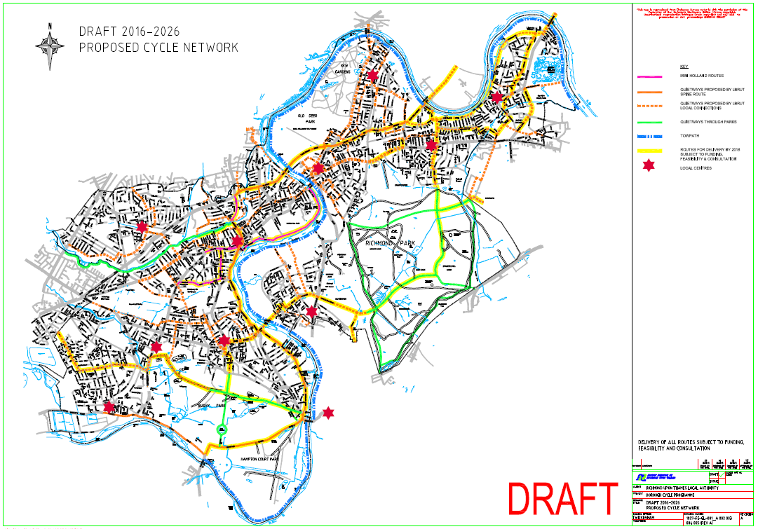

**A7 Safer HGVs**

A range of initiatives will be delivered to give both cyclists and HGV drivers a greater appreciation of the issues they each face when navigating London’s roads. Measures to encourage fleet operators to equip their vehicles with the latest technology to assist them in detecting cyclists in the vicinity of their vehicle will also be implemented.

* The Council currently has Bronze FORS (Fleet Operator Recognition Scheme) accreditation and is seeking to progress towards Silver accreditation by 2020, and Gold by 2026
* All new Council contracts will need to meet FORS Bronze standard and a number of other conditions around vehicle equipment and driver training/checks (see Appendix 3).
* Contractors operating within the Borough and businesses with fleets will be engaged on their Work Related Road Risk policies and encouraged to sign up for a package of measures to ensure that they keep their vehicles and drivers up to standard. This will include free Safer Urban Driver Training which will be available to any fleet driver – HGV or LGV. This course also has a practical element whereby drivers receive on bike cycle training.
* Partnerships with business (particularly haulage firms) and London Buses will be used to facilitate ‘Exchanging Places’ programmes.
* Trial of innovative safety equipment

**A8 Enforcement against poor road user behaviour**

The Council supports the use of police resources to take enforcement action against any road user breaking road regulations. This includes infractions such as speeding, red light jumping, encroachment of vehicles into ASLs and cycling on the footway. Enforcement that is balanced and is not biased towards any one user group is usually most effective. The Council will work with the police to deliver joint enforcement and education events at three hotspot junctions every month. Additional campaigns that encourage mutual respect amongst all road users will also be considered.

**A9 Speed limits and traffic calming**

Research has been undertaken that has found that the greatest benefit for cyclist safety (and other road users) accrues from reducing traffic speeds (DfT 2011). This may be achieved through a variety of methods including street design that emphasises pedestrian and cyclist movement, physical traffic calming that is sensitive to the needs of cyclists (eg sinusoidal humps), and the use of lower speeds. The 20mph policy states that town centres and locations where vulnerable people gather, such as outside schools, will be prioritised. However, these limits should aim to be self-enforcing.

**3.2 Objective B – Develop cycling as an everyday option**

3.2.1 In order to develop cycling as an everyday option people need secure and convenient places to store their bikes at the start and end of their journey so that it can be more attractive than walking, catching a bus/train or getting in the car. The Council has already implemented cycle parking in many of the boroughs local centres and at other key trip attractors. However, during the summer months many of these stands are at capacity and further locations are required. Finding such locations in busy town centre areas can be challenging, and without such facilities there is often an increase in informal parking, which can be unsightly, obstructive and dangerous for pedestrians, particularly those with visual impairments, and other road users. Similarly there is a need to find ways of improving provision at the home and work end and the Council will work in partnership with housing associations, developers and businesses to achieve this.

3.2.2 People also need to be able to maintain their bike and ensure it is kept in good working order so that it is safe and easy to use. The Council runs regular ‘Dr Bike’ events where people can have their bike checked over and minor issues fixed on the spot.

3.2.3 For those who do not have anywhere to store their bike, other access options where bike ownership is not necessary need to be explored i.e. cycle hire.

**OBJECTIVE B - ACTIONS:**

**B1 Improved cycle parking**

Increased levels of cycle parking will be provided in a range of locations as set out below. It must be well designed to enable people to secure both the frame and wheels to the stand Location is also important in ensuring that there is natural surveillance for any on street stands and that any off street locations are safe, secure, well lit and weatherproof. Poorly designed and/or poorly located parking will not be appealing to cyclists and will not be used.

* **For residents**
* Work with housing associations, such as Richmond Housing Partnership, to provide secure cycle parking for their residents
* Produce guidance for residents on installing cycle storage at home and make this available online
* Trial a bike hangar solution where there is demand and support for it from local residents.
* **At workplaces**
* Businesses will be encouraged to apply for funding from TfL to install cycle parking and also associated facilities such as showers and lockers.
* **At schools**
* Through the School Travel Planning process, schools will be encouraged to review their on-site provision and improve facilities.
* **At stations**
* The Council will continue to work in partnership with South West trains to encourage them to improve provision at stations, where necessary. Consideration should be given to the development to Cycle Hubs where there is particularly high demand for cycle parking. These should be located close to station entrances wherever possible.
* **In new development**
* The Council will continue to ensure that new developments meet the cycle parking standards set out in the Council’s Development Management Plan.
* The Council will review the current standards to ensure that they meet the revised London Plan standards.
* **On street for visitors**
* A regular audit of cycle parking in local centres and other key trip attractors (leisure centres, GPs etc) will be undertaken to understand where more cycle parking is needed. Requests for new stands in other locations will also be considered.

**B2 Better cycle security**

The level of cycle theft in the Borough needs to be monitored to ensure that the right measures are being employed to reduce theft and to ensure that fear of theft does not impact on cycling levels. In 2014/15 there was a 12% decrease in cycle thefts from the previous year, and the Council would like to see this trend continue. A high proportion of thefts were from back gardens and poorly secured bikes.

Any measure to improve cycle security will be developed in collaboration with local police as well as specific area stakeholders such as transport interchange operators and town centre managers. Such partnerships should be ongoing and can be used to identify hotspots, identify new measures / initiatives and to provide feedback. The Council will provide advice on its website on how to keep bicycles secure, raise awareness of the latest tactics used by bike thieves and promote events where bike marking takes place.

**B3 Encouraging improved cycle maintenance**

It is important that people are equipped with knowledge on how to keep their bike in good working order so that they are safe and easy to use. Pointers will be provided online and the Council will also run regular ‘Dr Bike’ events where people can have their bike checked over and minor issues fixed on the spot. The provision of subsidised maintenance classes for residents will also be considered and those run by others promoted on the website. A trial will also be run with school children so that they can share this knowledge with their parents.

**B4 Facilitating bike ownership**

The Council will investigate the feasibility of facilitating a bike swap event for schools, enabling parents to upgrade their children’s bikes more cost effectively. Similarly the Council will provide support and advice online on buying a bike and the appropriate accessories (see Action C1).

**B5 Improving cycle hire options**

Cycle hire options will be kept under review, including trialling Brompton docks at railway stations. The Mayor of London’s cycle hire scheme cannot currently be expanded to the borough as there is insufficient funding from TfL to achieve a meaningful expansion under its current policy of growth from centre outwards (rather than allowing remote hubs). The Council awaits the new Mayor’s position on cycle hire expansion.

**B6 Removing abandoned bikes**

Bicycles that have clearly been abandoned are currently removed from the street following a seven day notice period. Approximately 100 bikes a year are removed by the Council and donated to the Clarendon School who run bike maintenance classes for young people with Special Education Needs.

**3.3 Objective C – Promote cycling as a safe, fun and healthy way to get around**

3.3.1 Delivering Objectives A and B will go a long way to encouraging more people to cycle. However there is even more the Council can do to raise awareness of the support available to help get more people cycling.

**OBJECTIVE C - ACTIONS:**

**C1 Providing an information resource for all**

Providing a comprehensive and accessible package of information on cycling is important in equipping people with the knowledge and support they need to take up and continue cycling. An online resource will be developed providing a range of information, as set out below, will be produced. Leaflets promoting the availability of this information and key initiatives will also be produced and made available at events and in reception areas run by the Council and partners, such as GPS, libraries and other community buildings.

Targeted campaigns will be delivered to encourage responsible cycling and driving behaviours. We will work closely with key partners such as the police, public health colleagues and community groups to deliver these campaigns.

**OUR CYCLING STRATEGY AND PLANS**

**LDF policy**

**Cycling strategy** - summary and link to the full document

**Current year’s delivery programme**

**Link to any current consultations**

**How to contact us / make a suggestion**

**GET CYCLING**

**Advice on buying a bike and accessories**

**Safer cycling** - general advice + cycle training

**How to keep your bike safe and secure** - home storage, parking, maintenance

**Bike hire** – links to companies providing this

**Finding the best route** - advice and link to journey planners/maps

**Link to ‘what’s on’ page**

**WHAT’S ON**

**Events**  - rides, Dr Bikes and other events

C**urrent scheme consultations**

**How to contact us or make a suggestion**

**Links** - to other pages

**SUPPORT FOR SCHOOLS AND BUSINESSES**

**Schools** - benefits, services offered/ funding, case studies, how to contact us

**Businesses -** benefits, services available from LBRUT, funding available from TfL)

**C2 Better local community engagement**

The Borough benefits from active and well-attended cycling clubs and organisations which provide further opportunities for both leisure and utility cycling. Partnership working with these organisations enables a series of organised events to be delivered that raise the profile of cycling in the Borough. For instance, Strictly Cycling is one such programme which delivers coaching sessions for grass track and “cyclo-cross” cycling. Cycling related events organised by others will be promoted on the Council’s webpages in an ‘events calendar’.

Events such as exchanging places events (in conjunction with TfL or local haulage firms) will continue to be run as an engagement tool on cycling matters but specifically to change the behaviour of cyclists around large vehicles. Dr Bike events will also be used as a way of engaging cyclists and raising awareness of safety issues and Council initiatives. The Council will also increase efforts to work with underrepresented and inactive groups to promote cycling and raise awareness of consultations on cycling schemes. During the development of cycle schemes opportunities will be taken to promote cycle training and other Council cycling initiatives to residents and businesses in the vicinity of the scheme.

Various safety campaigns aimed not just at cyclists but also at motorists being alert to cyclists have been run in the past with poster, banner and bus back campaigns and will be rolled out where it is visible and the message will have an impact.

**C3 Ongoing schools engagement**

During 2015, the Council worked with 35 schools out of 72 (49%) to help them develop School Travel Plans (STPs). Of these schools, 21 achieved Bronze level, 6 Silver and 8 achieved the highest Gold standard. It is anticipated that further schools will get engaged in the process during 2016. By participating in the travel planning process these schools have been eligible for funding from TfL and the Council to deliver improved cycle parking facilities and to run other initiatives designed to encourage pupils, parents and staff to travel to school by bike such as Cycle to School days, biker’s breakfasts etc. The Council will continue to work with schools to encourage them to achieve higher levels of STP accreditation and to apply for funding to help deliver more cycling initiatives.

There is a need to deliver further initiatives to help change the ethos of schools’ and parents’ perception of safe travel to school by bike, to try and ingrain the culture of riding before children reach the age of independent travel which usually coincides with going to Secondary School. To help achieve this, the Council will set up a new School Cycling Champion initiative, which will invite schools to nominate a teacher, parent or pupil to encourage cycling and raise awareness of cycle safety issues within the school environment.

The Road Safety Education team will continue to offer Level 2 cycle training in all schools free of charge, and deliver other safety education initiatives to help improve awareness of road safety issues. These initiatives will build on the cycling related educational measures that are currently on offer which sees the Borough’s school children receive training and advice on all modes of transport at Junior Citizen, peer to peer learning via the Junior Safety Officer scheme, and cycling is also covered in scooting and pedestrian training and as a module for the young driver package for 16-18 year olds.

**C4 More effective business engagement**

The Council will be encouraging the borough’s businesses to sign up to the Healthy Workplace Charter. As part of this they will be required to assess how their staff travel to work and for business purposes, and to consider how they can be encouraged to travel more sustainably, promoting cycling as an option. As well as having healthier employees with fewer absences, cycling can help businesses to reduce the costs associated with car parking provision and use. A range of initiatives can be implemented by businesses to support and encourage cycling, some of which TfL and the Council can help to fund or deliver as set out below:

* Work with businesses make sure they are aware of the information / support that is available from the Council, including provision of cycle training, safety talks, Dr Bikes etc.
* Raising awareness of the funding available directly from TfL for cycle parking, lockers bikes, bikers breakfasts etc
* Promoting cycling amongst Council staff and Members, providing information on the staff intranet and a link to the broader cycling webpages, and keeping Council facilities under review
* Medium and large employers are encouraged to sign up to the 2 Wheels London campaign which sees businesses receive quarterly e-zines with safety info and offers

**C5 Working with Public Health Partners**

Encouraging more people to incorporate cycling into their daily routines has a key role to play in improving public health. One in six adults are estimated to do less than 30 minutes of physical activity a week (made up of at least 10 minute bouts of moderate intensity activity). We will therefore work closely with health partners and practitioners to develop initiatives that raise awareness of the benefits of cycling and the support that is available from the Council to enable more people to start cycling. Input from the public health team will help to identify groups of residents who may most benefit from greater levels of physical activity.

4 Implementation Plan

4.0.1 This chapter of the strategy sets out a short term implementation plan for the above actions. Delivery of these actions will require funding from a range of sources, and partnership working both with different teams within the Council and also external stakeholders.

**4.1 Funding**

4.1.1 Funding for the actions within this plan is likely to come from the following sources. However, it should be noted that due to the change in Mayor, the Council is awaiting confirmation of what TfL funding to be available over the coming years:

* Local Implementation Plan (LIP) funding – boroughs bid to TfL for this funding in three year cycles. 2016/17 is the third year in the current cycle. There may be up to two interim LIP years whilst the new Mayor’s Transport Strategy is developed and new LIP guidance issued.
* Borough Cycle Programme (BCP) funding – this is a supplementary funding pot for the provision of cycle parking, cycle training, driver training, the development of cycling strategies and staff resource. Boroughs bid for this over three years as part of their LIP submission.
* Incubator funding – boroughs are invited to bid for funding for the delivery of innovative schemes that trial new technologies and ideas.
* Mini Holland funding – although Richmond was not successful in acquiring full Mini Holland funding, the Twickenham Town Centre elements of the bid were of particular interest to TfL, who had provided initial funding to undertake feasibility and concept design work on a number of routes.
* Developer funding **–** contributions are sought from developers to make improvements to the highway in the vicinity of the development.

**4.2 Partnership working**

4.2.1 Many of the actions within this strategy will require the Council to work with both internal and external partners in order to secure their delivery. Sustained partnerships can open up and ease lines of communication with interested parties to ensure that information is shared and opportunities are not missed.

4.2.2 The delivery of the actions within the strategy will require input from a variety of teams across the Council including Planning, Public Health, Sports/Leisure and Community Safety. Partnership working with external stakeholders will also be crucial in delivering a number of the actions, including TfL, neighbouring boroughs, the Royal Parks, South West Trains, The Metropolitan Police, Richmond Housing Partnership and Richmond Cycling Campaign and the local CTC to name a few.

4.2.3 All schemes that propose physical changes to the highway will require consultation with residents, businesses, cycle groups and other stakeholders. This is an important part of scheme development and ensures the views of the people travelling through the location in question are considered from an early stage. The Cycling Liaison Group meets quarterly, and offers a forum for discussion of emerging proposals.

**4.2.3 Implementation Plan**

An **indicative** implementation plan is shown in the table on the next page. This plan will be refreshed every three years, in line with the LIP and BCP programme submissions.

|  |  |  |
| --- | --- | --- |
| **TABLE 4 - IMPLEMENTATION PROGRAMME** | | |
| **ACTION** | **Scheme** | **Timescale** |
| **A - Making cycling journeys safer and easier**  It should be noted that all implementation timescales are subject to feasibility/design work, consultation results and availability of funding. | | |
| **A1**  Improved cycle network | Mini Holland (including London Road and Heath Road)  Quietways  Other network improvements  Cycle contraflows - feasibility / design / implementation | Feasibility/design in 2016.  Phase 2 – by end of 2017  Subsequent phases in medium to long term  Ongoing  Feasibility – 2015/16  Implementation Phase 1 - 2016/17  Implementation Phase 2 – 2017/18 |
|  | All Green junction - feasibility/design work on all green phase for cyclists.  Review of cycle casualties | Feasibility/design work – 2015/16 to 2016/17  Implementation – 2016/17  Ongoing annual review |
| **A3**  Better Bridges | Provide ramps for cyclists on footbridges | A further 2-3 bridges in 2016/17. |
| **A4**  Integrating cycling into new schemes | Ongoing in all new schemes | |
| **A5**  Well maintained routes | Ongoing programme of carriageway renewal, confirmed on an annual basis | |
| **A6**  Cycle training | Rolling programme of training sessions in school undertaken by approved cycle trainers. Training also offered to adults.  Promotion of cycle training to hard to reach groups | |
| **A7**  Safer HGVs | Continued delivery of Safer Urban Driving courses  Incorporation of conditions into new Council contracts  Progression towards Silver FORS | |
| **A8**  Road user behaviour | Rolling programme of training and safety campaigns. | |
| **A9**  Reducing speeds | Continued rotation of speed indicator devices, and other speed reducing schemes where appropriate and evidenced. | |
| **B - Developing cycling as an everyday option** | | |
| **B1**  Improved Cycle parking | Rolling annual programme to provide additional cycle parking Borough-wide, including at key trip generator sites such as rail stations, retail/commercial centres and off-street in housing estates. | |
| **B2**  Improved Security | Revise webpages with further detail on how to lock bikes safely and locations of cycle stands  Develop further initiatives in conjunction with police | 2016/17  Ongoing |
| **B3**  Maintaining bikes | Review workshops run across the borough and ensure info is provided online | Keep this under review |
| **B4**  Cycle hire | Consider trial of Brompton scheme at a borough railway station | 2016/17 |
| **B5**  Abandoned bikes | Continue to remove abandoned bikes from street | |
| **C – Promoting cycling as a safe, fun and healthy way to get around** | | |
| **C1**  Information resource | Develop webpages with updated and expanded content.  Produce leaflets with links to the website and expand social media presence. | 2016/17 and then regular updates |
| **C2**  Engaging the community | Ongoing programme of engagement with underrepresented and inactive groups in partnership with public health colleagues | |
| **C3**  Cycling to School | Rolling programme of a range of measures to help encourage cycling to school, including School Travel Plans, improved cycle parking, cycle to school days, road safety programmes in schools. | |
| **C4**  Cycling to work | Produce webpages geared towards supporting businesses in encouraging more employees to cycle to work  Use other mechanisms to promote cycle to work | 2016/17  Ongoing |
| **C5**  Public Health Partnership | Partnership project with public health to encourage more workplaces to promote walking/cycling to work as part of Healthy Workplace Charter | Continuation/evolution of 2015/16 project |

5 Monitoring and Targets

5.1 The monitoring plan set out in this chapter is intended to keep a track of the delivery of actions in this strategy and their contribution towards achieving its overall vision and objectives, with annual reports to be compiled.

5.2 The Council has already achieved the previous Mayor’s Target of a 5% modal share for cycling by 2026, for trips originating in the Borough. It is recognised that the Mayor’s target is a pan London target and in Richmond there a greater potential to exceed this. The Council has therefore set a series of realistic but ambitious targets to achieve by 2020 and 2026.

5.3 The monitoring plan makes use of data being collected by the Council, TfL, the DfT and the police. Table 5.1 contains a series of high level targets which will monitor outcomes from the investment that is being made in cycling. Table 5.2 shows a series of indicators to monitor the Council’s deliverables as part of this strategy, which should contribute to achieving the high level targets set out in Table 5.1.

|  |  |  |  |  |
| --- | --- | --- | --- | --- |
| **Table 5.1 – High Level Targets** | | | | |
| **Target** | **How Measured** | **Baseline** | **Target** | **Linked to which objective** |
| Cycling Mode Share | TfL data | Current rate for all trips is 7% | 15% by 2026 | All |
| Number of daily cycle journeys | DfT and TfL/Council counts | 4,571 average (DfT) | 10% increase per year across all sources | All |
| Cycle to work mode share | Census | Current rate is 4% (for LBRUT residents) | 6% by 2021 | All |
| Cycle to school mode share | Hands-up school surveys | Current rate is 7% for primary school, 3% for secondary school | 2020 – 8% for primary, 6% for secondary school  2026 – 9% for primary, 9% for secondary | All |
| Reduction of the rate of cyclist involved in accidents | Accident statistics data, LTDS |  | 5% reduction in casualty rate by 2020, 10% reduction by 2026 (from 2015 baseline) | A |
| Website hits | Number of hits p/a | 719 hits in year on cycling homepage (July 2014- July 2015) | 25% increase by 2017, 50% by 2020 and 100% by 2026 (from 2015 baseline) | C |
| Broaden demographic of people cycling – more women, elderly people etc | Census | 2011 journey to work census data:  **Male** = 66%, **Female** = 34%;  age **16-19** = 2%; **20-29** = 15%,  **30-39** = 33%,  **40-49** = 28%; **50-59** = 16%;  **60+** = 6%  **White** = 6% **Asian** = 2% **Black** = 3% **Mixed** = 6% **Other ethnicity** = 4% | Broader cross section by 2021 | C |

**DELIVERY INDICATORS**

|  |  |  |
| --- | --- | --- |
| **Table 5.2 – Annual delivery indicators** | | |
| **Indicator** | **How Measured** | **Linked to which objective** |
| Number of km of cycle network completed  Percentage of core network completed | Council data | A |
| Percentage of foot bridges with ramps | Council data | A |
| Number of school children receiving cycle training | Council data | A |
| Number of adults receiving cycle training | Council data | A |
| Number of cycle parking spaces delivered | Council data | B |
| Number of cycle thefts | Police data | B |
| Number of schools with Bronze / Silver / Gold level STP | Council data | A,C |