Terrace Gardens – Sloping Bed Proposal
Why are we consulting?

The restoration project of 2008/2009 included the replanting of many areas in Terrace Gardens. However, the sloping bed below the Night watchman's Hut and adjacent to the old toilet block was one of the areas deferred due to lack of resources. We are now in a position to rejuvenate and bring new life to this fairly substantial area and we are seeking your comments on the proposals below.

The proposal

There are three key elements to the scheme that we would like your feedback on . Further details of each are provided below.

Hard Landscaping
There is a flower bed situated on a west facing slope, and due to a combination of its gradient, clay soil and the potential for ground movement, we plan to terrace the slope using retaining walls made from granite kerbs which will be re-used from Whitton High Street. The Gardens already contain many york stone or granite retaining walls, so the new walls will be in keeping with the existing style and materials. The shallower sloping beds created by the new retaining walls will be filled with flowering plants. We are also proposing a new paved seating area at the base of the existing slope, which will look out over the upper and middle lawns of the Gardens.

Planting
The proposed planting will be a sustainable mixture of attractive, drought tolerant plants providing large quantities of nectar and pollen for Bees, Butterflies and other insects. It will be full of flowers, with grasses added to provide structure and a neutral foil to the brighter flowers. The plants will be set out in an informal way, so they mingle amongst one another and produce an overall feeling of colour, softness and movement. The photos below are examples of similar planting schemes. The main flowering season will be summer, but the plants selected will also retain their seed heads in autumn and winter, which will provide structure as well as a winter food source for seed eating birds. The planting as a whole will not require intensive maintenance, and it will be cut back at the end of winter.
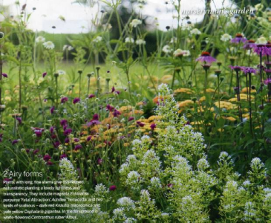
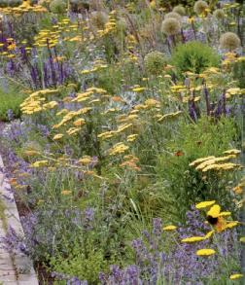
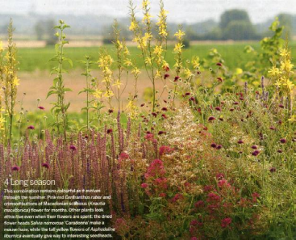
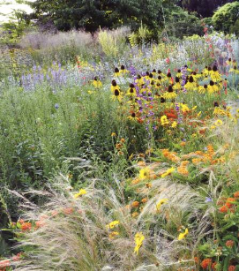

Tree Work
We have looked at the trees in this area and are proposing to carry out selective tree removal to manage the slope and to improve the appearance and function of the landscape. There are fifteen existing trees in this area and two stumps. We propose to remove seven of the trees including two Yew trees, one Holly, one Pagoda Tree, one Laburnum, one Portuguese Laurel and one Apple. The Laburnum has a poor structure and the Portuguese Laurel has died. The Pagoda Tree is removed in favour of a Himalayan Birch because the trees are too closely planted and the latter tree will be more appropriate in the proposed design. The Apple, Holly and two Yews are close to the location of the retaining walls and they could not be retained with the anticipated root damage. The remaining trees including two False Acacia trees, one Silver Birch, two Holly, one Himalayan Birch, one Yew and a Snowy Mespil will be retained. The overall scheme cannot go ahead without the tree work outlined above.

Timing
The old planting was sprayed off during the summer. Subject to consultation tree removal would commence in October 2013, followed by hard landscaping over a 6 week period and planting taking place immediately after completion of the hard landscaping.

