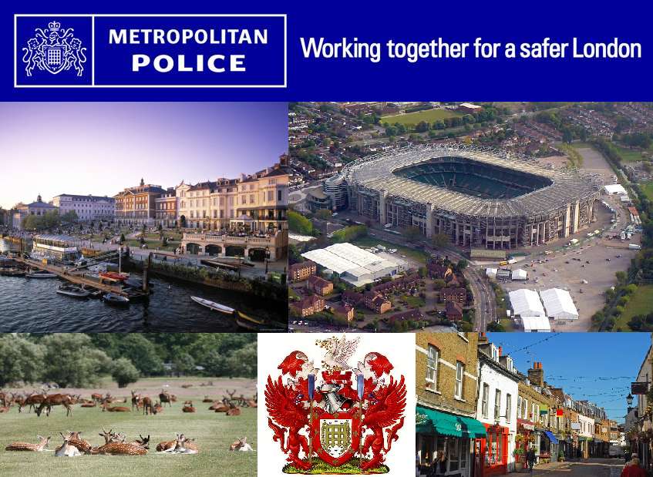



**Richmond upon Thames**

**Strategic Assessment**

**1 April 2016-31 March 2017**

**Author:** Nicholas Hall, Intelligence Analyst

(DRAFT VERSION 7 )

**Contents**

1. **Executive Summary**
2. **Introduction**
3. **Methodology**
4. **Borough Demographics**
5. **Community Safety Partnership Performance**
6. **Overall Crime performance 2011-2017**
7. **Safer Neighbourhoods**
8. **Standing Together Against Extremism and Hatred**
9. **Tackling Violence Against Women and Girls**
10. **Keeping Young People and Children Safe**
11. **Reducing Re-Offending**
12. **Conclusion**
13. **Priorities**

**1. Executive Summary**

* Richmond remains the fourth safest borough in London, according to the Iquanta Home Office website. It remains the safest borough for violent crime and race hate crime.
* Overall crime in Richmond has risen by 9% or 658 crimes from April to November 2016 compared with last year.
* Burglary offences remain almost level, down 4 crimes during this period (from 921 to 917)
* Vehicle offences have seen a 32% rise during this period (from 971 to 1279)
* Police recorded anti-social behaviour (ASB) has seen a 7% rise in calls from April to November 2016
* Council recorded anti-social behaviour (ASB) has seen a 30% rise in calls from April to November 2016
* Domestic violence incident reporting has risen by 0.7%, with718cases compared to713 in the same period last year.

**2. Introduction**

The overarching aim of this Strategic Assessment is to identify medium to long-term crime and disorder issues which are impacting on the London Borough of Richmond upon Thames. The implications of these issues and possible future threats will also be considered.

The main purpose of this product is to provide a clear and concise summary of the problems faced by Richmond Borough, in order to review the Community Safety Partnership Plan and support strategic decision making and resource allocation by the Community Safety partners.

**3. Methodology**

The date parameters for this Strategic Assessment are 01/04/16 to 30/11/16 unless otherwise stated. This 8 month period should be understood as part of the 3-5 year analysis of crime trends on the borough.

Iquanta crime data has been used to populate charts and graphs in this assessment and data has been gathered from partnership databases and Council databases.

**4. Borough Demographics**

Richmond upon Thames is a unique London borough as it is the only borough that is situated to both the north and south of the River Thames, with a river frontage of 21 miles. The borough is not entirely urbanized and contains a significant number of parks and open spaces including Richmond Park, Bushy Park and Kew Gardens. Richmond Borough is well connected to central London by National Rail and London Underground District Line Services run from Richmond and Kew Gardens.

There are 193,585 (2014 estimate) residents in Richmond, with 14% recorded as being from a black or minority ethnic (BME) background. Whilst Richmond as a whole is far less diverse than neighbouring boroughs to the North and West, this ranges from 9% in Teddington ward to 30% in Heathfield ward.

|  |  |  |  |
| --- | --- | --- | --- |
| **CRIME TYPE** | **TOTAL** | **CHANGE** | **POSITION** |
| **ALL CRIME** | 7946 | Up 9% (+ 658 crimes) | 4th/32 |
| **BURGLARY** | 917 | Down 0% (- 4 crimes) | 8th/32 |
| -Residential | 485 | Up 7% (+33 crimes) | 4th/32 |
| - Non-Residential | 432 | Down 8% (- 37 crimes) | 22nd/32 |
| **VEHICLE CRIME** | 1279 | Up 32% (+308 crimes) | 13th/32 |
| - Theft of | 368 | Up 33% (+ 92 crimes) | 11th/32 |
| -Theft From | 683 | Up 25%( +137 crimes) | 13th/32 |
| **VIOLENCE** | 2427 | Up 8% ( + 180 crimes) | 1st/32 |
| **SERIOUS ACQUISITIVE CRIME** | 1601 | Up 17% (+ 234 crimes) | 5th/32 |

**5. Community Safety Partnership Performance**

Richmond remains one of the safest boroughs in London with a rate of 58.41 crimes per 1000 population for April to November 2016 (total of 7,946 offences). Richmond is the fourth safest borough in London; it has fallen from third safest in 2015-16.

The safest four boroughs are Bexley, Harrow, Sutton and Richmond. Bexley is the safest borough in London.

**6. Overall Crime Performance 2011-17**

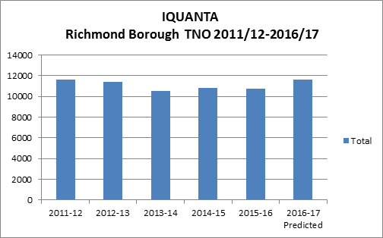

(This is 12 month data except for 2016-17 which is extrapolated from the first 8 months of the year)

The following statistics are taken from the latest iQuanta updates (as of Quarter three 2016-17) and the Metropolitan Police performance dashboard as of 30/11/16, that track performance over the last 8 months.

Any data included later in the document will be based on crime type or caseload analysis; this performance data is strategic and should be used for any reporting on targets and expected performance.

Extrapolated analysis suggests that the final end of year figures (April 2016-March 2017) will show a possible 9% rise in crime. (There were 7946 crimes between April and November 2016, compared to 7288 in the same period in 2015.)

Richmond remains in the best four performers for Total Notifiable Offences out of the 32 London boroughs and this is not expected to change.

**7. Safer Neighbourhoods**

**Volume and Priority Crimes**

Of the three main crime types which are important to the local police and the Community Safety Partnership (CSP), there have been some impressive reductions but also rises too.

* Burglary offences remain almost level, down 4 crimes during this period (from 921 to 917)
* Vehicle offences have seen a 32% rise during this period (from 971 to 1279)
* Violent crime has risen by 8% (from 2247 to 2427).This increase has affected almost all London boroughs and Richmond remains the safest borough for violent crime.

**Crime Summary**

Burglary offences remain one of the volume crimes on the borough, in the last three years a police strategy targeting “hot streets”, has been very effective in reducing both Residential and Non-Residential Burglary. This involves looking at locations where burglary has been a historical problem and then focusing resources via partnership working, such as communication campaigns, analysing insecurity data and pro-active operations.

Residential Burglary was reduced by 7% between April-Nov 2016, for a period earlier in the year; Richmond was the safest borough for residential burglary a remarkable achievement.

Non-residential Burglary was reduced by 8% between April-Nov 2016, insecure outbuildings were a consistent issue between 2013-15, this has significantly improved in the last 18 months. Pedal cycles are consistently the most common item stolen from sheds

The four year chart below shows a steady reduction in overall burglary in the four years before 2016-17.

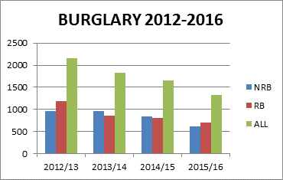

There is still work to do on continuing to keep residents focused on security, with both burglary types. 18 months of insecurity analysis has seen a small improvement overall but the same types of insecurity remain. These include unlocked front doors, open ground floor windows and patio doors as well as pedal cycles left insecure in front and back gardens. The evidence would suggest that around 15-20% of burglary offences occur where insecure locations have been targeted. One particular insecurity hotspot is the summer months where ventilation is needed; this is where insecure offences usually peak.

All insecure data is based on CRIS reports where this information has been clearly recorded.

Vehicle crime has been the central problem crime in 2016-17, it is not isolated to Richmond Borough, neighbouring boroughs have seen similar high crime increases, particularly with Theft of Motor vehicles.

The four year trend shows that while Theft from Motor Vehicle is steadily falling, Theft of Motor Vehicle is rising slowly; overall offences in 2015/16 were up as well.

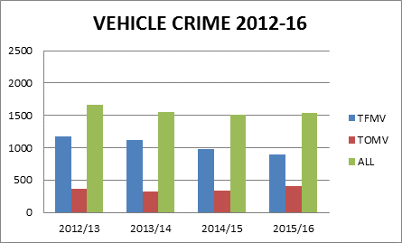

Theft of Motor Vehicle offences have risen by 33% between April-Nov 2016, with two wheel thefts being the main driver from April to October. Targeted police responses to this issue have reduced the two wheel aspect of Theft of Motor Vehicle from midsummer onwards. The trend as of November 2016 was improving regarding two wheel offences.

Mopeds and scooters have been the main vehicle type targeted, with cross border offenders identified. Steadily from Autumn 2015, mopeds and scooters replaced cars as the main vehicle type, by summer 2016, almost 70% of all Theft of Motor Vehicle offences were mopeds or scooters. Insecurity was not an issue with these vehicles, barely 1% of these offences involved insecurity, with suspects using bolt cutters, angle grinders or “barrelling”, to steal these vehicles. It should be noted that theft of motor vehicle has always had very low insecurity percentages.

Theft from Motor Vehicle offences have risen by 25% between April-Nov 2016, this crime type is consistently a volume crime on the borough and vehicle insecurity remains a real problem.

Despite communication campaigns targeting vehicle security and advising not leaving items on show in vehicles, the insecurity percentages remain around 12-13%, the community safety partnership will look at the most effective ways to get this message out to residents in the coming year. Analysis shows that laptops, satnavs and other valuables are left on display and vehicles remain unlocked.

It is a difficult situation for community safety where the constant messages are not being heeded, there seems to be a feeling that as Richmond is a safe borough, security of property and vehicles is not that important by a significant minority of residents. However, Richmond is a safe borough, neighbouring a few boroughs with higher crime levels and can be seen by criminals as a soft target, complacency regarding crime prevention will only make this worse.

When insecure data is collated for Vehicle Crime, Burglary and Pedal Cycle Theft since April 2015, the overall trend shows a 2% improvement in figures since the targeted campaigns started with Pedal Cycle Theft and Theft from Motor Vehicle showing the best improvement. Residential Burglary remains the main concern. It should be noted that securing a residential property is a far more effective deterrent than securing a non-residential property, such as a shed. It should not be forgotten that security figures are still 85% secure at least but it’s the fine margins of preventable crime which are the concern.

(A criminal could easily break a padlock on a shed; however, this padlock would denote a secure location. A secure house would involve a much higher challenge to the offender)

All insecure data is based on CRIS reports where this information has been clearly recorded

**ASB**

Council recorded ASB is a mix of council internal staff reporting and resident reporting, it is mostly environmental ASB(such as litter, fly-tipping and graffiti), unlike police recorded ASB which is mostly to do with more traditionally classified human interaction (neighbour disputes, rowdy behaviour, vehicle nuisance)

**Council**

Council recorded ASB is currently showing a rise of 30% between April and November 2016, (up from 3585 to 4702 reports) this is the busiest period for ASB and is expected to remain the same.

Fly-tipping and Graffiti have seen the highest rises in the April-Nov 16 period, the rise in Graffiti is due to resident driven reporting of graffiti issues during this period while fly-tipping has been a consistent concern in Greater London for the last few years. (However more than a third of incidents recorded as fly-tipping were related to bin bags rather than household appliances, fixtures and fittings). Noise reports have been reduced in 2016-17.

The three main wards are South Richmond, Twickenham Riverside and East Sheen.

There is a mix of local resident concern and established issues on the borough over the last five years, there can be targeted resident efforts to report some categories of ASB with lead to rises in report totals.

**Police**

Police recorded ASB has risen 7% (from 2671 to 2852 calls) between April and November 2016.

The main wards were Twickenham Riverside, Hampton North and South Richmond. The two town centre wards are traditionally in the top three, while Hampton North suffers from cross border ASB on the Hounslow border. South Richmond saw a reduction in ASB.

Police recorded ASB is generally related to human interaction and behavior, nuisance neighbours and rowdy behaviour, this has not changed in 2016-17

The ASB situation in general is showing a trend towards a rise in ASB for 2016-17, partly due to increased resident reporting and confidence in general reporting. Repeat caller issues from the same victim remain the most sensitive side of ASB in Richmond, these issues need a careful response and a multi-agency focus. Due to this, they are the hardest calls to deal with, sometimes creating their own hotspot in quieter wards.

**Homelessness**

Homeless people are at greater risk of being a victim to some types of crime. The following data was reported by local authority homelessness returns for 2015-16:

* 61% of homeless were from a White background,18% were from a BME background, the ratios for border boroughs were: Wandsworth (29/47%) and Hounslow (33/47%)
* 4% of the Richmond caseload were deemed in priority need, a similar percentage to neighbouring boroughs, however a higher percentage in Richmond were deemed “Eligible but not homeless”
* 39% of the caseload was housed by private sector in Richmond and 20% in hostels, with 4% local authority. The main difference compared to neighbouring boroughs was the low local authority housing numbers in Richmond but this is explainable by the sale of Richmond housing stock in 2000.

**Road Safety**

Traffic data has been supplied by the Environment and Community Services department with data available from the year to March 2015 and year to March 2016.

* The data shows casualties in the borough are down by 16%, with 453 casualties in the 12 months to March 2016, compared to 539 in the year to March 2015.
* There was 1 fatality in the 12 months to March 2016, compared to 3 in the previous year.
* The number of people being killed or seriously injured in the 12 months to March 2016 was unchanged from the previous year.

**8. Standing Together Against Extremism and Hatred**

**Hate Crime**

Richmond has traditionally had very low levels of hate crime and remains one of the safest London boroughs for racial hate crime in the Metropolitan Police area for the period April-November 2016.

**Overview – 32 boroughs**

An overview of the main strands of Hate Crime reported to the Metropolitan Police shows a clear trend towards more overall reporting, indicating more confidence in police procedure and a rise in faith hate crime reporting. The latter possibly influenced by events in the Middle East and the rise of ISIS, followed by the Syrian crisis. The “Brexit effect” cannot be discounted in Greater London as well.

Disability Hate Crime is the hate crime category which has been most problematic for under reporting, but has seen a significant rise in the latest period (see table below).

Homophobic crime has remained almost steady throughout this period.

|  |  |  |  |  |  |
| --- | --- | --- | --- | --- | --- |
|  | Homoph | Racist | Faith | Disability | Total number of hate crimes |
| Apr-Nov 2012 | 10% | 83% | 6% | 1% | 7829 |
| Apr-Nov 2013 | 10% | 81% | 8% | 1% | 7993 |
| Apr-Nov 2014 | 10% | 80% | 9% | 1% | 10304 |
| Apr-Nov 2015 | 11% | 79% | 9% | 1% | 12174 |
| Apr-Nov 2016 | 10% | 76% | 10% | 4% | 14784 |

(Data from MOPAC. Metropolitan Police total (not Richmond only)

**Race Related Hate Crime**

In Richmond, Race Hate Crime has risen by 24% from 136 to 168 crimes; this is expected to remain the same. Richmond has fallen from safest to third safest for race hate crime in the Met area; confidence in reporting is a driver in these figures.

With victims of hate crime, white people were the most common victims (33%), followed by Asians (27%). The male/ female split was 53/47%.This fits in with the demographic profile of offences in last 3-4 years but the white percentage has risen slightly in last two years linked to comments about travellers and east Europeans, the Brexit issues are part of this.

Victims classified as BME constituted 47% of all Hate Crime victims, this is a further fall on the 2015-16 percentages but this will have been affected by “Brexit” and “anti-traveller” sentiment expressed where the victims are eastern European or from a traveller background.

The main difference between suspects and victims remains the fact that 80% of suspects were White males.

The majority of racial offences involved using racial insults and usually took place on public transport or at street level. There were no clear seasonal trends. There is a strong element of “passing through” crimes, on public transport where the suspect is not a borough resident. 66% of victims were borough residents, where information was available.

**Disability Hate Crime**

There were 12 incidents of disability hate crime between Apr-Nov 16, according to the local CSU; Richmond had the best sanction detection rate during this period, within all 32 boroughs, at 33%. Disability types were 50% mental and 50% physical. There is no direct comparison to the previous period due to the situation with under reporting which would only distort this comparison.

**Religious Hate Crime**

Faith hate crime in between Apr-Nov 16 has increased, mainly Islamaphobic crime up from 4 incidents to 14. These cases involved racial comments, insinuations of being terrorists and references to their faith. Violence was more common in this category than any others, with four violent cases of Islamophobia.

Anti-Semitic hate crime has fallen during this period from 3 to 2 incidents recorded

With the current tense situation in the Middle East and Syria in particular, along with the terror attacks in Europe during 2016, the religious hate crime problem remains an issue throughout London.

Muslim females are likely to be at an increased risk of being the target for hate crime, especially if they are wearing the niqab or other clothing associated with their religion.

**Homophobic Hate Crime**

Homophobic hate crime has risen from 15 to 37 reports.

The majority of both victims and suspects of homophobic crime were white males aged between 18-40. The victim male/female split was 62/38%.

**Violent Hate Crime**

4% of all the incident strands above was classified as most serious violence, with one incident of Grievous Bodily Harm. This percentage has fallen 2% from the previous period.

12 out of 168 victims were listed as having a vulnerability or disability.

**Other Hate Crime**

From 24/06/16-30/11/16, 22 out of 104 (21%) hate crimes reported have had a “Brexit” element.

The main pattern has been where the suspect has declared, “we voted to get you lot out” or “why haven’t you gone home yet?”. Harassment was the main crime type for these hate crimes.

NB. Some of the comments about “go back to your own country” are ambiguous and may not be linked to Brexit

During the same period, a number of stickers were found in the Whitton and Heathfield area using Islamophobia and Xenophobic terminology. These stickers were posted on behalf of “National Action”, a BNP style youth organisation that was banned by the government in December 2016.

Since October, no new stickers have been reported but the sentiments and style seemed to linked to the uneasy post-Brexit climate for BME residents and communities.

While other hate crime remains low compared to some other areas of the UK, these offences will be monitored over the coming years, especially as the Brexit process continues.

**Summary Analysis**

Violent hate crime remains very low, with low level violence and harassment as the main forms of hate crime in Richmond. The usual situation is town centre public transport issues, where there is verbal abuse and name calling.

While the post-Brexit problems and the homophobic rise in offences are concerning, there is also an element of confidence in reporting these issues to the police, where higher numbers, as with DV reporting is a good thing.

The London-wide rise in disability hate crime reporting is most welcome and Richmond police are at the forefront of detecting these offences.

**9. Tackling Violence Against Women and Girls**

**Domestic Abuse**

**Summary**

Metropolitan Police statistics from April to November 2016 show a 0.7% rise in domestic abuse compared to the previous year (up from 713 to 718 notifiable offences).

This is a significantly smaller increase than previous years but still shows, as with other victim-focused crimes, that confidence in reporting has improved. The percentage of incidents becoming notifiable crimes remains consistent in the last three years, between 46-49% of all incidents become notifiable crimes.

Within the domestic violence incidents, the levels of notifiable crime and violent crime remain steady, there has not been a continued increase in GBH offences, in fact most serious violence has fallen by 8% in the period from April to Nov 2016, forming 23% of all notifiable crimes. Violent offences formed 56% of all notifiable crimes.

The female/male ratio of victims of domestic violence remains at 75/25%, which is almost exactly reversed for domestic violence suspects, where it is 24/76 % female to male. Female suspect figures continue to slowly rise; this is also matched by a small rise in male victims.

The level of repeat victims and repeat suspects has risen too, by a percentage point, with repeat suspects rising steadily in last few years.

Comparable figures for in depth case analysis such as inter familial domestic violence, based on last year’s analysis, show that the figures have risen by 1% at 22% of suspects having inflicted violence on a family member.

*(These figures are based April-Nov 16 figures; the projected totals are expected to remain similar in percentage terms. Crime totals from Met Website)*

**Multi-Agency Risk Assessment Conference (MARAC) 2015-16**

The Richmond MARAC meets monthly and shares information on the borough’s highest risk cases of domestic violence and abuse and agrees through a risk management plan how to reduce the risk to victims and their children.

The MARAC caseload was up 13% from 149 cases last year to 168 (19 cases) when compared with the same period (April to November) in the previous year.

The predicted total for the full year 2016-17 (April to March) is 250 up from last year (228) by 22 cases a rise of 10%.

46 MARAC cases from April to Nov 16 are classed as repeat cases, which is up 16 cases from the corresponding period in the year before.

Safelives guidelines (previously known as CAADA) recommend that an effective MARAC process should identify between 20% to 35% of the total cases being heard as repeat cases.

Referrals in the last few years have mostly been from Independent Domestic Violence Advocacy (IDVA) service and the local police. From April-Nov15 50% of cases were referred by the IDVA service, with 29% Police and 21% other. From April-Nov 16 the case referral percentages were IDVA (41%), Police (38%) and 21% other. (The main other referrer was children’s social care in both time periods)

The percentage of MARAC cases from a BME background has risen from 36 to 45 in the two periods covered, after a review of BME case categorisation , these figures are much lower than between 2010-14 but more realistic. These percentages remain higher than the borough BME population, which stands at 14%

Only 2% of cases were identified as involving LGBT victims, this is lower than last year and has been consistently low over the past few years. Disability cases have risen by 1%, to 7% of all referred cases.

Male victims has fallen from 9% to just 3% of all referrals, this is an area that has not matched the overall DV picture, however this possibly confirms either that men are less commonly victims of the most serious DV or that there is under reporting from men experiencing domestic violence.

**Independent Domestic Violence Advocacy (IDVA) Service**

The national charity Refuge is commissioned to provide the borough’s IDVA service and produce quarterly statistics on their work with domestic abuse victims. The statistics provide information on the reduction of risk to victims, the reduction and cessation of violence and abuse and a range of outcomes for victims who access the service. The information is available for the first three quarters of 20166.

The main vulnerability of victims during this period was mental health conditions, sometimes caused by the experiences the victim has gone through but also as a result of previously existing conditions. Most victims are not currently living with their abusive partner, this partner usually being described as “ex-intimate”. This has not changed significantly year on year.

When the type of abuse is looked at, “controlling behaviour” rather than physical or sexual abuse is the main type, linked to jealousy and insecurity, which is very much a central feature of abusive relationships. Controlling behaviour has been the main type of abuse for three years now.

**10. Keeping Children and Young People Safe**

**Child Sexual Exploitation (CSE)**

Between April and October 2016 there were 16 cases of alleged CSE investigated and classified, of which, nine are currently open. This is a lower total than last year but a higher percentage of these cases are classified as “open”.

There 3 cases per month in 2015-16, this has fallen to 2.28 cases in 2016-17, to date.

81% of alleged victims were female and three quarters were recorded as White British. All victims were aged between 12 and 17, however only one was aged below 14.

44% of cases involved situations such as improper relations with older men, periods of going missing overnight and sharing images. Only two cases involved online CSE.

A majority of the young persons involved were listed as missing from home or care, truancy and mental health concerns were not very prevalent. Only one child had a disability listed.

At this stage of the developing CSE analysis, the ratio of cases discussed and closed, to cases open and ongoing would suggest very low levels of CSE at the current time.

Missing persons data is problematic when being used as an accurate indication of CSE in particular but can show tensions and issues relating to individuals which may not appear elsewhere. From the missing persons data available there does seem to be small number where elements of CSE are being alleged, however these are usually reports where concern is expressed, and not open investigations

**11.Reducing Re-Offending**

**Offender Management**

The integrated offender management scheme (IOM) has been running in Richmond since September 2012, with monthly panel and strategy meetings.

This summary looks at the progress of offenders managed within the IOM scheme and the subject of nomination panel meetings and the current offending profile in Richmond. Overall probation case data no longer covers both Richmond and Kingston boroughs which means that we no longer have an issue with data and numbers

|  |  |  |  |
| --- | --- | --- | --- |
| Year  (Previous 12 months rate: 66%) | Re-offend rate% | Re-Offend Number | Max cohort number |
| **IOM Year One 2012-13** | 31% | 11 | 35 |
| **IOM year Two 2013-14** | 56% | 14 | 25 |
| **IOM Year Three 2014-15** | 33% | 9 | 27 |
| **IOM Year Four 2015-16** | 56% | 18 | 32 |

The re-offending rate during the last four years of the IOM scheme remains below the 66% baseline; both the first and third year rates were impressive.

There is some discussion over using measures to evaluate police responses to re-offending, usually seen as the negative/punitive side of measuring performance but actually vital. Two factors are essential in creating a workable cohort; firstly there must be precise and careful selection of offenders for inclusion on the scheme*.* Secondly, there must be engagement from all partners in understanding and thinking laterally regarding difficult recidivist offenders

Positive Life Outcome measures (PLOs) record the many areas of living where the offenders are in need of assistance or lacking in some way, such as accommodation, education, drug treatment engagement, engagement with probation and others.

The evidence presented from Year Four PLO’s would suggest that we have a cohort with established treatment needs, including drug and alcohol addition. Employment levels are very low, (a small number have gained employment and have reduced their offending accordingly). Engagement with the scheme shows that less than 40% of the cohort was positively involved. The majority of offenders were in accommodation of some kind.

Due to the complicated lives of the offender cohort, with behavioural problems, drug and alcohol addiction plus other lifestyle issues, offender rehabilitation remains a challenge. .

The consistent problem areas where the offender management programme remains less successful are in tackling engagement and employment. There has been some improvement with these areas but they remain weaker than accommodation and drug treatment numbers. Sustained employment remains difficult; this further exacerbated by educational disabilities and other mental health concerns, which can limit opportunity.

The scheme offers help in all areas, however this needs consent from the offender and more often than not, this is not forthcoming from the small number of prolific offenders on the scheme.

**Drug Test on Arrest (DTOA)**

The data below looks at the period from April-November 2016. There is also an analysis of the link between DTOA and the Integrated Offender Management (IOM) process.

These statistics cover offenders from Richmond borough only. This data enables a picture to be drawn of offending habits and to identify the cross borough threat from offenders and inform the IOM process.

There have been 114 arrests of persons who have offended in Richmond between April-November 2016 of whom 99% were drug tested.

Of these 114, 66 were trigger offences with the positive test rate standing at 49%. The main drug detected was both cocaine and opiates.

The main trigger offence for all positive tested individuals was acquisitive crime (58%), as this is a volume crime in the borough. 64% of positive tested individuals were residents of Richmond borough. The main cross borough location for offenders was Hounslow with 14%.

Compared to 2015-16, the Hounslow offender proportion has risen by 1%, 7% more Richmond resident offenders have been tested.

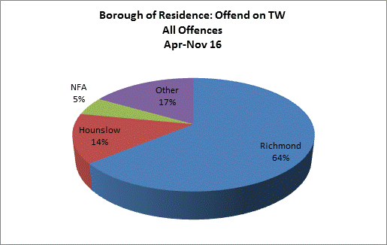

These figures show that cross-borough offending remains a problem for Richmond, with 36% of positive tested individuals residing outside the borough. However, these percentages also reflect targeted police work on resident offenders and this has resulted in a further 7% reduction in the cross borough offender presence on 2015-16 figures. Of the positive tested cohort, 20% were from bordering metropolitan boroughs.

(NB. Trigger offences cover acquisitive crimes such as burglary, theft, shoplifting and drug supply)

**12. CONCLUSION**

Crime is predicted to rise by 9% in 2016-17, the largest rise in seven years, while there have been positive signs with burglary reductions, vehicle crime,(in particular two wheeled motor vehicle theft ) has risen significantly and contributed towards the rise in recorded crime.

It should be noted however that the position of Richmond among the 32 london boroughs has not changed (fourth safest as of Nov 2016), this is an example of the low crime numbers that Richmond traditionally experiences.

Crime has risen across the Metropolitan Police boroughs during 2016-17, this should be taken into account, along with a recorded rise in hate crime during this period.

Richmond remains a safe and affluent place to live in Greater London, with the lowest violent crime rate. In the coming year, the community safety partnership will target vehicle and property insecurity, anti-social behaviour, vehicle crime and burglary as part of the new MOPAC priorities. There will also a focus on high harm offences.

**13. PRIORITIES**

**Local Priorities: Burglary, Vehicle Crime, ASB**

**- Measures to be confirmed**

* **Reducing Re-Offending;**
* **Tackling Violence Against Women and Girls ;**
* **Keep Children and Young People Safe;**
* **Standing Together Against Extremism and Hatred**

**- Mandatory high harm measures to be confirmed**