**Sexual Health Commissioning Strategy**

**2014-2018**

Table of Contents

Executive Summary 3

1. Introduction 5

1.1 Importance of sexual health 5

1.2 Purpose and scope of strategy 5

1.3 Methodology 6

2. Sexual health in Richmond borough 7

2.1 Unintended pregnancies 7

2.2 Sexually transmitted infections 9

2.3 HIV 14

2.4 Inequalities 16

2.5 Sexual health knowledge among young people 17

2.6 Local voice 18

3. Sexual health services 20

3.1 National context 20

3.2 Local services 21

4. Outcomes 25

5. Commissioning priorities 26

5.1 Increase the focus on prevention and sexual health promotion 26

5.2 Strengthen community-based sexual health services 31

5.3 Commission high-quality services 34

6. Financial implications 42

References 43

|  |
| --- |
| Executive Summary Sexual health is a key public health issue and it is vital that local people have access to high-quality support and services.  Good sexual health is important to individuals as well as to society as a whole. Unintended pregnancies and sexually transmitted infections (STIs) can negatively affect the health and wellbeing of individuals. However, they can also present a wider risk to other people – for example, someone may have an STI without experiencing any symptoms and unwittingly pass it on to a partner, or to a baby during pregnancy. Poor sexual health can also result in substantial costs to society through healthcare costs as well as costs relating to poor education, employment and social outcomes in the long-term.  The purpose of this strategy is to identify commissioning actions that can be taken to support improvements in sexual health within Richmond borough. This is a joint strategy between London Borough of Richmond upon Thames and NHS Richmond Clinical Commissioning Group (CCG).  The strategy covers the commissioning responsibilities of the two organisations.   * Local authority – services relating to prevention, contraception and STI testing and treatment (except for human immunodeficiency virus (HIV) treatment) that are commissioned by Public Health, as well as HIV social care and support services commissioned by adult social care * CCG – services relating to abortions, sterilisation and vasectomy   Although the sexual health need in Richmond is relatively low compared to other boroughs within London, overall it is quite similar to national levels. Continued improvements in prevention initiatives and sexual health services are required to support improvements in sexual health outcomes. Nationally, the main groups of people at higher risk for poor sexual health are young adults, people from black ethnic groups and men who have sex with men (MSM) – these same groups are at higher risk locally.  Sexual health services cover the provision of advice, prevention, testing and treatment. In order to control infection, prevent outbreaks and reduce unwanted pregnancies, a range of principles have historically been applied to sexual health services. Services are open access (no need for a referral), free of charge, confidential and not restricted by age or place of residency. These principles help to ensure universal and rapid access to services and help to address issues of stigma associated with poor sexual health.  Provision of sexual health services is complex and there is a wide range of providers – including community providers, primary care (GP practices and pharmacies), hospitals and the voluntary sector. There is clear evidence that sexual health interventions and services are cost-effective.  It is intended that this strategy will support achievement of the following high-level outcomes:   * Reduce the number of unintended pregnancies, particularly among young people * Reduce the number of people affected by STIs and HIV * Reduce inequalities in sexual health |
| There are three commissioning priorities within this strategy. These priorities will be achieved through a number of objectives, which are outlined on the next page.  Implementation of the strategy will require changes within the existing sexual health budget. A shift of investment into evidence-based prevention initiatives and exploration of alternative models of service delivery that can help to increase cost-effectiveness are necessary in order to achieve long-term savings. Strengthening community-based services and moving appropriate activity out of genito-urinary medicine (GUM) services is a key aspect of the strategy. An ‘invest to save’ approach is required, but increased investment in community-based services may need to occur in planned phases over time.   |  | | --- | | **Commissioning Priority 1**  **Increase the focus on prevention and sexual health promotion**   * Increase sexual health knowledge and resilience among young people * Improve awareness of sexual health services * Ensure provision of free contraception from a range of services * Increase the uptake of long-acting reversible contraception * Increase the prevention role of services outside of sexual health settings |  |  | | --- | | **Commissioning Priority 2**  **Strengthen community-based sexual health services**   * Increase the provision of sexual health services in community settings * Ensure that sexual health services are embedded within core health services * Align the commissioning of sexual health services provided in community and primary care settings |  |  | | --- | | **Commissioning Priority 3**  **Commission high-quality services**   * Ensure that services are delivered at accessible locations and times * Consider alternative methods of service delivery, including online services and self-testing * Ensure that services meet the needs of people from high-risk groups * Ensure that robust clinical governance and safeguarding arrangements are in place * Ensure comprehensive, evidence-based management of STIs, including partner notification * Ensure that all professionals are appropriately trained, including those working outside of sexual health settings | |

1. **Introduction**
   1. **Importance of sexual health**

Sexual health is a key public health issue and it is vital that local people have access to high-quality support and services.

Good sexual health is important to individuals as well as to society as a whole. Unintended pregnancies and sexually transmitted infections (STIs) can negatively affect the health and wellbeing of individuals. However, they can also present a wider risk to other people – for example, someone may have an STI without experiencing any symptoms and unwittingly pass it on to a partner, or to a baby during pregnancy. Poor sexual health can also result in substantial costs to society, through healthcare costs as well as costs relating to poor education, employment and social outcomes in the long-term. In addition, certain groups tend to experience higher risks of poor sexual health, in particular young people, people from black ethnic groups and men who have sex with men (MSM) – resulting in substantial health inequalities.

* + 1. **Unintended pregnancies**

An unintended pregnancy is a pregnancy that is mistimed, unplanned or unwanted at the time of conception[1]. It is mainly the result of a lack of, inconsistent or incorrect use of contraception. Up to half of all pregnancies are unplanned. While many of these pregnancies will become wanted, they can have a major impact on individuals, families and wider society[2] – particularly if an unplanned pregnancy occurs during adolescence. Although socio-economic disadvantage can increase the risk, teenage conceptions occur in all socio-economic groups. Teenage pregnancy is generally associated with poorer health, education and economic outcomes for young parents and their children – for example, teenage parents are 20% more likely to have no qualifications at age 30 and children of teenage mothers have a 63% increased risk of being born into poverty2.

* + 1. **STIs and HIV**

Untreated STIs can result in serious health consequences and are the main preventable cause of infertility2,[3],[4]. Many people with STIs may not be aware that they are infected as they may not experience any symptoms. This can mean that an STI may be passed on to others and that the individual does not receive treatment at an early stage, which would help prevent health complications in the long-term. Untreated STIs can also facilitate transmission of human immunodeficiency virus (HIV). Prompt diagnosis and treatment of STIs is therefore crucial to protect public health.

* 1. **Purpose and scope of strategy**

The purpose of this strategy is to identify commissioning actions that can be taken to support improvements in sexual health within Richmond borough.

This is a joint strategy between London Borough of Richmond upon Thames and NHS Richmond Clinical Commissioning Group (CCG).

The strategy covers the commissioning responsibilities of the two organisations.

* Local authority – services relating to prevention, contraception and STI testing and treatment (except for HIV treatment) that are commissioned by Public Health, as well as HIV social care and support services commissioned by adult social care
* CCG – services relating to abortions, sterilisation and vasectomy

Sexual health services commissioned by NHS England are not included within the scope of this strategy, but important links to these services have been highlighted where relevant. This includes HIV treatment, contraception provided as part of the core GP contract, sexual assault referral centres and cervical screening.

* 1. **Methodology**

A detailed sexual health Joint Strategic Needs Assessment (JSNA) was developed to inform this strategy. This provides a picture of sexual health in Richmond borough and an overview of current sexual health services. It then reviews those services against local needs, national policy and evidence of what works to improve sexual health.

Information in the JSNA is taken from a number of sources – including publicly available data, confidential data that is presented in summary form and information from stakeholder engagement.

Stakeholder engagement was carried out in a number of ways:

* Engagement with current providers through contract management meetings and discussions at the local Steering Committee on Sexual Health (SCOSH).
* Surveys of GP practices and community pharmacies
* An annual health and wellbeing survey of school-aged children
* A sexual health peer research project carried out by Richmond Youth Council
* User surveys for individual services

1. **Sexual health in Richmond borough**
   1. **Unintended pregnancies**

An unintended pregnancy is a pregnancy that is mistimed, unplanned or unwanted at the time of conception1. It is mainly the result of a lack of, inconsistent or incorrect use of contraception. Numbers of teenage conceptions and abortions can therefore be used as proxy indicators of a need for more effective and accessible contraception.

* + 1. **Teenage conceptions**

Teenage pregnancy is generally associated with poorer health, education and economic outcomes for young parents and their children. Although socio-economic disadvantage can increase the risk, teenage conceptions occur in all socio-economic groups. Risky behaviour, absent parents and lower educational attainment can also have an important impact. Although national rates are at their lowest level since records began in 19692, continuing to reduce teenage conceptions is a national priority and an indicator is included within the Public Health Outcomes Framework.

Around 50 teenagers conceive per year in Richmond and reducing this number should continue to be a priority. In Richmond, 66% of teenage conceptions end in abortion, compared to 62% in London and 49% in England.

Richmond has a relatively low teenage conception rate[5] – 19.9 per 1000 women (aged 15-17) in 2012, compared to 25.9 in London and 27.7 in England. Although the local rate has remained relatively steady over recent years, other areas have seen significant reductions and Richmond’s rate is no longer significantly lower than that of London.

**Conception rate per 1000 females aged 15–17 (1998-2012)**5

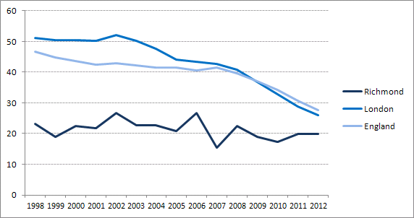

*Source = ONS 2012 conception statistics*

* + 1. **Abortions**

Up to half of all pregnancies are unplanned and are experienced by women from all social backgrounds. These can have a major impact on individuals, families and wider society2.

During 2012, there were 571 women in Richmond who had an abortion. The rate of abortions (15.7 per 1,000 women aged 15-44) is significantly lower than in London (22.4 per 1,000) but similar to England (16.6 per 1,000).

Within Richmond, almost one-quarter of abortions are to women aged 35 or over, compared to 15% in England. This difference reflects the age structure of the local population. Nationally, just over half of women having an abortion have previously had a live or stillbirth[6]; this data is not available at a local level but emphasises the importance of maternity and health visiting services in providing advice on contraception.

**Percentage of abortions by age group (2012)**6

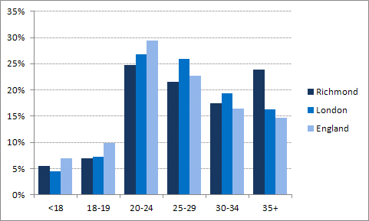

*Source = ONS 2012 abortion statistics*

Around one-third of abortions (34%) in Richmond are among women who have had an abortion previously, compared to 43% in London and 37% in England. This is the lowest percentage in London. Among women aged under 25 who had an abortion in Richmond in 2012, more than one-quarter (27.4%) had previously had an abortion – similar to England. This percentage has generally increased over the last decade, although there has been fluctuation in Richmond (a trend line is shown on the graph below). This is not specifically a local problem, but it may suggest that contraceptive services are failing to meet the needs of all young people[7].

**Percentage of repeat abortions among women aged under 25 (2005-2012)**6

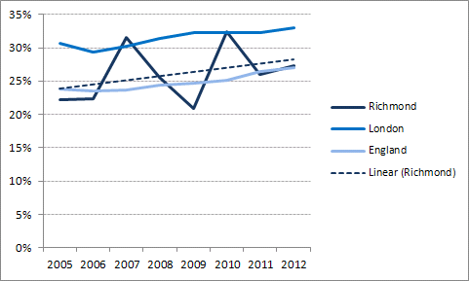

*Source: ONS, abortion statistics 2005-2012*

These patterns indicate that more work needs to be done to promote effective contraception, including ensuring support into adulthood and following childbirth.

* 1. **Sexually transmitted infections**

Untreated sexually transmitted infections (STIs) can result in serious health consequences and are the main preventable cause of infertility2,3,4. Untreated STIs can also facilitate transmission of HIV. Prompt diagnosis and treatment of STIs is therefore crucial to protect public health.

* + 1. **STI diagnoses**

During 2012, a total of 1,297 acute STI diagnoses were made among Richmond residents[8]. The STI rate in Richmond (692 per 100,000) is significantly lower than England (804 per 100,000) and especially London (1,337 per 100,000). Richmond is ranked 124 out of 326 local authorities in England (1 is the highest rate). This pattern is seen for most STIs, except for Chlamydia where Richmond has a low diagnosis rate (see section 5.2.2 for further information).

The numbers and rates of the main STI diagnoses are shown in the graph below.

**Rate of main acute STI diagnoses per 100,000 (2012)**8

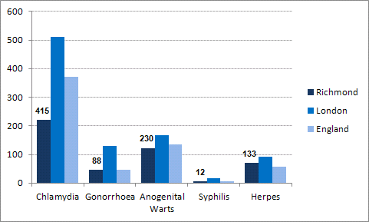

*Source = PHE, Number & rates of acute STI diagnoses in England, 2009 - 2012*

Overall, STI rates have remained relatively stable over recent years in Richmond, but there have been increases in Herpes (one-third increase since 2009) and particularly in Gonorrhoea (a 66% increase in the last year). This may partly be reflected by improvements in screening (increases have been seen in other areas as well) and by fluctuations due to relatively small numbers in Richmond – but it remains a cause for concern.

The age and sex distribution of STI diagnoses in Richmond can be seen in the graph below. More diagnoses were made among males (57%) compared to females (43%). Over 40% of acute STI diagnoses are among those aged 15-24, which is similar to London.

**Rate of acute STI diagnoses per 100,000 by age group and gender (2012)****[9]**

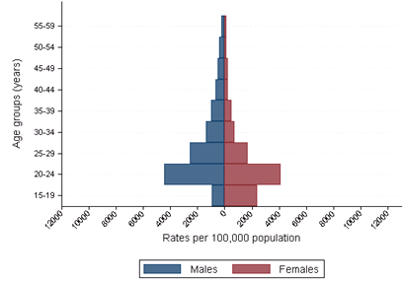

*Source: PHE, Richmond upon Thames Local Authority sexually transmitted infections and HIV epidemiology report (LASER): 2012*

Fifteen per cent of all STI diagnoses in Richmond are among MSM, which is lower than in London (20%). However, the majority of syphilis and gonorrhoea diagnoses are among MSM, and Richmond ranks 44 among 326 local authorities in England for syphilis and ranks 57 for gonorrhoea (1 is the highest rate) – much higher than the overall STI rank of 124.

Although numbers are small (fewer than 50 cases per year), the STI rate among people from black ethnic groups is more than double the overall rate.

**Rate of acute STI diagnoses per 100,000 by ethnic group (2012)**9

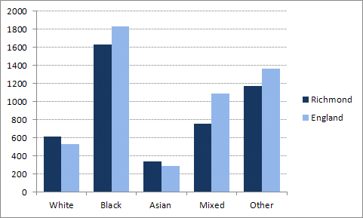

*Source: PHE, Richmond upon Thames Local Authority sexually transmitted infections and HIV epidemiology report (LASER): 2012*

In addition to the inequalities highlighted above, higher STI rates are usually seen in more deprived areas at a national level. However, there is no clear pattern within Richmond of higher STI rates in areas that are more deprived. It is therefore important to ensure that there is universal access to sexual health services across the whole borough.

**Rate of acute STI diagnoses per 100,000 by deprivation category (2012)**9

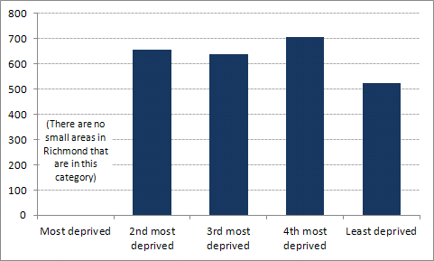

*Source: PHE, Richmond upon Thames Local Authority sexually transmitted infections and HIV epidemiology report (LASER): 2012*

* + 1. **Reinfection rates**

Reinfection with an STI is an indicator of persistent risky behaviour. In Richmond, an estimated 7.7% of women and 10.8% of men presenting with an acute STI during 2009-2012 became reinfected with an acute STI within a year. These figures are slightly lower than nationally (9.6% for women and 12% for men). Reinfection rates are higher among young women in Richmond – 11.5% of young women compared to 5.6% of young men (age 15-19).

Sections on the main STIs are presented below.

* + 1. **Chlamydia**

Chlamydia is the most prevalent STI in England, particularly among young adults. Most people with Chlamydia do not have any symptoms. If left untreated, Chlamydia infections can persist for months or years and can lead to long-term fertility problems[10]. Unlike some other STIs, a large proportion of Chlamydia diagnoses are found among people who have only had one partner in the past year10. Once diagnosed, Chlamydia can be easily treated with antibiotics.

The National Chlamydia Screening Programme (NCSP) seeks to address this issue by regularly testing sexually active under-25s who do not have any symptoms as a routine part of primary care and sexual health consultations. A high diagnosis rate is not a measure of ill health as for other STIs – it reflects success at identifying infections that may not otherwise be diagnosed and treated. The NCSP recommends that local areas achieve a diagnosis rate of 2,300 per 100,000 young people in order to result in a decrease in prevalence.

In Richmond, a total of 415 people were diagnosed with Chlamydia in 2012, including 238 people aged 15-24. The local diagnosis rate was 1,308 per 100,000, compared to 1,979 per 100,000 in England. Please see section 5.2.2 for further information on the NCSP in Richmond.

* + 1. **Gonorrhoea**

Gonorrhoea is becoming an increasingly important public health issue as it can quickly develop resistance to antibiotics. In 2012, 88 people in Richmond were diagnosed with Gonorrhoea – almost three-quarters of these diagnoses were among MSM. Richmond ranks 57 among 326 local authorities in England for gonorrhoea (1 is the highest rate) – much higher than the overall STI rank of 124.

Along with other areas, Richmond has seen a large increase in the number of Gonorrhoea diagnoses during the past year – up by 66%, compared to a 27% increase in London. This may partly be reflected by improvements in screening, as well as some fluctuations due to relatively small numbers in Richmond – but it remains a cause for concern.

**Rate of Gonorrhoea per 100,000 population (2009-2012)**8

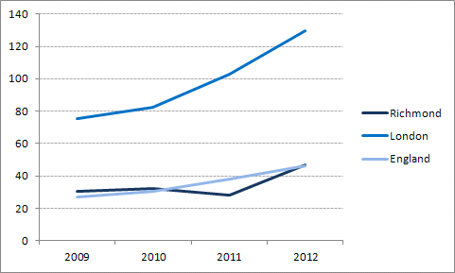

*Source = PHE, Number & rates of acute STI diagnoses in England, 2009 - 2012*

* + 1. **Syphilis**

Nationally, syphilis rates are at their highest since the 1950s2. The number of syphilis cases diagnosed in Richmond is very small and fluctuates annually. Almost all diagnoses are among MSM. Richmond ranks 44 among 326 local authorities in England for syphilis (1 is the highest rate) – much higher than the overall STI rank of 124.

* + 1. **Genital Herpes**

Herpes rates have been steadily increasing over recent years. In Richmond, 133 residents were diagnoses with Herpes in 2012 and the number of diagnoses has increased by one-third since 2009.

**Rate of Herpes per 100,000 population (2009-2012)**8

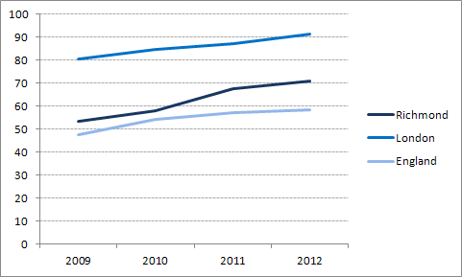

*Source = PHE, Number & rates of acute STI diagnoses in England, 2009 - 2012*

* + 1. **Anogenital warts**

In Richmond, 230 people were diagnosed with Warts during 2012. The diagnosis rate of Anogenital Warts has remained steady over recent years at a regional and national level, while Richmond has seen a steady decrease (14% decrease since 2009).

* 1. **HIV**

Although health outcomes have improved drastically for people with HIV over recent years, it remains a serious disease for which there is no cure or vaccine. Around one in four people living with HIV are unaware of their HIV status. Once people have a diagnosis of HIV, they can access effective treatment and are less likely to pass on the infection to other people.

There are 304 Richmond residents diagnosed with HIV who access care services – with 22 people newly diagnosed in the last year[11],[12]. Although numbers seem relatively low, prevalence has increased by 42% over the last four years and by over 80% in the last decade. This is due to new diagnoses as well as an ageing cohort of diagnosed people.

Richmond has a prevalence of 2.4 HIV diagnoses per 1000 adults, compared to 1.5 in the UK. Although this is one of the lowest rates in London, Richmond is officially classed as a ‘high prevalence’ area.

Applying national research data, it is estimated that there around 100 people in Richmond living with HIV who are unaware of their HIV status.

Most Richmond residents diagnosed with HIV are males, with males aged 35-54 accounting for over half of the total number. Residents aged 55 and over account for 20% of the total number, which has increased from 14% in 2010 – reflecting an ageing of the cohort which is also seen nationally.

**HIV diagnosed persons seen for HIV care, by age group and gender (2012)**11

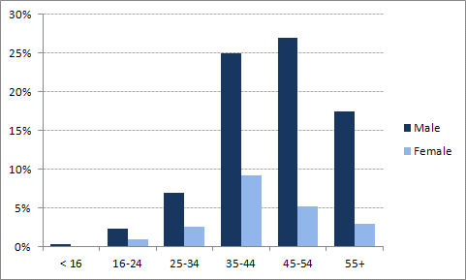

*Source: PHE, SOPHID 2012*

The most common probable route of infection in Richmond is sex between men (63%), and this percentage is higher than in the United Kingdom (44%). Sex between men and women accounts for a further third of infections in Richmond.

**HIV diagnosed persons seen for HIV care, by risk group (2012)**11**,[13]**

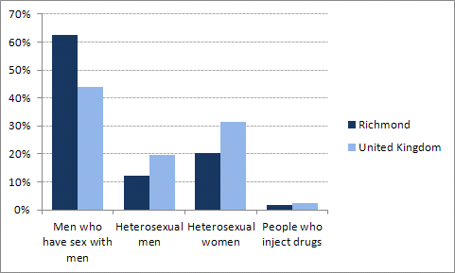

*Source: Richmond data from PHE, SOPHID 2012; UK data taken from HIV in the United Kingdom: 2013 report*

Two-thirds of residents diagnosed with HIV are from white ethnic groups. People from black ethnic groups account for a further 20%, mainly women from black African ethnic groups. Black ethnic groups account for less than 1% of the total population in Richmond[14].

Although it is not possible to fully analyse local HIV data by different levels of deprivation, there is an indication that the prevalence rate is higher in the relatively deprived areas in Richmond.

Diagnosis at an earlier stage of HIV infection substantially improves health outcomes for the individual and helps to reduce onward transmission. An indicator on late HIV diagnosis is included as part of the Public Health Outcomes Framework. During 2010-12, 41% of new cases in Richmond were diagnosed after the point at which they should have started treatment (late diagnosis), compared to 45% in London and 48% in England. However, due to low numbers it is difficult to compare this figure with other areas. Late diagnosis is more common in older age groups (aged 50 and over) than younger age groups, and in heterosexual men and women compared to MSM.

* 1. **Inequalities**

Nationally, the main groups of people at higher risk for poor sexual health are young adults, people from black ethnic groups and men who have sex with men (MSM). These same groups are at higher risk locally.

**Comparison of population size, number of STI diagnoses and number of HIV diagnoses among main high-risk groups in Richmond**

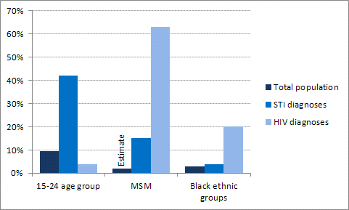

Information on inequalities is included in the sections above where appropriate, but a summary of groups at higher risk is provided below.

* + 1. **Age**

Over 40% of acute STI diagnoses are among those aged 15-24.

However, the needs of adults older than this age group should not be overlooked. Almost one-quarter of abortions in Richmond are to women aged 35 or over, compared to 15% nationally, and this age group accounts for one-quarter of STIs diagnosed at a genito-urinary medicine (GUM) service – these findings reflect the age structure of the local population. In addition, residents aged 55 and over account for 20% of people diagnosed with HIV, reflecting an ageing of the cohort which is also seen nationally.

* + 1. **Lesbian, gay, bisexual and trans people**

Lesbian, gay, bisexual and trans (LGBT) people experience a number of health inequalities and national research indicates that a high proportion of LGBT people have never been tested for STIs2.

Men who have sex with men (MSM) are at a particularly high risk of poor sexual health. MSM account for 63% of people diagnosed with HIV in Richmond and 15% of all STI diagnoses are among MSM. Most diagnoses of syphilis and gonorrhoea are among MSM – Richmond ranks 44 among 326 local authorities in England for syphilis and ranks 57 for gonorrhoea (1 is the highest rate), which is much higher than the overall STI rank of 124.

* + 1. **Ethnicity**

People from black ethnic groups (mainly black African women) account for 20% of all HIV diagnoses in Richmond, whereas black ethnic groups only account for 3% of the total population. In addition, the STI rate among people from black ethnic groups is more than double the overall rate, although numbers are relatively small (46 diagnoses in 2012).

* + 1. **Deprivation**

Higher STI rates are usually seen in more deprived areas at a national level. However, there is no clear pattern within Richmond of higher STI rates in areas that are more deprived, although there is some indication of a higher HIV prevalence in areas that are relatively deprived.

* + 1. **People with disabilities**

People with disabilities have the same sexual health needs as other people and research indicates that they are as sexually active as people without disabilities[15]. They may face barriers that make sexual relationships more difficult, such as cultural prejudice and lack of opportunity[16]. People with disabilities may also face barriers to sexual health information and services, such as lack of physical access and appropriate materials (e.g. easy-to-read leaflets). However, most people with disabilities can benefit from sexual health services designed to reach the general community15.

In particular, people with learning disabilities face specific barriers to sexual health support and may be vulnerable to sexual abuse. The Family Planning Association states that: “Coping with puberty, sexual identity and sexual feelings can be more difficult for people with learning disabilities who might be struggling to understand their emotions and their body[17]”. National research indicates that young people with learning disabilities do not have good access to sex and relationship information or education2.

Limited data is available locally to assess the sexual health needs of people with disabilities.

* + 1. **Homeless people**

Homeless people have a higher risk of poor sexual health and may be vulnerable to sexual abuse, for example if they come under pressure to exchange sex for food and money.

In 2013-14, there were 150 rough sleepers in Richmond borough. The Housing Options and Resettlement teams provide signposting and advice on health promotion, including signposting to sexual health services. (Homelessness JSNA, LBRuT)

* + 1. **Sex workers**

Some sex workers are at higher risk of poor sexual health and may be vulnerable to sexual abuse as well as other issues that may impact on their sexual health needs, such as drug and alcohol problems2. They may experience barriers in accessing sexual health services due to a number of factors, such as stigma and leading chaotic lives. There is limited data available on sex workers within Richmond borough.

* 1. **Sexual health knowledge among young people**

Richmond borough carries out an annual health and wellbeing survey of school-aged children. Over 4,000 young people took part in the 2012 survey. The findings from this survey indicate that levels of sexual health knowledge among secondary school pupils are generally good but could be improved. For example, 58% of pupils said that condoms are a reliable method of preventing infections like HIV or Chlamydia, compared to 54% in a wider national sample of secondary school pupils. The survey findings also indicate that there is variation in knowledge, for example 62% of year 10 girls correctly said that Chlamydia can be treated and cured, compared to 35% of year 10 boys.

* 1. **Local voice**

The opinions of local residents and service users about sexual health services were gathered through three main engagement routes – an annual health and wellbeing survey of school-aged children, peer research projects carried out by Richmond Youth Council on sexual health and on safeguarding young people and user surveys for individual services.

The findings from these engagement routes have been used alongside other information, including information from engagement with local professionals, to inform the commissioning priorities in this strategy.

A summary of the main findings is provided below.

* + 1. **Sex and relationships education**

Around half of young people stated that the education received in school or college was ‘okay’ and around 15% (higher among males) stated that it was poor. In another survey, around one-third of year 10 pupils reported that they could not remember the teaching or did not find it useful. Findings indicate a variable level of knowledge about sexual health among local young people.

* + 1. **Young people’s services**

The importance of knowing that a service is confidential and non-judgemental was raised by young people.

Over half of young people surveyed said that they would like sexual health advice and services to be located at school/college. GP practices were also popular choices, as were youth centres and health centres (especially among females).

56% of year 10 boys and 68% of year 10 girls said that they know where they can get condoms free of charge and 40% of year 10 pupils knew that there is a young person’s sexual health service available locally.

* + 1. **Safeguarding young people**

Young people demonstrated some basic knowledge about safeguarding, but responses indicated that their understanding was limited. Some young people seemed to have an idea of where to go for support on safeguarding issues (e.g. schools), but many did not know where to seek support.

Around 10-20% of young people completing a questionnaire stated that they have friends that have experienced relationship abuse, but it was found that this seemed to be a very ‘normal’ experience in the lives of young people that were interviewed. Young people seemed unaware of where they can get appropriate support relating to relationship abuse.

Very few young people seemed fully aware of the dangers posed online. Some were found to be taking appropriate precautions online but others were not. Very few people said that their parents know what they do online.

* + 1. **Service user satisfaction**

Although service user satisfaction data is limited, the data indicates a generally positive experience. Almost 100% of CASH service users surveyed said they would be happy to use the service again. Overall experience of the BPAS abortion service was rated by service users at an average of over 9 out of 10.

1. **Sexual health services**

Sexual health services cover the provision of advice, prevention, testing and treatment. While individual needs may vary, there are core needs such as accurate, high-quality information and support to enable people to make informed and responsible choices. Sexual health services should be seen as an essential component of the prevention and healthcare services available to local people.

* 1. **National context**
     1. **Principles for service provision**

In order to control infection, prevent outbreaks and reduce unwanted pregnancies, a range of principles have historically been applied to sexual health services.

Services should be:

* **Free of charge –** Important to ensure universal access.
* **Open access –** A referral from a health professional is not required. This can be important for reasons of anonymity but also ensures rapid access to treatment which helps to prevent complications, onward transmission of disease or unplanned pregnancy.
* **Not restricted by age or place of residency –** Some people may choose to travel to services away from their area of residence, perhaps for convenience or for anonymity.
* **Confidential –** Standards of confidentiality over and above other health services are important in addressing stigma associated with poor sexual health and to encourage people to come forward for testing and treatment. People do not need to give their personal details in order to access services – although in practice most people are happy to provide these details.
  + 1. **National ambition**

Department of Health published two key documents in 2013 – ‘A Framework for Sexual Health Improvement in England’2 and ‘Best practice guidance for local authorities’3.

Within the Framework document, the Government outlined its ambition to improve the sexual health and wellbeing of the whole population. In order to support this ambition, the following must be achieved:

* Reduce inequalities and improve sexual health outcomes
* Build an honest and open culture where everyone is able to make informed and responsible choices about relationships and sex
* Recognise that sexual ill health can affect all parts of society – often when it is least expected
  + 1. **Commissioning responsibilities**

Following on from the Health and Social Care Act (2012), commissioning responsibilities for sexual health services are complex. A summary of the main commissioning responsibilities is provided below.

* **Local authorities** – The majority of sexual health services are now commissioned by Public Health within local authorities
* **Clinical Commissioning Groups (CCGs)** – CCGs are responsible for commissioning abortion, sterilisation and vasectomy services
* **NHS England** – NHS England is responsible for commissioning HIV treatment and care, sexual assault referral centres, cervical screening and contraception provided under the core GP contract.

Because of the need to ensure universal provision of these essential services, the commissioning of comprehensive, open-access sexual health services is a mandatory function for local authorities. Under national regulations, local authorities are required to arrange for the provision of:

* Open access sexual health services for everyone present in their area; covering
* Free STI testing and treatment (except HIV treatment), and notification of sexual partners of infected persons; and
* Advice on contraception and preventing unintended pregnancy, and reasonable access to a broad range of free contraception.

It must be noted that the regulations do not cover preventive interventions, such as information provision or education, outreach, youth services and condom distribution schemes and marketing of services3. However, these are essential aspects of sexual health care and are crucial to improve outcomes and protect the health of the local population. In addition, prevention of unintended pregnancies and STIs is highly cost-effective.

* + 1. **Principles of best practice in commissioning**

The Government’s Framework document provides six key principles for commissioning sexual health services which have informed the development of this strategy for Richmond borough. A summary of these principles is provided below.

1. **Prevention is prioritised**

Evidence-based interventions that motivate people to alter their behaviour are commissioned, including in non-health settings.

1. **Leadership and joined-up working**

Commissioners work closely together and with key local partners to ensure that sexual health services are of a high quality and are not fragmented. Health and Wellbeing Boards have a key role in promoting joined-up working.

1. **Focus on outcomes**

Challenging outcomes measures are produced, used to develop plans and monitored over time.

1. **Wider determinants of sexual health are addressed**

Strong links are made with other key determinants of health (e.g. alcohol and drug misuse, smoking, mental health and violence), in order to tackle them in a joined-up way – contributing to a reduction in health inequalities.

1. **Commissioning of high-quality services**

Services are commissioned from high quality providers with appropriately trained staff and are offered in a range of settings, with robust care pathways to ensure a seamless service. Patient feedback is used to ensure that services meet needs.

1. **The needs of more vulnerable groups are met**

Services are able to meet the needs of groups who may be vulnerable and at risk from poor sexual health.

* 1. **Local services**

This section below provides a summary of sexual health services available to local residents and patients. Please refer to the JSNA for a detailed overview of current sexual health services and a review of services against local needs, national policy and evidence of what works to improve sexual health.

Provision of sexual health services is complex and there is a wide range of providers – including community providers, primary care (GP practices and pharmacies), hospitals and the voluntary sector.

Sexual health services include:

* General prevention and awareness raising activities provided through a range of services.
* HIV prevention and support services, delivered mainly via voluntary organisations.
* Provision of contraception through GP practices, community pharmacies, Walk-In Centre and the C-Card Scheme which provides free condoms for young people.
* Community contraceptive and sexual health (CASH) service provided by Hounslow & Richmond Community Healthcare NHS Trust (HRCH), and a family planning service provided by a GP practice. These services focus mainly on contraception provision and advice and are located in Teddington, Whitton and Twickenham.
* Chlamydia screening provided by a number of community, primary care and hospital services, online and through a range of outreach settings managed by Terrence Higgins Trust.
* Genito-urinary medicine (GUM) services in hospitals, mainly for the testing and treatment of STIs. There is no GUM service provided within Richmond borough as these are usually based at hospitals. The services most used by Richmond residents are located at West Middlesex and Kingston Hospitals.
* Chlamydia treatment will also be available for young people through the Walk-In Centre in Teddington and some community pharmacies during 2014-15.
* Abortion services provided by British Pregnancy Advisory Service (BPAS) and hospitals.
* Sterilisation services provided through hospitals and a vasectomy clinic at a GP practice.

Sexual health services account for £2.4 million of the Public Health budget and for over £250,000 of the CCG budget. GUM services account for the largest part of this spend at around £1.7 million per year. The other main areas of spend are CASH, abortion services, Chlamydia screening and contraception provided by GP practices.

A diagram of the main sexual health services is provided below, with some indication of activity levels. Please note that activity numbers are provided for Richmond residents and/or patients only wherever possible, but activity data for some services does include out-of-area residents (e.g. CASH, C-card scheme).



A map of the CASH service locations, family planning service at Park Road Surgery and GUM services most used by local residents, along with an indication of activity numbers, is provided below.

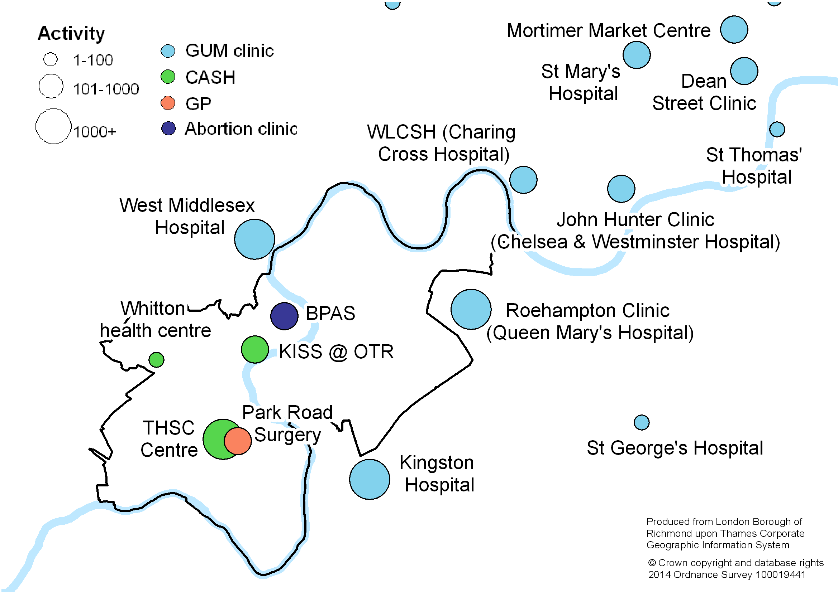

1. **Outcomes**

It is intended that this strategy will support achievement of the following high-level outcomes:

* Reduce the number of unintended pregnancies, particularly among young people
* Reduce the number of people affected by STIs and HIV
* Reduce inequalities in sexual health

1. **Commissioning priorities**

There are three commissioning priorities within this strategy. These priorities are presented in the following sections, along with a rationale for their inclusion and key objectives to achieving each priority. Next steps are outlined under each objective – a detailed implementation plan will be developed to take these forward.

|  |
| --- |
| **Commissioning Priority 1**  **Increase the focus on prevention and sexual health promotion**   * Increase sexual health knowledge and resilience among young people * Improve awareness of sexual health services * Ensure provision of free contraception from a range of services * Increase the uptake of long-acting reversible contraception * Increase the prevention role of services outside of sexual health settings |

|  |
| --- |
| **Commissioning Priority 2**  **Strengthen community-based sexual health services**   * Increase the provision of sexual health services in community settings * Ensure that sexual health services are embedded within core health services * Align the commissioning of sexual health services provided in community and primary care settings |

|  |
| --- |
| **Commissioning Priority 3**  **Commission high-quality services**   * Ensure that services are delivered at accessible locations and times * Consider alternative methods of service delivery, including online services and self-testing * Ensure that services meet the needs of people from high-risk groups * Ensure that robust clinical governance and safeguarding arrangements are in place * Ensure comprehensive, evidence-based management of STIs, including partner notification * Ensure that all professionals are appropriately trained, including those working outside of sexual health settings |

* 1. **Increase the focus on prevention and sexual health promotion**

Prioritising prevention is one of the six key principles outlined in Department of Health’s ‘Framework for Sexual Health Improvement in England’. Age-appropriate information and support are required to help people make informed and responsible decisions. Accurate, high quality information needs to be available in combination with evidence-based preventative interventions that focus on behaviour change – including in non-health settings.

In order to improve sexual health outcomes, the Framework document also made it clear that building an open and honest culture around sexual health was crucial in enabling everyone to make informed and responsible choices.

Prevention of unintended pregnancies and STIs is highly cost-effective. For example, for every £1 spent on contraception, £11 is saved in other healthcare costs[18]. Further investment in prevention is necessary in order to achieve long-term savings.

* + 1. **Increase sexual health knowledge and resilience among young people**

|  |
| --- |
| **Next steps**   * Consider options to improve sexual health promotion initiatives for young people as part of a planned review of the existing programme of initiatives to support prevention of risky behaviour. * Encourage greater engagement of schools and youth services in sexual health promotion, as part of the wider programme of initiatives to support prevention of risky behaviour. * Support improvements in sex and relationship education within PSHE through collaborative working with partners, including the school nursing service and sexual health services. * Consider reviewing the questions relating to sexual health in the annual health and wellbeing survey of school-aged children, to provide a greater understanding of the needs of young people with respect to sexual health matters. |

For young people, evidence suggests that effective prevention work should include a comprehensive programme of sex and relationships education. The Chief Medical Officer’s report in 2011 recommended that this should be strengthened in order to ensure that young people acquire appropriate knowledge before their first sexual experience.

However, a recent national report by Ofsted stated that Personal, Social, Health and Economic (PSHE) education was ‘not yet good enough’ in over a third of schools, particularly with respect to sex and relationships education. The report pointed out that, without age-appropriate education during primary and secondary ages, some young people might be left vulnerable in dealing with risky situations.

Improving sex and relationships education was identified as a priority within a recent review of school health services in Richmond. Within a research study carried out by the Richmond Youth Council, around half of young people stated that the education received in school or college was ‘okay’ and around 15% (higher among males) stated that it was poor. In a local school survey, around one-third of year 10 pupils reported that they could not remember the teaching or did not find it useful. Findings from the school survey also indicated a variable level of knowledge about sexual health among local young people.

Schools settings play an important role in prevention and sexual health promotion. Ongoing engagement with headteachers and school nurses with respect to the sexual health agenda is important – including engagement with free schools, academies and independent schools in the borough. This can build on wider work with schools to improve resilience, self-esteem and communication skills among children and young people. Most sexual health services and the local school nursing service are now commissioned by Public Health, which provides an opportunity to further strengthen the links between these services.

Community and youth settings can also play a key role in sexual health promotion. For example, information on and provision of condoms was by far the most common reason for attendance at the young people’s drop-in information service at Off The Record in 2013-14, with almost 500 attendances.

Options to improve sexual health promotion initiatives should be considered as part of a review of the existing programme of prevention of risky behaviour initiatives for young people. The establishment of Achieving for Children in 2013, a joint children’s service between Richmond and Kingston boroughs, offers an opportunity to share learning between the boroughs.

* + 1. **Improve awareness of sexual health services**

|  |
| --- |
| **Next steps**   * Review the marketing of sexual health services to members of the public, including learning from other areas. * Consider how awareness of local sexual health services can be improved among professionals working outside of sexual health settings (e.g. GPs and youth workers), so that they can signpost people to appropriate services. |

In order to ensure good access to a choice of services, provision of sexual health services is complex and there is a wide range of providers – including community services, primary care services, hospitals and the voluntary sector. Due to this complexity, it may not always be clear to residents what the best options are to access services.

In a recent school survey, 56% of year 10 boys and 68% of year 10 girls said that they know where they can get condoms free of charge and 40% of year 10 pupils knew that there is a young person’s sexual health service available locally. Although these figures are promising, there is substantial room for improvement.

Information on sexual health services is available on two websites that are jointly commissioned across South West London – ‘SWISH’ for adults[19] and ‘Getting It On’ for young people[20]. Over 3,000 people visited the Richmond page of the SWISH website in 2013-14. Use of the ‘Getting It On’ website has increased substantially since it started, and there were over 15,000 visits to the Richmond pages last year. A number of key services are signposted on these websites. However, the SWISH website does not include pharmacy services and neither website includes specialist services provided by GP practices.

The CASH service also has a website and leaflet for its services and signposts to some other sexual health services. Local GUM services also have their own websites.

In a recent survey, a number of community pharmacies stated that more publicity is required for Chlamydia screening and EHC services. Most respondents considered posters and leaflets to be the most successful promotional methods for sexual health enhanced services, but SWISH, Getting It On and pharmacy websites were also mentioned. In a recent survey of GP practices, most respondents considered flagging systems during consultations and promotion of services in waiting rooms to be the most successful methods with regards to uptake of sexual health enhanced services.

Learning from promotional methods in other areas will be helpful in ensuring that Richmond residents understand the local service options. In addition, it is important to consider how awareness of local services can be improved among professionals working outside of sexual health settings (e.g. GPs and youth workers), so that they can signpost people to appropriate services.

* + 1. **Ensure provision of free contraception from a range of services**

|  |
| --- |
| **Next steps**   * Continue to commission free contraception from a range of local services. * Encourage new services and locations to become outlets for the C-Card scheme. * Review the eligibility criteria for the C-Card scheme, including learning from other areas that have already expanded the criteria. * Encourage more community pharmacies to provide free EHC. |

Free contraception is available from a range of local services, which offers local people choice and good access.

NICE guidance on contraceptive services recommends that free condoms should be available and readily accessible for young people under the age of 25. In line with this guidance, Richmond borough is part of the C-Card scheme in London which provides access to free condoms for young people. This is a good example of a preventative service that is provided in a range of settings, including non-health settings. A total of 19 outlets are currently available in Richmond borough, including Richmond College, youth clubs and Off The Record (a voluntary sector service that provides support and counselling for young people). Youth offending and hostel teams have also been recently trained to distribute free condoms through the scheme. Almost 10,000 free condoms were distributed during 2012-13 – the majority at Richmond College and Off The Record. Consideration should be given to options to further expand this scheme, with regards to locations and eligibility.

In addition to regular methods of contraception, emergency contraception can help to prevent unwanted pregnancy when regular methods have failed or have not been used. This includes emergency hormonal contraception (EHC – known as the ‘morning after pill’) and IUDs. Emergency contraception is more effective the earlier it is used after unprotected sex and should therefore be available easily and from a range of settings2. NICE guidance on contraceptive services recommends that there should be local arrangements in place to ensure that young women can easily obtain free oral emergency contraception[21]. In addition to free provision of EHC at GUM, CASH, GP practices and the walk-in centre, free EHC is available for under-25s within community pharmacies to help increase accessibility. During 2013-14, a total of 321 young women received free EHC through pharmacies. However, only a small number of pharmacies provide this service and activity is mainly concentrated around Twickenham and Teddington (see map in section 5.3.1).

* + 1. **Increase the uptake of long-acting reversible contraception**

|  |
| --- |
| **Next steps**   * Consider ways to increase knowledge and awareness about LARC, especially among young people. * Work with GP practices that do not provide LARC services to raise awareness about services available and ensure that patients are signposted. * Include a greater focus on LARC within the CASH service specification when re-procuring this service. * Public Health and CCG to work with abortion service providers to review their role in providing LARC, including evaluation of the BPAS telephone contraceptive counselling service. |

Condoms and the oral contraceptive pill are the most popular methods of contraception in England. Although condoms should always be used to protect against STIs, long-acting reversible contraception (LARC) methods have been found to be much more effective at preventing pregnancy[22] even after only one year of use[23], and also more cost-effective21. LARC includes contraceptive injections, implants, intra-uterine system (IUS) and intrauterine device (IUD). Awareness and acceptability of LARC methods is increasing, resulting in an increase in use.

Increasing numbers of GP practices are providing LARC services. Specialist LARC services are provided at a number of GP practices in Richmond and GP practices that do not provide LARC services can refer patients to other practices. A total of 21 practices provide IUD insertion with 790 patients seen during 2013-14, and 18 practices provide contraceptive implants with 244 patients seen. GP practices are also giving information about LARC methods to over 90% of women prescribed oral and patch contraceptive methods – slightly higher than in London and England. However, although these numbers are positive, the vast majority of women visiting GP practices for contraception are still using non-LARC methods. Almost 12,000 women were prescribed oral and patch contraceptive methods at GP practices during 2012-13.

Based on data from CASH services in England, LARC is now used by 30% of female attendees as their primary method of contraception (2012-13), up from 18% in 2003-04. The uptake of LARC in Richmond’s CASH service is 21.6% (2013-14), compared to 28% in London and 30% in England (2012-13). This is relatively low compared to some other local areas – over 30 CASH services in the country have LARC rates of over 40%. Local uptake of LARC is highest among older age groups. Women aged 35 and over account for 17% of total attendances for contraception but account for 37% of attendances for LARC. A greater focus on LARC must be considered as part of re-commissioning plans for this service.

Evidence suggests that contraception (particularly LARC) provided by abortion services can reduce repeat abortions2. During 2013-14, 125 women (30%) using the BPAS service received a LARC method of contraception. Data from the contraceptive counselling service provided by BPAS indicates that telephone advice can lead to a stated intention to use LARC.

* + 1. **Increase the prevention role of services outside of sexual health settings**

|  |
| --- |
| **Next steps**   * Encourage new non-health services to become outlets for the C-Card scheme. * Collaborate with partners to identify opportunities for joint working with other risky behaviour prevention services and learn from other areas, especially regarding links between sexual health and substance misuse. |

Prevention and sexual health promotion initiatives are already carried out within a range of non-sexual health services. For example, the C-Card scheme in Richmond College and Off The Record, and youth offending and hostel teams have also recently been trained on the scheme. As well as strengthening these links, the prevention role of other services should be increased. This is particularly important for other risky behaviour services, such as substance misuse services. Commissioners should jointly consider ways to increase the role of sexual health services in opportunistic identification, brief interventions and signposting for service users with potential substance misuse issues.

* 1. **Strengthen community-based sexual health services**

Community services have historically focused on prevention and contraception, whilst GUM services in hospitals have focused on management of complex contraceptive problems, STI testing and treatment. National policy is to move towards a more integrated model of service delivery, to allow easy access to a range of services that can meet the majority of sexual health and contraceptive needs[24]. Sexual health services are increasingly being provided outside of GUM services and in primary care and community settings. This is particularly important for Richmond because there is no GUM service located within the borough.

As well as improving access, introducing more sexual health services where appropriate into primary care and community settings may be more cost-effective in the long-term due to the relatively high cost of attendances at GUM services and the year-on-year increase in activity. This will also allow GUM providers to focus specialist resources on patients with more complex needs.

* + 1. **Increase the provision of sexual health services in community settings**

|  |
| --- |
| **Next steps**   * Consider introducing more widespread STI and HIV screening in community settings. * Include a greater focus on Chlamydia screening within the CASH service specification when re-procuring this service. * Evaluate the new community locations for Chlamydia treatment. * Public Health and CCG to work with BPAS to evaluate the STI and HIV screening aspect of the service |

Recent developments in diagnostic tests have resulted in greater access outside of hospital settings to STI and HIV screening for people who are not experiencing any symptoms. CASH services in some other local areas, including Hounslow, are commissioned to provide STI and HIV screening for people without symptoms as part of a routine sexual health check-up. The CASH service in Richmond is not currently commissioned to provide HIV screening. Introducing more widespread screening may help to increase the normalisation and de-stigmatisation of STI and HIV testing. Evidence suggests that offering rapid HIV tests within community settings can increase the uptake of testing among MSM, and this should be considered as part of the development of community services.

Currently, the CASH service located within Richmond borough is only commissioned to offer Chlamydia and Gonorrhoea screens for young people as part of the National Chlamydia Screening Programme (NCSP). The proportion of total screens achieved through CASH is low at 5% compared to 15% nationally and over 20% in a number of other London boroughs.

BPAS is currently commissioned to offer screens for Chlamydia, Gonorrhoea and HIV and up to two-thirds of offers are accepted.

In addition to expanding screening, national guidance recommends that young people should be given a choice of treatment locations as part of the NCSP. Currently, anyone testing positive for Chlamydia is referred to GUM for treatment. During 2014, Chlamydia treatment will be introduced in the Walk-In Centre in Teddington and in selected community pharmacies so that there is a choice of locations within the borough.

* + 1. **Ensure that sexual health services are embedded within core health services**

|  |
| --- |
| **Next steps**   * Encourage more GP practices and especially community pharmacies to offer Chlamydia screening to young people. * Public Health and CCG to work collaboratively with GP practice colleagues, SWAGNET and NHS England to explore how GPs can be supported to offer HIV tests as part of routine care, in line with NICE guidance. * Public Health and CCG to work collaboratively to explore options for introducing more widespread HIV testing programmes, including using learning from the HIV testing pilot in GP practices. |

Further embedding sexual health services into core healthcare services will help to improve access within the borough, increase cost-effectiveness and support normalisation and de-stigmatisation. Core healthcare services include GP practices, community pharmacies and hospitals.

**Contraception**

GP practices and community pharmacies are key local providers of sexual health care. GP practices are the most frequently chosen first point of contact for those with sexual health concerns and are the largest provider of sexual health services, particularly the provision of contraception as part of their core contract. Increasing numbers of GP practices are providing more specialist sexual health services, such as IUD insertion and contraceptive implants.

Services provided at community pharmacies also help to ensure good access due to their high street location, long opening hours and non-medical setting. A number of community pharmacists are offering emergency contraception and condoms as part of the C-Card scheme.

Next steps relating to contraception services in GP practices and community pharmacies are included in previous sections of the strategy.

**Chlamydia screening**

As part of national efforts to make every contact count, routine healthcare consultations provide an opportunity to offer STI screening – which can also be a cost-effective use of resources. This is particularly important for Chlamydia as it is the most prevalent STI in England (particularly among young adults), most people do not experience any symptoms and it can result in long-term health problems if left untreated. The NCSP seeks to address this issue by regularly testing sexually active under-25s who do not have any symptoms as a routine part of primary care and sexual health consultations.

GP practices account for 18% of screens in Richmond which is similar to England, but a number of other boroughs are achieving over 25%.

Screens carried out in pharmacies account for less than 2% of all screens in Richmond, similar to the national rate. Young people who request EHC in community pharmacies should be offered a Chlamydia screen but, in practice, this is done variably. During 2013-14, 27% of young women who requested EHC at pharmacies took up the offer of a Chlamydia screen, but this was as high as 76% in one pharmacy. This indicates potential for improvement.

**HIV testing**

Once people have a diagnosis of HIV, they can access effective treatment, experience improved health outcomes and are significantly less likely to pass on the infection to other people.

Universal testing is recommended in GUM, antenatal, abortion and substance misuse treatment services. Expanding testing to other health services can help to increase access.

As part of routine clinical practice, it is recommended that GP practices offer HIV tests to patients presenting with a number of clinical conditions, patients who are considered to be at an increased risk of HIV (including MSM) or when requested by patients. The extent to which tests are being offered as part of routine clinical practice in Richmond is not clear. Options to increase awareness and share good practice should be considered, in partnership with NHS England. SWAGNET will be carrying out a sexual health training needs assessment among GP practices during 2014, which will be helpful in giving us a better understanding of how GPs and primary care can be supported to offer HIV tests as part of routine care.

Richmond is now officially classed as a ‘high prevalence’ area for HIV. National guidance recommends that local areas above a HIV prevalence of 2 per 1,000 should consider introducing widespread HIV testing policies, which are thought to be cost-effective. Although Richmond has been just below this threshold for some time, it has exceeded the threshold for the last two years and commissioners (local authority and CCG) should consider options for introducing HIV testing. More widespread HIV testing will result in a reduction in the number of people unaware of their HIV infection and a reduction in the number of people with a late diagnosis.

Widespread HIV testing policies include offering a test routinely to everyone attending hospitals for general medical admissions and to everyone registering as a new patient with a GP practice. Using national modelling work, it has been estimated that HIV testing of 75% of general medical admissions would cost around £38,000 for Richmond per year (CCG responsibility), and that testing of 75% of new GP registrations would cost over £100,000 for Richmond (local authority responsibility). However, these would be new services and uptake may not be as high as 75% initially. Options for offering HIV tests in Kingston Hospital are currently being explored. Learning from other areas that have already implemented similar programmes will be important.

Findings from a number of pilot projects on increasing HIV testing outside of sexual health settings indicates that offering a HIV test is feasible and acceptable to both patients and staff2. An HIV testing pilot carried out in two Richmond GP practices also found that encouraging patients to test was not found to be a challenge. Learning from this pilot should be used in development of a local HIV testing programme.

* + 1. **Align the commissioning of sexual health services provided in community and primary care settings**

|  |
| --- |
| **Next steps**   * Consider options to align the commissioning of sexual health services provided in community and primary care settings as part of the re-procurement of services. * Work with colleagues across London to further analyse the concept of an integrated tariff for sexual health services. |

It is crucial to continue to commission a wide range of services in primary care and community settings in order to ensure good access. However, it can be complex to market the services to residents and there are fragmented contracting arrangements. Although individual services work towards achieving good outcomes for service users and there is communication between the services, there is no overall focus on working towards improving outcomes across the system.

Because Richmond does not have a GUM service located within the borough, it is difficult to align all sexual health services. However, options to align sexual health services provided in community and primary care settings should be considered as part of the re-procurement of services. This will help to ensure clear marketing of the options available, clear care pathways between services, a greater focus on working towards shared outcomes and less fragmented contracting arrangements. If sexual health services are aligned, it may also be easier to work more closely with related services, such as school nursing and substance misuse.

The idea of developing a tariff to cover both GUM and CASH services has been explored in London over a number of years. This would provide equal payment for activity at similar levels of complexity across all services, with the aim of obtaining transparency, better value for money and further integration of sexual health services. A draft tariff was developed in London but this was halted with the NHS reforms in 2013. However, recent discussions have resulted in a commitment across many boroughs to refresh the analysis of data collected from services and to learn from other regions that have already introduced a sexual health tariff. Richmond will participate in London-wide work to further analyse the concept of an integrated tariff.

* 1. **Commission high-quality services**

Sexual health services must be delivered in ways that increase access and address the needs of the local population. It is also essential that robust clinical governance and safeguarding arrangements are in place to ensure that service users receive safe, high-quality sexual health services provided by appropriately trained staff.

* + 1. **Ensure that services are delivered at accessible locations and times**

|  |
| --- |
| **Next steps**   * Review locations and opening times when developing service specifications as part of re-procurement of community-based services. * Encourage more community pharmacies to provide sexual health services, particularly on the eastern side of the borough. |

In order for people to be able to readily access services, it is important to provide a choice of services in different locations and settings, with a range of opening days and times. The location of services needs to be considered in terms of accessibility by public transport, appropriateness of venue for a clinical service and reducing the potential stigma associated with attending sexual health services.

There is no GUM service located within Richmond borough – the services most used by Richmond residents are located at West Middlesex and Kingston Hospitals. These services are open at a range of times throughout the week but not at weekends.

The Walk-in Centre in Teddington provides EHC for free and is open on seven days per week from 8am until 9/10pm.

CASH services are provided mainly on a walk-in basis in Teddington, Whitton Corner and Twickenham (a young person’s service). The family planning service provided by Park Road Surgery is also located in Teddington. The general walk-in service is available on three evenings per week, with the young person’s service on one late afternoon per week and a specialist LARC clinic on one morning per week. The Park Road clinic runs on a Monday evening, which offers good access after weekends. There is currently no CASH or family planning service on Fridays or at weekends. There is also no CASH service located on the eastern (Richmond) side of the borough – attendance data shown in the map below indicates that the services are used more by people living on the western side of the borough.

**Map of CASH attendances by postcode of residence**

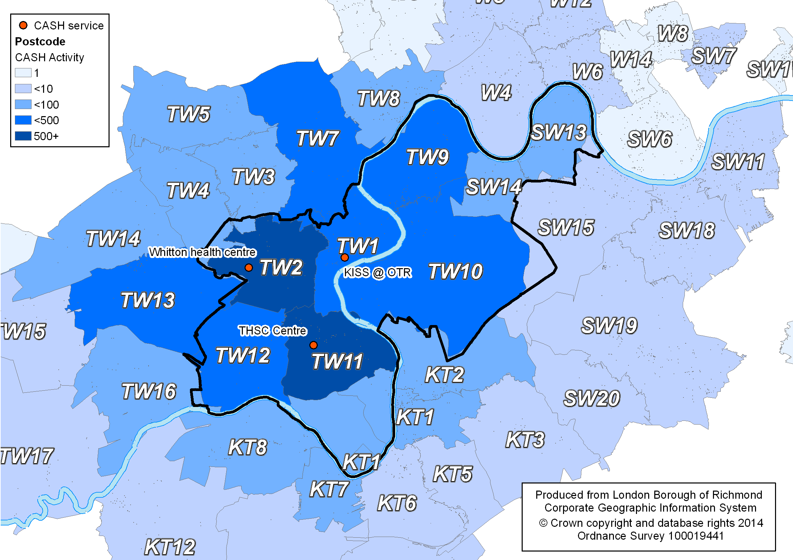

Almost all GP practices provide at least one of the sexual health Locally Commissioned Services and there are a number that provide all three services – which are quite evenly spread across the borough.

**Map of GP practices by provision of sexual health enhanced services**

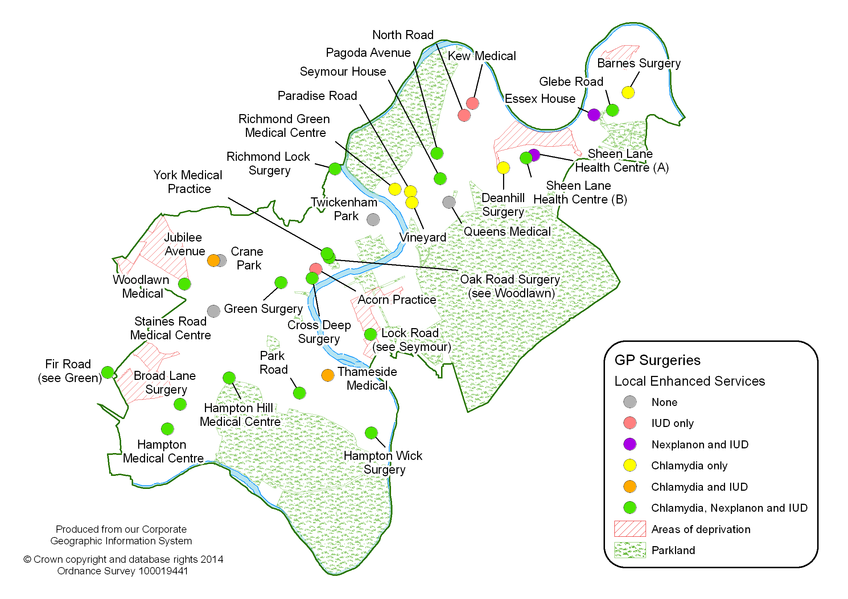

However, there are smaller numbers of community pharmacies that provide sexual health Locally Commissioned Services and provision is patchy in some areas, especially on the eastern side of the borough.

**Map of community pharmacies by provision of sexual health enhanced services**

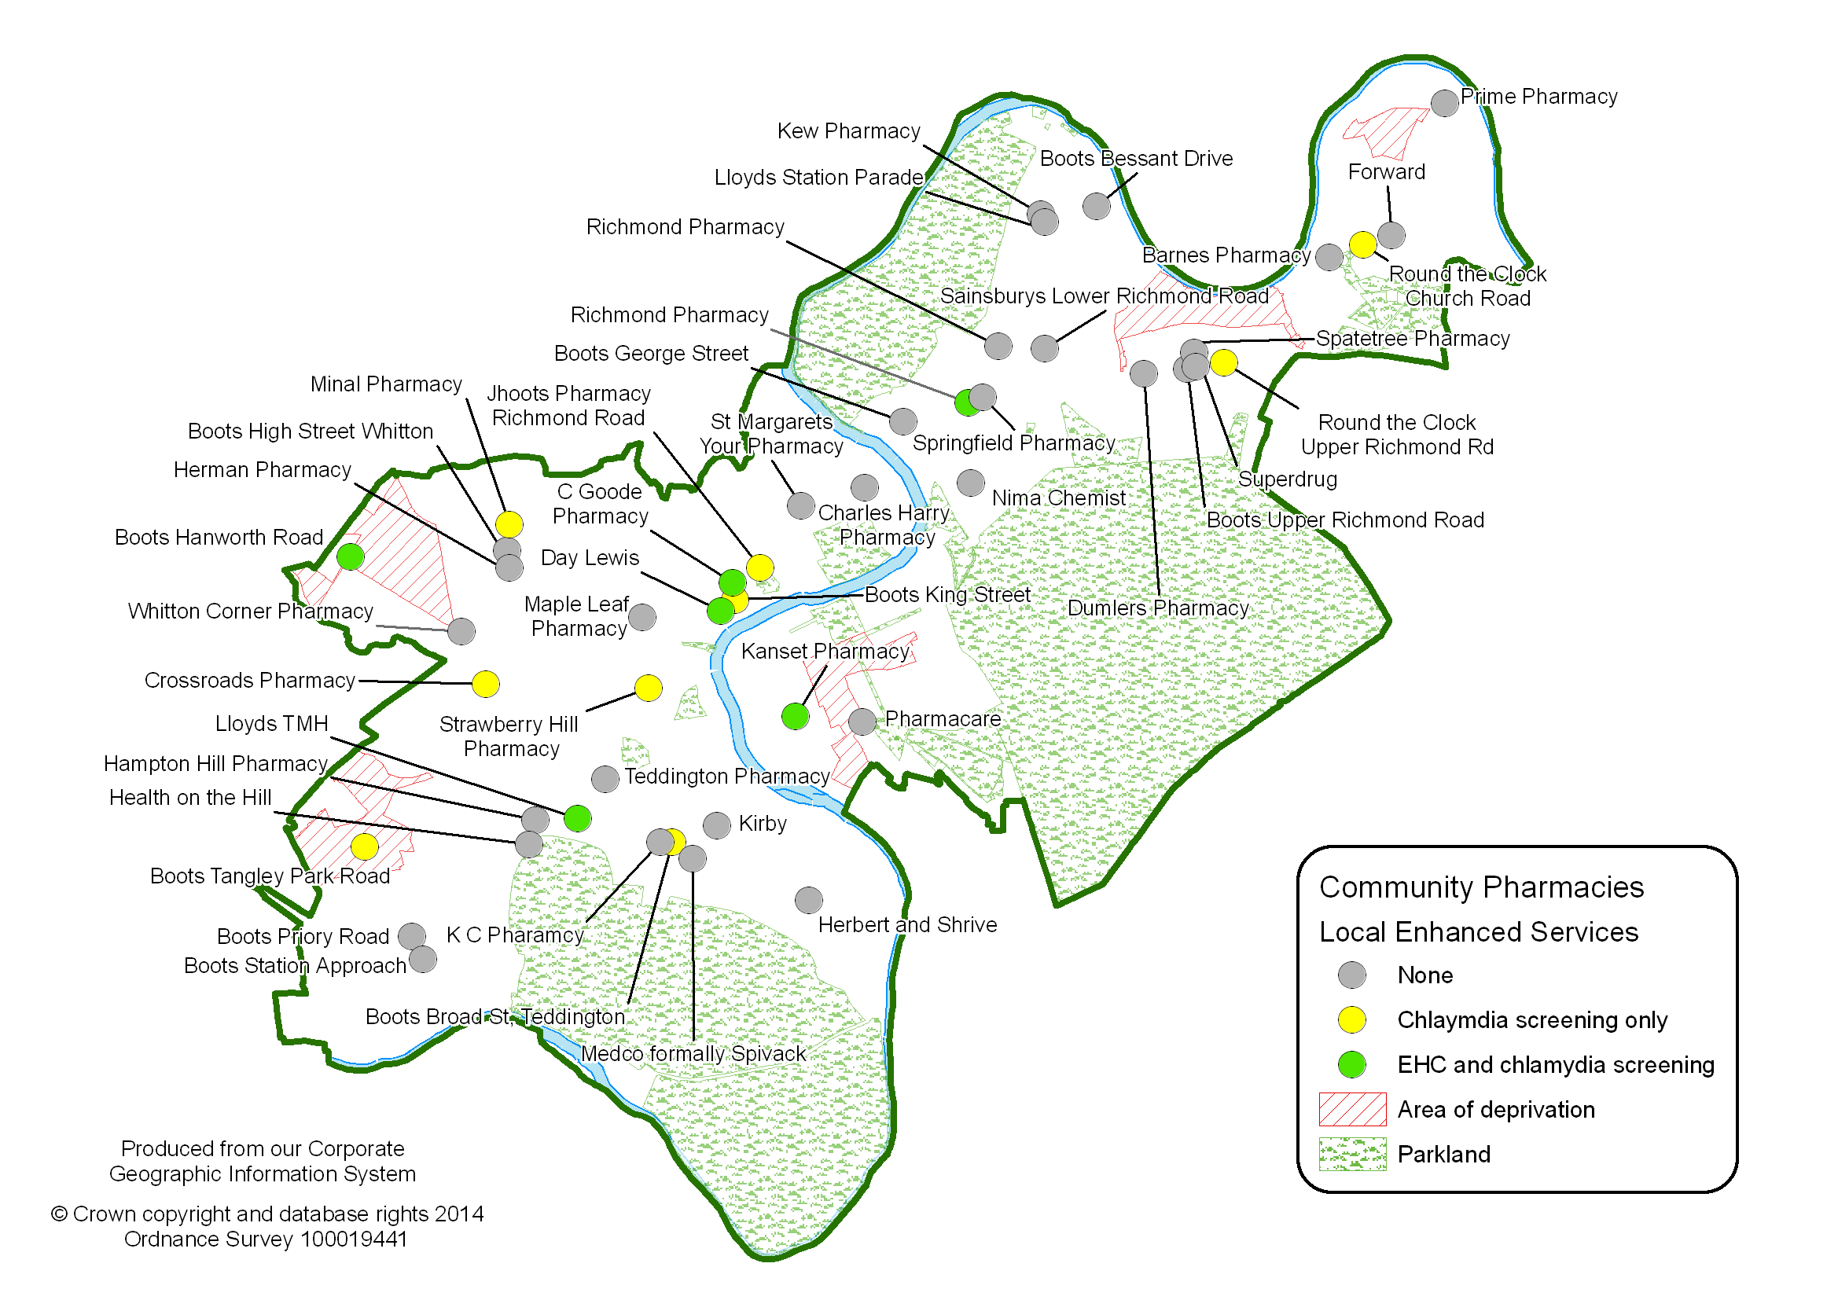

The map below also indicates that provision of EHC is concentrated around Twickenham and Teddington. Although it is difficult to draw robust conclusions, initial analysis of data for EHC and Chlamydia screening indicates that the services are used more by people living on the western side of the borough. More pharmacies should be encouraged to provide sexual health services, to increase access across the borough – particularly at weekends when there is limited provision through other services.

**Map of community pharmacies by EHC activity**

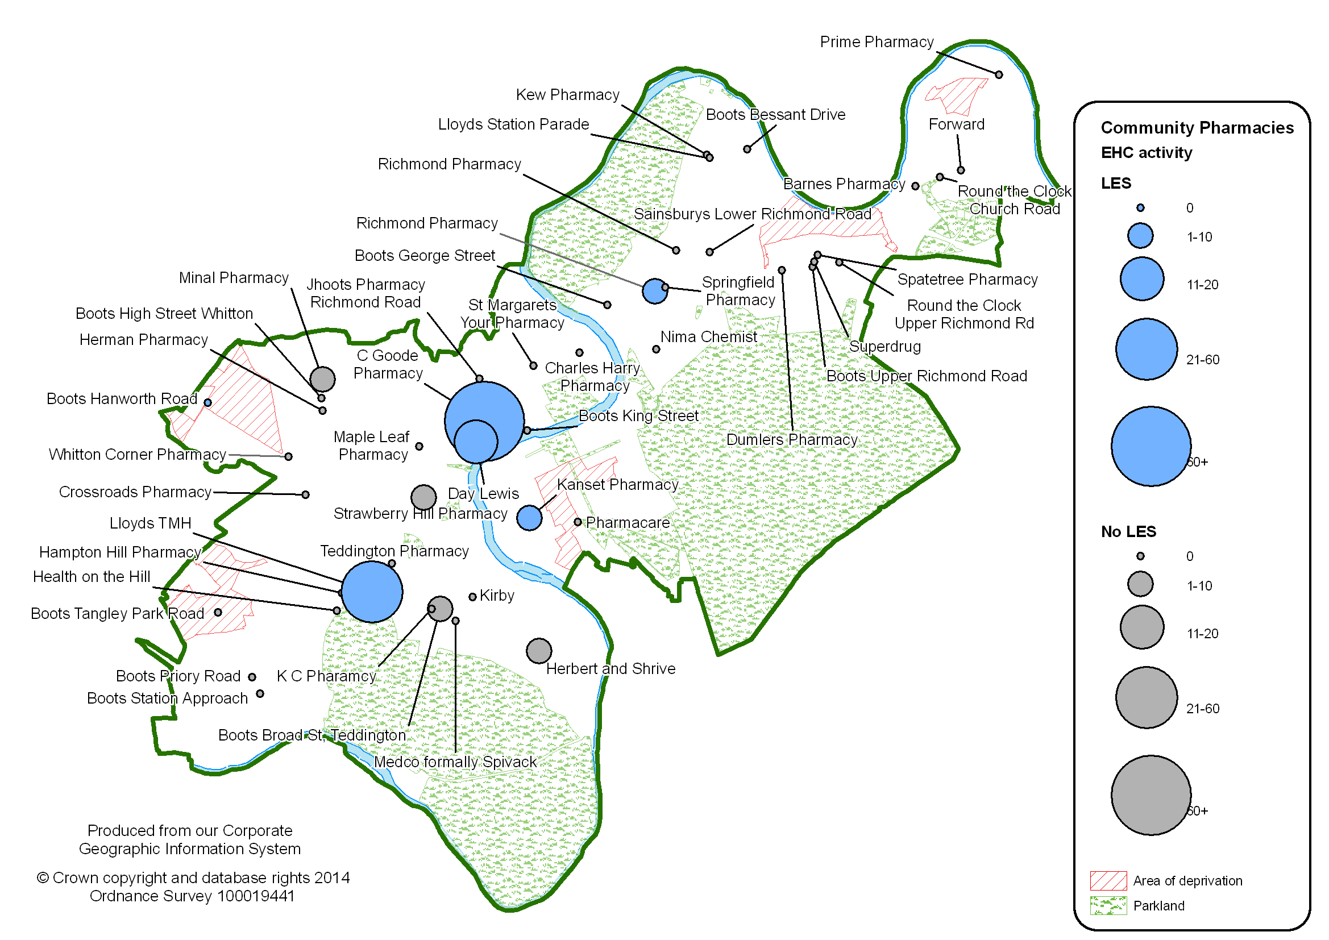

* + 1. **Consider alternative methods of service delivery, including online services and self-testing**

|  |
| --- |
| **Next steps**   * Consider introducing self-testing services for STIs and HIV within the community for people without any symptoms. * Consider options for expanding online STI and HIV screening, using learning from other areas and from the ‘freetest.me’ website for Chlamydia screening. * Explore the use of technological innovations to support sexual health prevention and marketing of local services. |

Sexual health services must be delivered in ways that increase access and address the needs of the local population. Alternative ways to deliver a modern service should be considered, especially considering the age profile of sexual health service users. This may include an increased use of self-testing services (in person or online), smartphone apps and phone consultations. These options can be important for increasing access among young people as well as adults who have busy lives, and can also help to deliver services at a lower cost.

Self-testing is available at some GUM services, including at Kingston GUM service through its ‘U-Test’ service. This is for people who do not have any symptoms and is led by sexual health technicians. The service involves self-taken samples (e.g. urine sample) and a blood test. Negative results are sent to patients by text message and patients with positive results are followed up over the phone. About 5% of people attending the Kingston GUM service use only the ‘U-Test’ service.

Self-testing for Chlamydia is already available online as part of the NCSP through the ‘Freetest.me’ website. Young people in Richmond can order free screening kits online, have them delivered to home and then return by post the completed screening kit. Results can be provided in a number of ways and anyone receiving a positive result is followed up by Terrence Higgins Trust. A total of 345 screens were carried out during 2012 through this website, which accounts for around 8% of all screens. Use of this service has increased by one-third in the last year and further growth should be encouraged. There have been no invalid screens through this service, which indicates that the screening kits are being used properly.

Online self-testing for other STIs (including HIV) is being introduced in other local authorities. For example, adult residents in Greenwich can order free self-testing kits online for HIV, Chlamydia, Gonorrhoea, Syphilis and Hepatitis B and C. This takes the form of a fingerprick blood test and clear instructions are provided online. Results are provided by text or over the phone. However, this is a relatively recent development and it will be important to learn from areas that have piloted these services.

Richmond is part of the C-card scheme in London which provides free condoms to young people. A smartphone app is currently being developed to signpost young people to venues that provide the scheme.

Telephone consultations are used to deliver counselling on contraceptive use for women who have contacted BPAS to access their abortion service. Although this contraceptive counselling service is relatively small, data indicates that most women contacting the service have been using either no contraception or condoms, whereas after the counselling most women state that they intend to use LARC.

* + 1. **Ensure that services meet the needs of people from high-risk groups**

|  |
| --- |
| **Next steps**   * Carry out an audit of relevant local services against ‘You’re Welcome’ criteria. * Work with partners to review HIV prevention services and ensure that they meet the needs of the local population. * Conduct further detailed projects to assess how local sexual health services can better meet the needs of people from high-risk groups. |

It is important to ensure that there is universal access to sexual health services across the whole borough. However, universal services must be able to support the specific needs of high-risk groups. This includes young people, people from black ethnic groups, LGBT people, people with disabilities, homeless people and sex workers.

Further detailed work is needed to more fully understand how the needs of particular groups are being met by current services and how services can be improved.

**Young people**

The Department of Health has developed quality criteria for young people friendly health services, known as ‘You’re Welcome’. Research carried out among local young people confirmed the importance of key aspects included within the You’re Welcome criteria, such as confidentiality of services. An audit of local services should be carried out to assess which services meet the criteria and where improvements are required.

**People from black ethnic groups**

The HIV prevention programmes commissioned by the borough work closely with Black African communities. The programmes in South West London and South London are being reviewed during 2014-15 to ensure that services are meeting the needs of the populations of all participating boroughs. Detailed work is also required to assess the extent to which sexual health services meet the needs of people from black ethnic groups.

**LGBT people**

Aspects of the HIV prevention programmes commissioned by the borough work closely with MSM as a high-risk group, particularly the London-wide programme, but the focus of the south West London HIV Prevention Programme is primarily on working with Black African communities. The programmes in South West London and South London are being reviewed during 2014-15 to ensure that services are meeting the needs of the populations of all participating boroughs – this is particularly important for Richmond as MSM account for almost two-thirds of people diagnosed with HIV. Detailed work is also required to assess the extent to which sexual health services meet the needs of LGBT people.

**People with disabilities**

Detailed work is required to assess the extent to which current sexual health services meet the needs of people with disabilities and how services can be improved. Practical steps such as easy-to-read leaflets and introducing appointment slots into walk-in services may be helpful. National guidelines and examples of best practice should be used to inform any service developments – for example, the Royal College of Nursing has developed on online learning resource about how services can support the sexual health needs of people with learning disabilities[25]. Learning from other areas will also be helpful – for example, Kingston has recently introduced a monthly sexual health clinic specifically for young people with learning disabilities.

**Other high-risk groups**

Further detailed work is needed to assess how local sexual health services can better meet the needs of other high-risk groups, such as homeless people and sex workers.

* + 1. **Ensure that robust clinical governance and safeguarding arrangements are in place**

|  |
| --- |
| **Next steps**   * Update clinical governance arrangements for sexual health services and review the quality indicators included in service specifications. * Review the PGD policy relating to community pharmacy services. * Update safeguarding arrangements for sexual health services and ensure that robust referral pathways to support services and appropriate information sharing protocols are in place for safeguarding issues. * Promote information and guidance on safeguarding issues such as online safety and relationship abuse (e.g. relevant sections on the Getting It On website) among young people and key professionals such as school nurses. |

It is essential that robust clinical governance and safeguarding arrangements are in place to ensure that service users receive safe, high-quality sexual health services2. Public Health is supported by the CCG and the Clinical Lead for sexual health to ensure that clinical governance processes are robust in all sexual health services. Clinical governance arrangements for sexual health services should be updated and clarified within service specifications as part of re-procurement processes.

A number of community pharmacies provide free EHC for young women and some will begin to offer Chlamydia treatment as part of the NCSP during 2014. As these are walk-in services, Patient Group Directions (PGDs) are required to provide the legal framework for community pharmacists to supply this medication without a prescription. Public Health developed a PGD policy soon after the transfer to the local authority, which outlines how PGDs are developed, approved and implemented. This policy was developed to manage the transitional period and should be reviewed in light of NICE guidance.

Professionals working in sexual health services are well placed to identify issues of safeguarding such as sexual and relationship abuse, female genital mutilation (FGM) and child sexual exploitation (CSE). For example, research suggests an association between domestic violence and abortions2.

As sexual health service specifications are updated during re-procurement processes, safeguarding arrangements must be updated to ensure that they adhere to the latest guidance and policies for both children and adults, including guidance and local protocols on FGM and CSE. Commissioners should ensure that robust guidelines, referral pathways to support services and appropriate information sharing protocols (e.g. with police) are in place for safeguarding issues2, [26]. For example, referral pathways should be in place from abortion services to substance misuse services, mental health services and support services for domestic and sexual violence2.

In a peer research project about safeguarding young people carried out by Richmond Youth Council, young people seemed unaware of where they can get appropriate support, particularly regarding relationship abuse, and many did not take appropriate precautions online. Information on these topics is available on the Getting It On website, but young people may not be aware of the site or may only use it when seeking information about sexual health services.

* + 1. **Ensure comprehensive, evidence-based management of STIs, including partner notification**

|  |
| --- |
| **Next steps**   * Include specific, up-to-date reference to national standards on management of STIs when developing service specifications, as appropriate. * Encourage GP practices to carry out Chlamydia screens using the NCSP route, to ensure consistency in the management of young people testing positive. * Consider how professionals carrying out Chlamydia screening in core health services can be supported in the longer term to take on responsibility for the management of results, including partner notification. * Consider how partner notification will be carried out when developing STI and HIV screening opportunities outside of GUM services. |

National standards on the clinical management of STIs and HIV are developed by the British Association for Sexual Health and HIV (BASHH), the Faculty of Sexual and Reproductive Healthcare (FSRH) and the British HIV Association (BHIVA).

Partner notification can help protect patients from re-infection, protect partners from long-term consequences of having an untreated infection and help protect the wider community from onward transmission of STIs2. Partner notification can therefore also be very cost-effective. Although local data is not available, nationally over 30% of partners who were tested for Chlamydia and Gonorrhoea were also found to have the infection[27]. For HIV the figure is around 10% nationally and 22% in London.

As part of plans to strengthen community-based services and increase STI and HIV screening opportunities outside of GUM services, the crucial role of partner notification must be addressed when developing services – particularly if services are to be provided by professionals who may not currently carry out partner notification.

This is also the case for further integrating Chlamydia screening into core health services, as NCSP guidance states that GP practices should be encouraged to take on responsibility for the management of results, including partner notification. Embedding the management of the NCSP in core services is a longer-term aim. Under the current system whereby THT is commissioned to manage young people testing positive for Chlamydia outside of GUM services, having GP practices that carry out non-NCSP screens can result in inconsistencies in how people are managed if they receive a positive result.

* + 1. **Ensure that all professionals are appropriately trained, including those working outside of sexual health settings**

|  |
| --- |
| **Next steps**   * Ensure that robust training is available for staff who provide sexual health services, including a particular focus on prevention for professionals working outside of sexual health settings. * Carry out an audit of training undertaken by staff who provide sexual health services. * Use networks to raise awareness of available training courses. |

The sexual health workforce is diverse and staff should be supported to undertake appropriate training and development – including both specialist sexual health practitioners and non-specialist professionals, such as teachers and youth workers2. For professionals working outside of specialist sexual health services, high-quality training can support the development of skills and confidence in dealing with sexual health issues. This will be particularly important as part of strengthening community-based services, including services based in non-health settings.

In particular, SWAGNET will be carrying out a sexual health training needs assessment among GP practices during 2014. This will be helpful in understanding how GP practices can be supported in providing sexual health services.

1. **Financial implications**

There is clear evidence that sexual health interventions and services are cost-effective. Poor sexual health can result in substantial costs to society, through healthcare costs as well as costs relating to poor education, employment and social outcomes in the long-term.

Implementation of the strategy will require changes within the existing sexual health budget.

Prevention of unintended pregnancies and STIs is highly cost-effective, but is currently a small part of the sexual health budget. A shift of investment into evidence-based prevention initiatives is necessary in order to achieve long-term savings.

The strategy also recommends exploration of alternative models of service delivery that can help to increase the cost-effectiveness of sexual health services, such as online services and self-testing for STIs and HIV.

Strengthening community-based services and moving appropriate activity out of GUM services is a key aspect of the strategy and there are important new service areas to consider for investment in the community, such as HIV testing. As well as improving access for local residents, this should help to achieve long-term savings due to the relatively high tariff cost and unsustainable increases in activity in GUM services. Although it is intended that savings will be made from reducing GUM attendances for service users whose needs can be met in community settings, this is unlikely to be realised immediately as it will take time for improved community services to be embedded. In addition, the strengthening of community-based services may create an element of new demand, particularly among residents that currently access services in other boroughs. An ‘invest to save’ approach is required, but increased investment in community-based services may need to occur in planned phases over time.

**References**

1. [*http://www.cdc.gov/Reproductivehealth/UnintendedPregnancy/*](http://www.cdc.gov/Reproductivehealth/UnintendedPregnancy/)
2. *Department of Health (2013): A Framework for Sexual Health Improvement in England. 15 March 2013*[*https://www.gov.uk/government/uploads/system/uploads/attachment_data/file/142592/9287-2900714-TSO-SexualHealthPolicyNW_ACCESSIBLE.pdf*](https://www.gov.uk/government/uploads/system/uploads/attachment_data/file/142592/9287-2900714-TSO-SexualHealthPolicyNW_ACCESSIBLE.pdf)
3. *Department of Health (2013): Commissioning Sexual Health services and interventions: Best practice guidance for local authorities. March 2013.*[*https://www.gov.uk/government/uploads/system/uploads/attachment_data/file/144184/Sexual_Health_best_practice_guidance_for_local_authorities_with_IRB.pdf*](https://www.gov.uk/government/uploads/system/uploads/attachment_data/file/144184/Sexual_Health_best_practice_guidance_for_local_authorities_with_IRB.pdf)
4. *Local Government Association, Public Health England and Association of Directors of Public Health (2013): Sexual Health Commissioning: Frequently Asked Questions. February 2013*[*http://www.local.gov.uk/c/document_library/get_file?uuid=de86daf2-19e3-42f4-95c8-29bb6cc80a65&groupId=10180*](http://www.local.gov.uk/c/document_library/get_file?uuid=de86daf2-19e3-42f4-95c8-29bb6cc80a65&groupId=10180)
5. *Office of the National Statistics (2014): Conceptions in England and Wales, 2012. February 2014.*[*http://www.ons.gov.uk/ons/publications/re-reference-tables.html?edition=tcm%3A77-332828*](http://www.ons.gov.uk/ons/publications/re-reference-tables.html?edition=tcm%3A77-332828)
6. *Department of Health and Office of the National Statistics (2012): Abortion Statistics, England and Wales: April 2014*[*https://www.gov.uk/government/uploads/system/uploads/attachment_data/file/307650/Abortion_statistics__England_and_Wales.pdf*](https://www.gov.uk/government/uploads/system/uploads/attachment_data/file/307650/Abortion_statistics__England_and_Wales.pdf)
7. *National Institute for Health and Care Excellence (NICE) (2014): Contraceptive Services with a focus on young people up ti the age of 25. NICE guidelines PH51. March 2014.* [*http://www.nice.org.uk/guidance/PH51*](http://www.nice.org.uk/guidance/PH51)
8. *Public Health England (2012): Number & rates of acute STI diagnoses in England, 2009 – 2012.*
9. *Public Health England (2012): Richmond upon Thames Local Authority sexually transmitted infections and HIV epidemiology report (LASER). 2012*
10. *Public Health England (2014): Opportunistic Chlamydia Screening of Young Adults in England. Evidence Summary.*[*http://www.chlamydiascreening.nhs.uk/ps/resources/evidence/Opportunistic%20Chlamydia%20Screening_Evidence%20Summary_April%202014.pdf*](http://www.chlamydiascreening.nhs.uk/ps/resources/evidence/Opportunistic%20Chlamydia%20Screening_Evidence%20Summary_April%202014.pdf)
11. *Public Health England (2013): The Survey of Prevalent HIV Infections Diagnosed (SOPHID). 2012*
12. *Public Health England (2012): HIV very late diagnosis in London – March 2014 update. Confidential Report*
13. *Public Health England (2013): HIV in the United Kingdom: 2013 Report. November 2013.* [*http://www.hpa.org.uk/webc/HPAwebFile/HPAweb_C/1317140300680*](http://www.hpa.org.uk/webc/HPAwebFile/HPAweb_C/1317140300680)
14. *London Borough of Richmond upon Thames (2013): Census Borough Profile* [*http://www.datarich.info/resource/view?resourceId=41*](http://www.datarich.info/resource/view?resourceId=41)
15. *World Health Organisation (WHO) (2009): Promoting sexual and reproductive health for persons with disabilities: WHO/UNFPA guidance note.*[*http://www.who.int/reproductivehealth/publications/general/9789241598682/*](http://www.who.int/reproductivehealth/publications/general/9789241598682/)
16. *Sex and disability.* [*http://www.brook.org.uk/my-rights/sex-relationships-and-your-rights/sex-and-disability*](http://www.brook.org.uk/my-rights/sex-relationships-and-your-rights/sex-and-disability)
17. *Good sexual health for people with learning disabilities.* [*http://www.fpa.org.uk/specialist-sexual-health-services-people-learning-disabilities/sexual-health-and-relationships-training*](http://www.fpa.org.uk/specialist-sexual-health-services-people-learning-disabilities/sexual-health-and-relationships-training)
18. *McGuire A and Hughes D (1995): The economics of family planning services, London: Family Planning Association, 1995*
19. [www.swish.nhs.uk](http://www.swish.nhs.uk)
20. [www.gettingiton.org.uk](http://www.gettingiton.org.uk)
21. *National Institute for Health and Care Excellence (NICE) (2014): Contraceptive Services with a focus on young people up ti the age of 25. NICE guidelines PH51. March 2014.* [*http://www.nice.org.uk/guidance/PH51*](http://www.nice.org.uk/guidance/PH51)
22. *National Institute for Health and Care Excellence (NICE) (2005): long-acting reversible contraception (LARC). NICE guidelines CG30. October 2005.* [*http://www.nice.org.uk/guidance/CG30*](http://www.nice.org.uk/guidance/CG30)
23. *Public Health England (2014): Making it work: A guide to whole system commissioning for sexual and reproductive health and HIV. Final Draft*
24. *Department of Health (2010):Healthy Lives, Health People: Our strategy for public health in England. London.*[*http://www.dh.gov.uk/en/Publicationsandstatistics/Publications/PublicationsPolicyAndGuidance/DH_121941*](http://www.dh.gov.uk/en/Publicationsandstatistics/Publications/PublicationsPolicyAndGuidance/DH_121941)
25. *Vulnerable people’s sexual health.*[*http://www.rcn.org.uk/development/practice/cpd_online_learning/sexual_health_for_non-experts/vulnerable_peoples_sexual_health*](http://www.rcn.org.uk/development/practice/cpd_online_learning/sexual_health_for_non-experts/vulnerable_peoples_sexual_health)
26. *RCM, RCN, RCOG, Equality Now, UNITE (2013) Tackling FGM in the UK: Intercollegiate Recommendations for identifying, recording, and reporting. London: Royal College of Midwives.*[*http://www.equalitynow.org/sites/default/files/Intercollegiate_FGM_report.pdf*](http://www.equalitynow.org/sites/default/files/Intercollegiate_FGM_report.pdf)
27. *Public Health England, Sexually Transmitted Infections Annual Data (2012):* [*http://www.hpa.org.uk/stiannualdatatables*](http://www.hpa.org.uk/stiannualdatatables)