YOUTH CLIMATE CHANGE SUMMIT (16th October 2019)
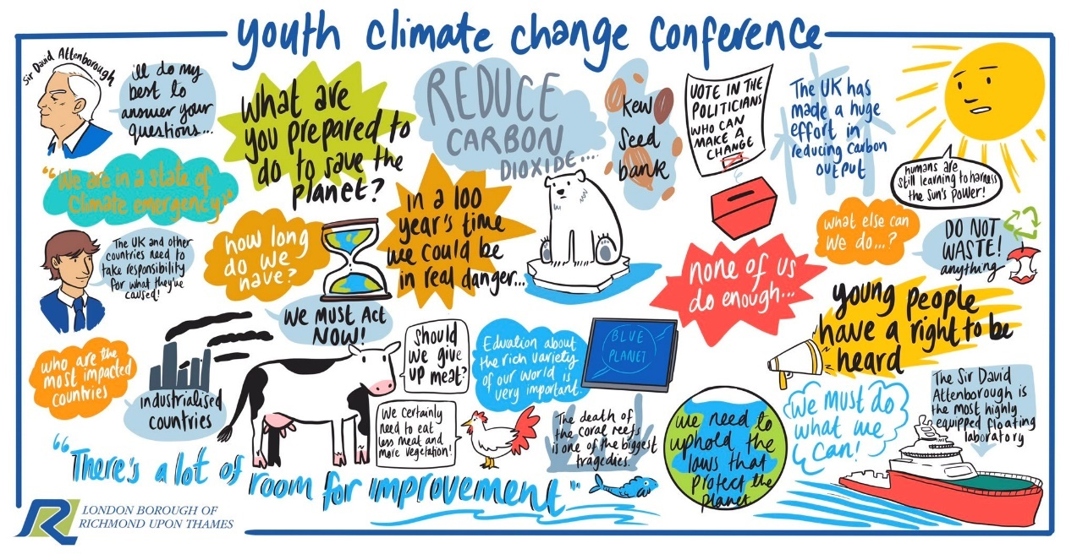
As part of the Richmond Council’s consultation on the borough’s Climate Change strategy a Youth Summit was held on the 16th October from 12noon – 5pm.
Over 160 young people attended from 17 schools across the borough. Schools included:
- Richmond upon Thames School
- Twickenham School
- Clarendon School
- Christs School
- St Richard Reynolds School
- Richmond Park Academy
- Turing House
- Greycourt School
- Waldegrave School
- Orleans Park
- Hampton School
- Hampton Prep
- Lady Eleanor Hollis
- Kew College
- Kew Green Prep
- Radnor House
- Hampton Court House School
At the start of the event, a small market place was held, where local organisations involved in environmental linked activities was held. Young people could find out more and ask questions before the summit. Stallholders included:
- Youth Services (AfC)
- Health and Social Care Plan (CCG / Council)
- Air Quality Team (Richmond Council)
- Active Travel (Richmond Council)
- Twickenham Cycling Club
- Richmond Environment Trust
- West London Waste
- Go Outside and Learn
- Waste Buster
- Plogolution
- Brilliant Play
- Refill London

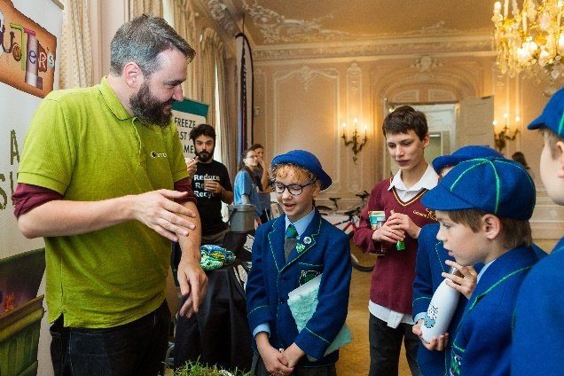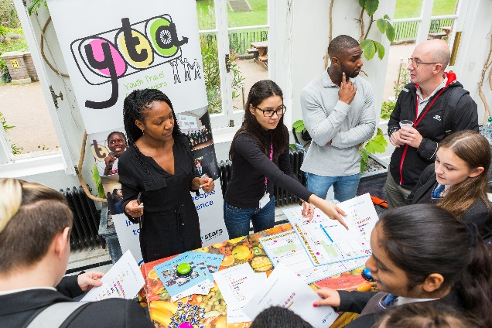

The event was opened by Cllr Gareth Roberts – the Leader of the Council. Key note speeches also included Joe Crabtree (the borough’s Youth Parliament Member) and Sir David Attenborough. Young people had the opportunity to quiz Sir David on environmental issues. To see a summary video, go to: https://www.youtube.com/watch?v=dGznYPoAjqc&t=119s
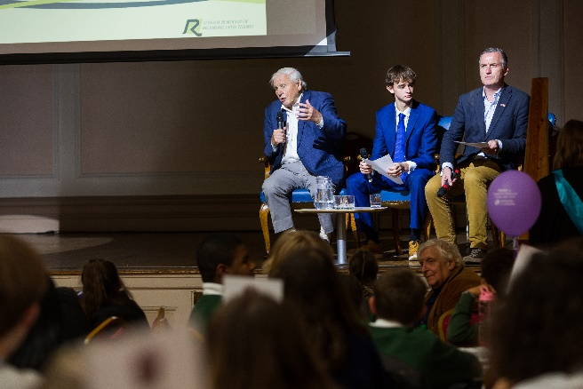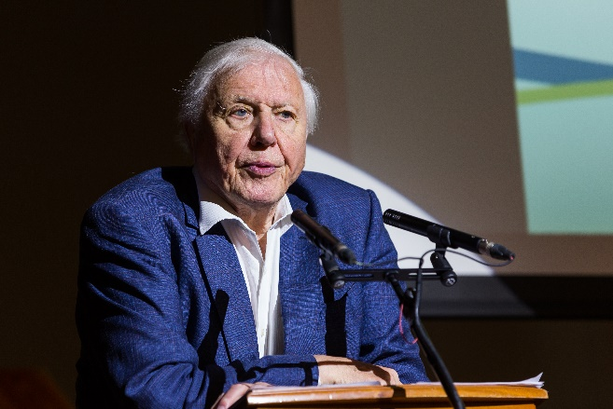

The actual summit was held in partnership with the Youth Council. Each school sat with their peers and table discussions were facilitated by a Youth Council representative.
Each school was asked to answer the below questions:
- How are you already seeing the impact of climate change?
- What ideas do you have to reduce the impact of climate change?
- What can your school do to reduce it’s carbon footprint?
There were three ways of capturing feedback:
- Interactive artist – Throughout the event an artist captured the essence and spirit of the event by creating ‘live art’.
- Feedback wall – school pledges were written on large boards around the room
- Table feedback sheets – Each table summarised their discussions on large reusable sheets on each table.
After the event, Sir David Attenborough planted a tree in the grounds of York House to commemorate the borough’s first Climate Change summit.
The below is a summary of the feedback from the young people. Key repeated ideas and suggestions include:
- More education in schools for young people
- More facilities for cycling around the borough
- Schools banning single use plastics
- Schools buying locally sourced produce and providing more vegan / vegetarian meals
- School lighting to be on motion sensors
- Schools having gardens / vegetable patches
- More trees across the borough
- Grants for schools to have sustainable energy sources e.g. solar panels
- More recycling bins
- Schools reducing the amount of paper printed and used – utilising new technology instead.

HOW ARE YOU CURRENTLY SEEING THE IMPACT OF CLIMATE CHANGE?
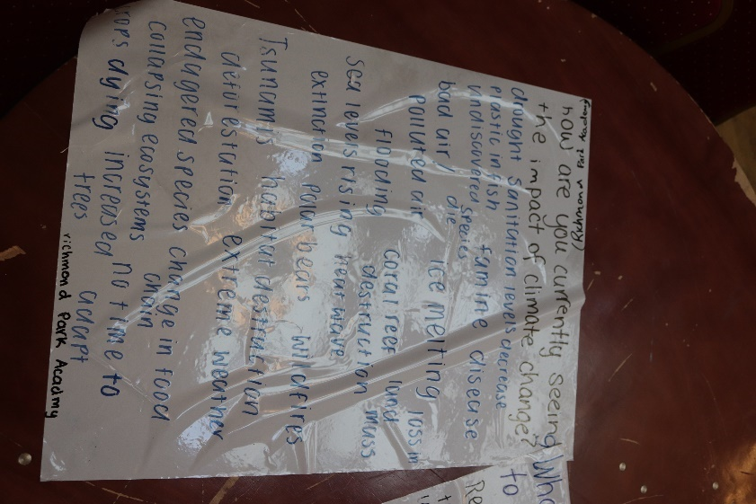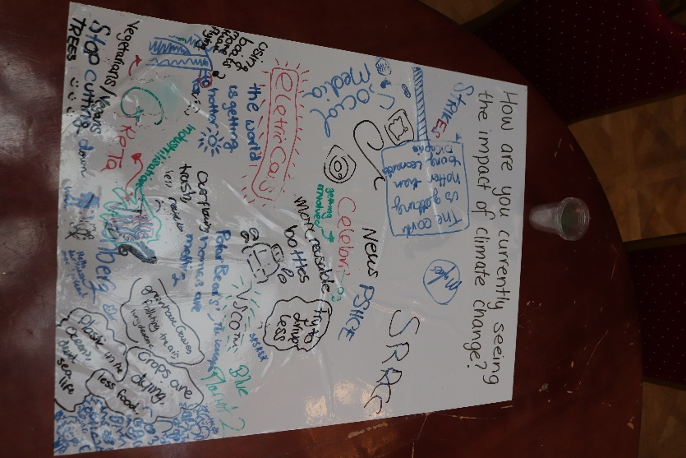
SCHOOL NAME | IMPACT
Hampton Court / Radnor House | On TV and in the Media – not sure what is true and what is rumour
 | Local events – some are cancelled because of flooding
 | Extreme weather e.g. heatwaves and hurricanes
 | Less animals in local parks
Kew College / Kew Green | Not being able to go outside as much – breathing bad air
 | Air smells more
 | Wildlife being hurt by Climate Change
 | River is over polluted
 | More people protesting to prevent climate change
Orleans Park | Unpredictable weather changes / patterns
 | At home, on the hottest day in the summer has a detrimental effect on everyday life
 | Plants suffer more in the hot weather
 | More wildfires
 | Colder winters
 | Increased rate of flooding
 | Impact through the way products are advertised in shops e.g. food wrap
 | More environmental groups e.g. Extinction Rebellion
 | Rise in sea water levels
Hampton School | More haze
 | More floods
 | Hotter summers
 | Decreasing bees
 | Extreme weather – sea level rising and floods
 | Shortage of food
 | Migration of birds
 | Rainforest burning
 | Too many trees are being cut down.
Hampton Prep | More smog
 | Extreme weather
 | More cars on the road
 | More people with breathing problems
 | More animals becoming extinct
Turing House | More heatwaves
 | Heavy rain
 | More floods
 | Plastic in rivers
 | More diseased trees
 | Fewer wild animals
 | More polluted air
 | Mass migration of people
Greycourt | Less bees
 | More flooding
 | More food consumption
 | More rubbish on the streets
 | More volatile weather
 | Less wildlife
 | More air pollution
Christs | Water acidification
 | Air pollution
 | Death of bees
 | Less flowers
 | Artic ice caps melting
 | Increase in extreme weather and wildfires
 | Hotter summers
 | No snow
 | Rising sea levels
St Richard Reynolds | School strikes
 | Social media
 | World getting hotter
 | Less trees
 | TV shows e.g. Blue Planet
 | Campaigners e.g. Greta Thurnberg
 | Crops are creating less food
 | Polar bear homes are melting
 | Air pollution
Richmond Park Academy | Drought
 | Plastic in fish
 | Famine and disease
 | Polluted air
 | Flooding
 | Sea levels rising
 | More endangered species
 | Coral reef destruction
 | Loss in land mass
 | Habitat destruction
 | More wildfires
 | Change in food chain
Richmond upon Thames School | Hotter days
 | Unpredictable weather
 | More polluted air
 | Dry grass
 | Oil spills
 | More algae on ponds
 | More seagulls
 | More chronic illness in young people
 | More wildfires
Clarendon School | More flooding
 | More emissions
 | More toxic air
 | Nature is going extinct
 | Less eco systems
 | More pollution
 | Easier to get fossil fuels
Twickenham School | Plants are dying
 | More documentaries
 | Less wildlife
 | Extreme increase of CO2
 | More pollution
 | Wildlife in the sea swallowing plastic
 | Cutting down trees
 | Air isn’t clean
 | River is flooding more
Waldegrave | More air pollution
 | Poorer air quality
 | Ecosystems being destroyed
 | Bad weather – heatwaves / tsunamis / hurricanes / droughts
 | Collapsing economies / destruction of cities and towns
 | Food shortages around the world
 | Threat to agriculture
Lady Eleanor Hollis | More air pollution
 | Hotter summers
 | Unpredictable weather
 | Rise in indicator species e.g. Bloodworms / Oak Caterpillar
 | Pollution floating in the Thames
 | Sea level rising
 | Rise in people being treated by the NHS for air pollution illnesses
 | Reduction in bees
 | Overall decline of insects

WHAT IDEAS DO YOU HAVE TO COMBAT CLIMATE CHANGE?
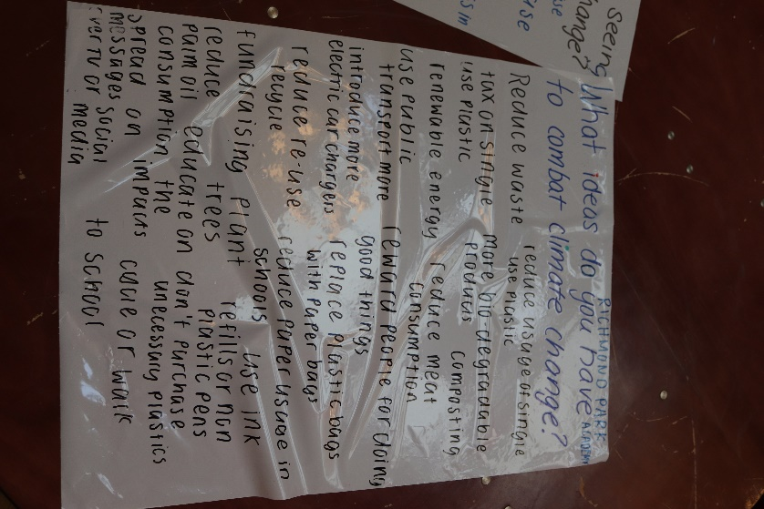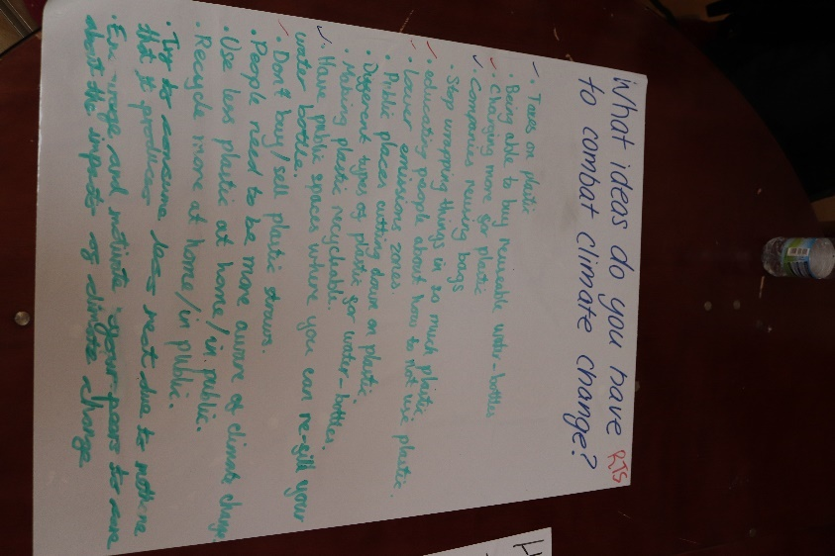
SCHOOL NAME | IDEAS
Hampton Court / Radnor House | Ban unstainable products and launch a campaign in schools
 | Promote the benefits of sustainable products to schools
 | Remove or reduce subsidies on cattle farms
 | Reduce the borough speed limit
 | Have a system where the Government and councils listen to scientific advice and act
 | Recognise Earth Day and switch off lights
 | Schools should be encouraging peer – to – peer conversations
 | Schools should only source food locally
 | Local super markets should be asked to only provide paper bags and not plastic
 | Borough should ask residents to reduce meat consumption
 | Schools should use more renewable energy sources
 | Better cycle paths across the borough - encourage more people to walk.
 | Introduce more education about Climate Change at schools
Kew College / Kew Green | More renewable energy sources e.g. solar panels
 | Collect more rainwater
 | More breeding of animals
 | More electric cars on the roads and charging stations.
Orleans Park | Reduce plastic and food waste
 | Driving less and using more public transport
 | Ask supermarkets to reduce their plastic packaging
 | Make more materials recyclable
 | Stop people buying single use products
 | Have a plastic ban week in Richmond upon Thames
 | Install more trees
 | Publicise businesses that do-good thing with food waste
 | Don’t send any waste to landfill
 | Ask super markets to recycle more
 | Only use compostable packaging e.g. beeswax
 | Manufacture more robotic ocean cleaners
 | Reduce the number of children people have
 | Plant more trees
 | More litter bins and recycling bins on the street
 | Encourage people to buy local and stop buying in supermarkets
Hampton School | Companies need to be more transparent about their climate change activities
 | More authority and illegal trade regulations in third world countries
 | Try to switch to more environmentally friendly amenities e.g. Energy providers / No palm oil / sustainable cotton and fabrics
 | Campaign for developed countries to take responsibility for the purchasing of goods which release CO2
 | Reduce single used plastics
 | Reduce meat consumption
 | Improve the labelling of goods e.g. food etc to show the impact of their production and purchase
 | Encourage locally sourced / fair trade and organic food
 | Set realistic goals on how to become a single use plastic free borough.
Hampton Prep | Use a milkman
 | Use more renewable products
 | Cut down the use of cars
 | More people should recycle
 | People should stop buying fast fashion
 | People should change their diet and stop buying meat
 | Stop unnecessary packaging
Turing House | We should reduce our:  - Plastics  - Energy consumption – better lighting  - Carbon emissions – more woodlands  - Food waste – buy smarter  - Paper consumption – particularly in schools  - Meat consumption – more vegetarians and vegans  Campaign to raise awareness  More people should use reusable cups
Greycourt | No car day – particularly in Richmond Park
 | Plant more trees
 | Put Climate Change on the curriculum
 | Better cycling lanes
 | Encourage super markets to stop using plastic packaging
 | More recycling bins near schools
 | Electric bins lorries
 | Promote subsidies for schools to use sustainable energy sources
Christs | More education
 | Create a citizen’s assembly
 | Eat and buy less meat
 | Ban cars from Richmond Park
 | Recycle more
 | Grow vegetables
 | Use bins properly
 | More cycling facilities
 | New buildings should all have motion censored lights
 | More education about the impact of fast fashion
St Richard Reynolds | Use boats rather than flying
 | People should drive less
 | Use metal straws and rulers not plastic
 | Stop printing paper
 | Don’t litter
 | Use water power
 | Use solar power
 | Cut down on car usage
Richmond Park Academy | Reduce waste
 | Tax single use plastic
 | Use renewable energy
 | Use public transport
 | Introduce more electric car chargers
 | Encourage reduce reuse and recycle
 | Reduce palm oil consumption
 | Spread messages on social media
 | Compost more
 | Reward businesses for doing good things
 | Ban plastic bags every where
 | Schools and businesses should use renewable ink cartridges
 | Cycle more
Richmond upon Thames School | Tax on single use plastics
 | Ability to buy reusable water bottles
 | Charge more for single use plastics
 | Companies to reuse plastic bags
 | Companies to stop wrapping things in plastic
 | Better education
 | More recycling points for single use plastics
 | Ban plastic straws
 | People should recycle at home
 | Encourage people to eat less meat
 | Everyone should campaign
Clarendon School | Make fossil fuels illegal
 | More solar panels
 | Don’t cut down trees
 | More nature sanctuaries
 | Stop wasting paper
 | Stop people washing things on high temperatures
 | Ban single use plastic
 | Use bees wax more
 | Only use eco-friendly cleaning products
Twickenham School | More water points around the borough
 | More electric charging points
 | People should stop going on planes
 | Stop using fossil fuels
 | All schools should provide refillable water bottles
 | People should only use recyclable materials
 | Plant more trees
 | More recycling bins
 | Clean up parks
 | More cycle paths
 | People should turn off their lights
 | More education
Waldegrave | School uniforms should be sustainable cotton
 | School uniforms from charity shops
 | Education around fast fashion
 | Ban plastic wallets in school
 | Better way of accessing reusable ink cartridges
 | Better way of sharing unused food
 | Turning off lights
 | Don’t use paper – use technology
 | Less meat and dairy
 | Use farmers market
 | Stop using cars
 | Stop using harmful chemicals
 | Businesses to use technology rather than calls
 | Introduce a flight tax for businesses
 | Stop Heathrow expansion
 | More provision for electric cars
Lady Eleanor Hollis | Tax single use plastic
 | People should use reusable bottles and containers in shops
 | People should say no to fast fashion
 | Provide people with more food waste bins
 | Drive less- make public transport more affordable
 | More facilities for electric cars
 | More grants for solar panels on schools and homes
 | People should eat sustainably
 | Campaign to encourage people to reduce plastic packaging from food
 | More food markets
 | Introduce a food mile limit.

SCHOOL PLEDGES
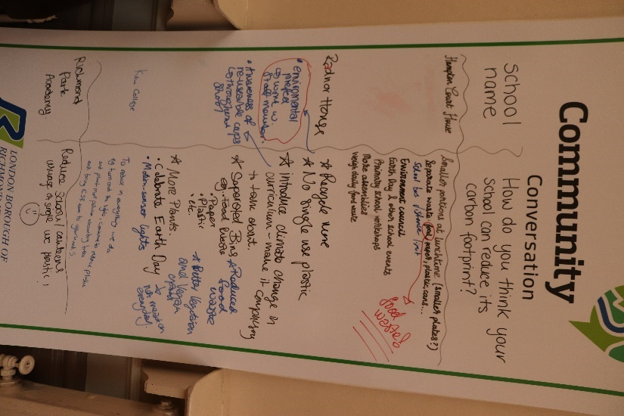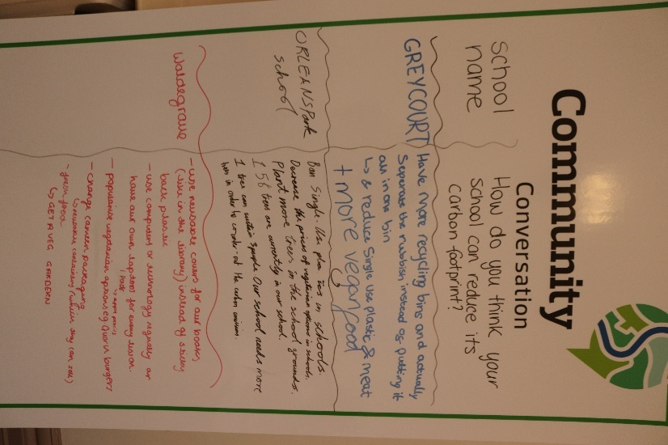
SCHOOL NAME | How do you think your school can reduce its carbon footprint?
Hampton Court House | Smaller portions at lunch time
 | Separate waste and better information for students about recycling
 | School bus distance limit should be in place.
Radnor House | Recycle more
 | Ban single use plastic and only use reusable cups and bottles
 | Introduce climate change into the curriculum and make it compulsory for young people to talk about it
 | Introduce separate bins for e.g. food waste / paper / plastic
 | More plants
 | Link in with national campaigns e.g. Earth Day
 | Install motion sensor lights
Richmond upon Thames School | School needs to use more natural light rather than closing blinds and using electricity
 | More recycling bins – with clear labelling so students understand them
 | Plant more trees
 | Have a vegetable garden
 | Launch an environmental club
St Richard Reynolds | More recycling bins
 | Install automated lights so they go off when no one is around
 | Turn off computers – they are on all the time
 | Ban single use plastics and insist students use reusable bottles
Turing House | Review how much waste is removed by the school
 | Reduce the amount of paper used by the school
 | Utilise more online resources regarding Climate Change
Twickenham School | Install more water fountains
 | Ban plastic straws
 | More recycling bins available
 | Offer vegan meals
 | Only use recycled paper
Christ’s School | Achieve green flag status at schools
 | Install more recycling bins
 | Ban single use plastic
Clarendon School | Improve the heating system
 | Stop wasting paper
Hampton School | Raise awareness of the Environmental Society
 | Increase social media presence of what the school is doing
 | Launch an eco-schools project
 | Ban single-use plastics
 | Only source food locally
 | Swap web browser to Ecosia
 | Launch meat free Monday
Hampton Prep | Only source food locally
 | Plan to produce less waste
 | Improve recycling and install more bins
 | Educate young people about climate change
 | Only have electric school vehicles and not diesel one
Lady Eleanor Hollis | Plant more trees and plants – install a live plant wall
 | Turn lights off when school is closed
 | Don’t idle school buses in school car park
 | Install beehives and bug homes
 | Introduce more renewable energy sources (e.g. solar panels)
 | Collect rainwater for plant watering and toilets
 | Reduce food waste and educate on food (i.e.: not having as much)
Kew Green | Install solar panels
 | Install more trees and plants
Kew College | Motion sensor lights
 | Ban single use plastics
 | Plant more trees
 | Bring ESR to years five.
Richmond Park Academy | Ban single use plastics
Greycourt | More recycling bins
 | Separate the rubbish
 | Ban single use plastics
 | Provide more vegan food options
Orleans Park School | Ban single use plastics
 | Decrease the price of vegetarian food
 | Plant more trees
Waldegrave | Use reusable covers for our books instead of plastic
 | Use computers / technology or have our own lap tops instead of paper
 | Provide more vegetarian or vegan catering options
 | Change canteen packaging
 | Get a veg garden
 | Locally source food

