Outline Joint

Primary Care Strategy

for discussion

July 2016

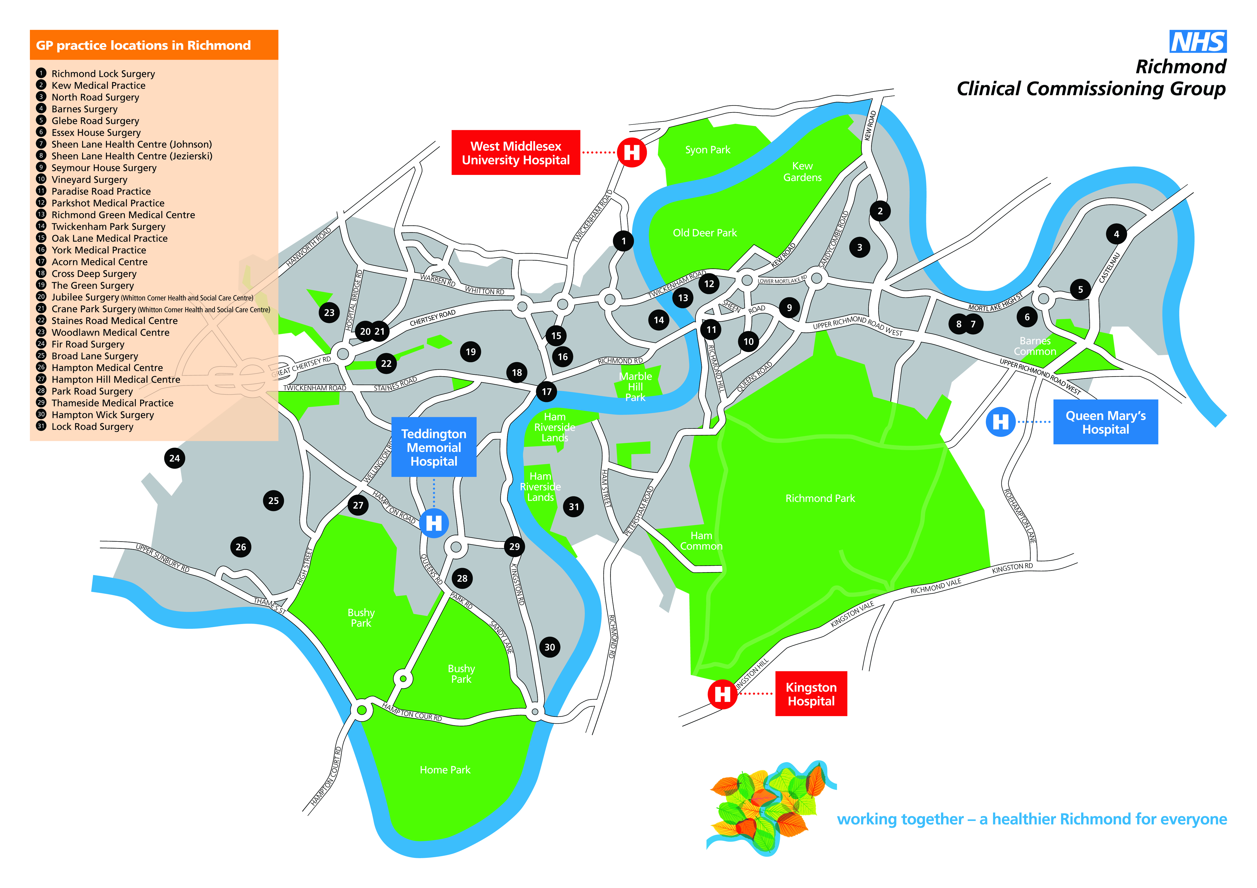

Outline Primary Care strategy

Introduction

Primary care is pivotal for the transformation of health and health services. 90 per cent of NHS activity takes place in primary for 7.5 per cent of the cost, seeing more than 320 million patients per year. However, the model of general practice that has served us well in the past is now under unprecedented strain and there are significant challenges that must be addressed.
We need to celebrate what primary care does well and retain what works, but we also need to see through significant changes to how primary care is organised, how services are delivered and how the workforce will develop. We will use the opportunities brought through the powers of co-commissioning to flex services to meet the London Strategic Commissioning Framework, which will improve access, proactive care and co-ordination of care.
Among the national challenges facing the NHS, those of particular relevance to Richmond are our ageing population with an increasingly higher life expectancy, growth in the number of people with long term and complex health conditions, alongside increases in social isolation across socio-economic groups, and a corresponding rise in public demand and expectations (Darzi 2008; NHS Five Year Forward View, 2014).
Definition of Primary Care
It is care provided in the community for people making an initial approach to a medical practitioner or clinic for advice or treatment. Primary care services include GPs, dental practices, community pharmacies, and optometrists.
Challenges
What are we trying to achieve
General practices in the borough of Richmond already provide a high standard of primary care. Quality care is achieved by focusing on the three domains of quality: patient safety, clinical effectiveness and patient experience. Quality will also be the thread linking each work stream of the Primary Care Strategy to ensure that we:
            - Embed quality in design stage of the service
            - Ensure quality in delivery
            - Provide quality assurance

We will build upon the work we inherit from NHS England commissioners to provide a quality improvement tool to support us reduce variation, improve performance and support practices to undertake actions required to achieve higher quality of primary care.
Richmond has 28 general practices, with a total registered population approximately 205,000.

The annual Public Health Report for 2016 identifies significant population statistics and public health factors, for our local area, in particular:

        - Key needs for children aged under 5
        - Key health and social care needs of older people, aged 75 and over including medical complexity, social isolation and loneliness.
        - Avoidable emergency admissions as a result of better management of long term conditions and admissions which may be preventable by better end of life care planning between patients, their families and the health professionals involved in their care.

Overall, the general health and wellbeing of our local population is above average and we will seek to build on and optimise this further. The local Joint Health & Wellbeing Strategy includes a number of initiatives that are important for the delivery of good health outcomes. Specific issues (as described in the Joint Strategic Needs Assessment, JSNA) include;

                - Maximising prevention opportunities
                - Reducing health inequalities
                - Minimising harms and threats to health
                - Planning for demographic change and promoting independence

National strategies
Within the last two years two key national strategies have been published by NHS England which provides vision for primary care transformation; The Five Year Forward View (2014) and The General Practice View (2016).
What this means for us is that our Primary Care strategy will be based around these key strategic priorities to guide us to shape our vision with key aim of providing high quality services at the right time and right place.
As well as that a key publication on the London Strategic Commissioning Framework provides a platform to find solutions to the challenges face in Richmond and across London. This framework identified three aspects of care that patients care the most these are;
- Accessible
- Proactive
- Coordinated
The table below is an illustrative of the specification to be delivered by all Commissioners in London to enable primary care to be transformed for better patient care.
- Accessible Care
Patient Choice | Patients will be given a choice of options on how to access primary care services and should be able to decide on the consultation most appropriate to their needs
Contacting the practice | Patients will be required to only make one call, click or contact in order to make an appointment. Practice teams will maximise the use of technology and actively promote online services to patients including appointment booking, prescription ordering, viewing medical records and email consultations
Routine opening hours | Patients will be able to access pre-bookable routine appointments with a primary health care professional at all practices  8 am – 6.30pm Monday to Friday and 8 am to 12 am on Saturdays
Extended opening hours | Patients will be able to access a GP or other primary care health professional 7 days per week, 12 hours per day (8am to 8pm or alternative equivalent based on local need) in their local area for pre-bookable and unscheduled care appointments.
Same day access | Patients who want to be seen the same day will be able to have a consultation with a GP, or appropriately skilled nurse on the same say within routine surgery hours at the practice at which they are registered.
Urgent and emergency care | Patients with urgent or emergency needs will need to be clinically assessed rapidly.  Practices should have systems in place and skilled staff available to ensure these patients are effectively identified and responded to appropriately.
Continuity of care | All patients will be registered with a named GP who is responsible for providing an ongoing relationship with them for care coordination and care continuity.  Practices will provide flexible appointment lengths as appropriate.

- Proactive care
Co-design | Practice teams will work with communities, patients, their families, charities and voluntary sector organisations to design ways to improve the health and wellbeing of the local population
Developing assets and resources for improving health and wellbeing | Practices will work with other teams to develop and map the local social resources available that could empower people to remain healthy, feel connected to others and to support in their local community (e.g. sports, culture, environment, voluntary sector.)
Personal conversations focused on an individual’s health goals | Where appropriate, patients will be asked about their wellbeing, capacity for improving their own health and their health improvement goals.
Health and wellbeing liaison and information | Practices will enable and assist people to access information, advice and connections that will allow them to achieve better health and wellbeing. This health and wellbeing liaison function will extend into schools, workplaces and other community settings.
Patients not currently accessing primary care services | Primary care teams will design ways to reach people who do not routinely access services and who may be at higher risk of ill health.

- Coordinated care
Case finding and review | Practices will identify patients who would benefit from coordinated care and continuity with a named clinician, and will proactively review those that are identified on a regular basis.
Named professional | Patients identified as needing coordinated care will have a named professional who oversees their care and ensures continuity.
Care planning | Each individual identified for coordinated care will be invited to participate in developing their own single care plan that can be shared with teams and professionals involved in their care.
Patients supported to manage their health and well-being | Primary care teams will create an environment in which patients have the tools, motivation and confidence to take responsibility for their health and wellbeing.
Multi-disciplinary working | Patients identified for coordinated care will receive regular reviews by a team involving health and care professionals with the necessary skills to address their needs. The frequency and range of disciplines involved will vary according to the complexity and stability of the patient as agreed with the patient/carer.

What the specification will mean for our population
