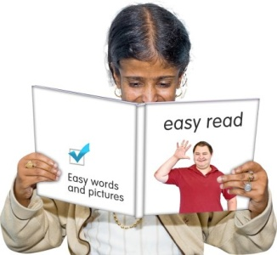
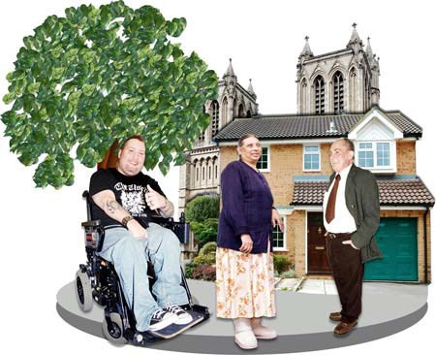

Richmond Upon Thames Learning Disability Strategy 2014 to 2017……….

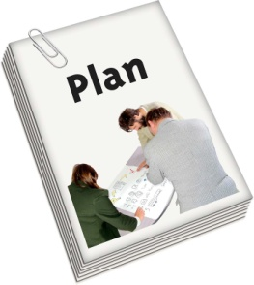
Our BIG

Easy Read

Introduction

This is our new learning disability strategy.

This Strategy is the plan for how leaders in Richmond are going to spend money on making the lives of people with learning disabilities better.

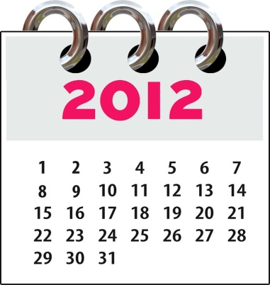
2017
This plan is for years from 2014-2017.

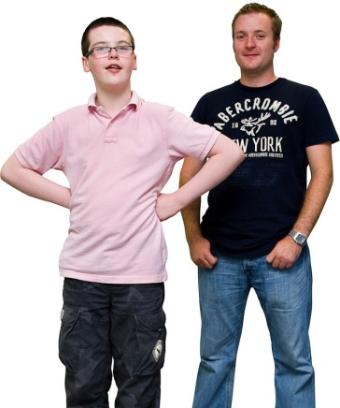
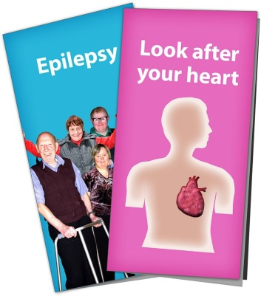

Vision

A vision is a goal for how we want things to be for people with learning disabilities in Richmond.

In Richmond we want to spend money in the best way to have:

- Services that help people with learning disabilities and their carers.

- Services that help people with learning disabilities have good health and stay well.

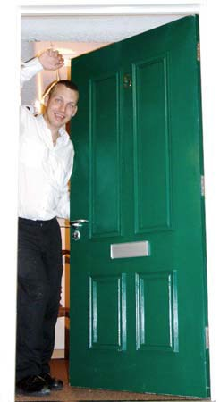

Vision

In Richmond we want to spend money in the best way to have:

- Services that support people with learning disabilities to be independent and make their own choices.

- Services that are planned by health teams and social care teams together.

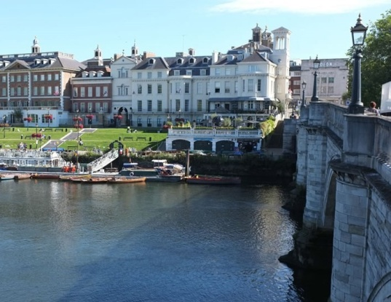
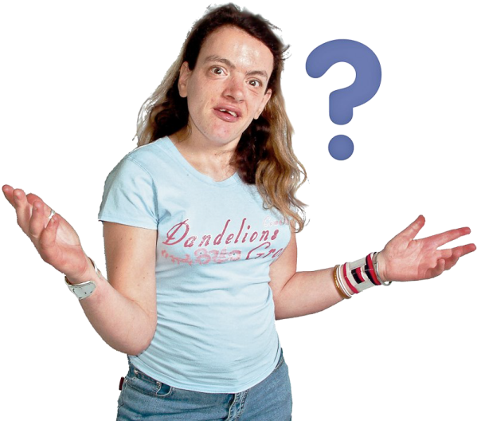

Why do we need a plan?

We need a plan to do lots of things:

  - To make it easier for people with learning disabilities to know what services will be available.

  - To make sure our services are right for people with learning disabilities in The London Borough of Richmond.

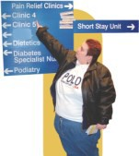
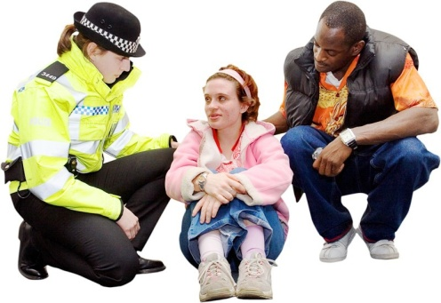

Why do we need a plan?

We need a plan to do lots of things:

  - To make sure we can have a better way at knowing which services we need and which we don’t.

  - To make sure we have services that allow people with learning disabilities to understand and make choices.

  - To keep people safe.

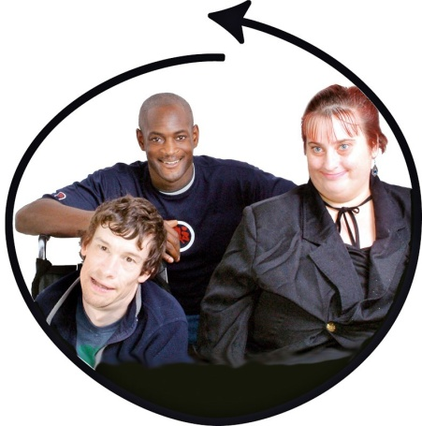

Why do we need a plan?

We need a plan to do lots of things:

  - To allow as many people with learning disabilities as possible to live in Richmond.

  - To make sure we help young people with learning disabilities who are leaving school to plan their future.

  - To make sure we have the right services in Richmond for everyone with a learning disability, both now and in the future.

Our Plan

We have talked to many people with learning disabilities in Richmond.

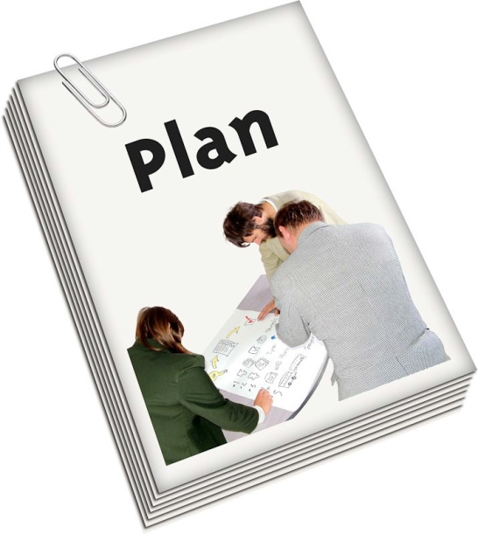

Your ideas have helped us write a long plan about the work we will do until 2017.

Our Plan

There are lots of details to this plan. Here are a few easy to understand sentences to help you.

Our plan will:

    - Help you and your carers be more independent, especially in how you spend money on getting the help you need.

    - Make sure that the services we provide really help you.

    - Make sure that you get better help from doctors, hospitals & health services.

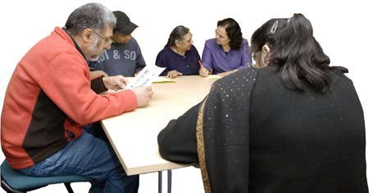
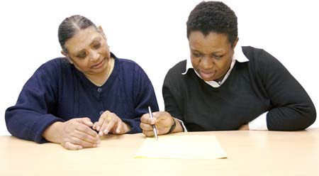

How are we doing?

We will check that we are doing everything on our plan very carefully, every year.

We will ask you to tell us how we are doing every year at a special event.

We want you to tell us about the services you receive. You can contact us at any time:

Telephone: Email: Address:

